

Dear Baccalaureate Nursing Student,

On behalf of the faculty and staff of the University of Windsor Faculty of Nursing, congratulations on your acceptance to the BScN program for Fall 2026!

We are thrilled to welcome you to our community and look forward to supporting you as you pursue your educational and professional goals.

Nursing offers many unique opportunities to make a difference in people’s lives. At UWindsor, we are committed to preparing you to become a competent, knowledgeable, and compassionate nurse, ready to thrive in any area of practice you choose. We are confident that your education here will equip you for a fulfilling and rewarding career in healthcare.
This admission package includes important information to help you prepare for the fall term; we encourage you to review it carefully. Once you’ve accepted your offer, review it to confirm all conditions have or will be met prior to your start in the fall.
Please plan to attend Head Start 2026, an informative program specifically designed to help you get ready for September. Details and dates will be available soon at https://www.uwindsor.ca/orientation/349/headstart.

Other exciting events are planned leading up to Head Start as well. Please find this information on our Faculty of Nursing website and follow us on Instagram and Facebook.

If you haven’t yet visited our campus, we encourage you to book a tour through the Recruitment Office.
Once again, congratulations on your acceptance! This is an exciting milestone for you and your family! We look forward to welcoming you on campus and wish you every success as you embark on your nursing education.
If you have questions, please don’t hesitate to reach out to us directly at nurse@uwindsor.ca.

Sincerely,


Dr. Debbie Sheppard-LeMoine, RN, PhD
Dean, Faculty of Nursing

What Makes the University of Windsor’s BScN Program Unique?
The Bachelor of Science in Nursing (BScN) program at the University of Windsor is designed to prepare confident, practice-ready nurses through early, continuous, and immersive clinical experiences—beginning in first year and building in complexity each year.
Students benefit from a strong balance of hands-on clinical practice, high-fidelity simulation, and theory-to-practice integration, including:
- Clinical practicum (placements) starting in first year, giving students early exposure to real-world nursing practice.
- Three full-time “consolidated” clinical practicum courses in the spring terms following first, second, and third year, allowing students to strengthen and apply skills learned in theory and lab courses.
- Two fourth-year preceptorships, where students work and learn one-on-one with a Registered Nurse or other health care professional:
  - one placement in an acute care hospital setting
  - one placement in a community-based setting
- Opportunities for specialty placements in senior years, such as oncology, paediatrics, obstetrics, emergency care, surgery, neurology, psychiatry, and community health.
- Simulation lab experiences every year of the program, featuring:
  - Standardized patients (trained actors portraying real patients)
  - Computerized, high-fidelity manikins that respond and react like real humans in clinical scenarios.
- Additional information about clinical practicum (placements) can be found at: http://www.uwindsor.ca/nursing/390/clinical-placements

Why Students and Families Choose Windsor Nursing

Students and parents consistently highlight the strong academic support, personalized learning environment, and commitment to student well-being:

- Award-winning professors and instructors who are recognized leaders and experts in nursing education and practice.
- Peer Mentors: upper-year nursing students who support skills development and confidence-building in labs.
- A dedicated Student Success Coordinator who provides academic guidance, course planning assistance, and ongoing student support.
- A Clinical Therapist specifically assigned to support nursing students’ mental health needs.
- A living, learning community specific to Nursing in Residence, fostering community and peer support.
  - Learn more about residence: http://www.uwindsor.ca/residence/

Did You Know?

- The University of Windsor is Canada’s southernmost university, offering one of the mildest and warmest climates in the country. It is located just south of Detroit, Michigan.
- Our campus is uniquely situated between Lake St. Clair and Lake Erie, along the scenic Detroit River offering a gorgeous walking/ cycling path spanning from the University of Windsor to the downtown core.
- Windsor is one of the few nursing programs in Ontario that offers the opportunity to complete an international exchange semester in senior years, with a partner institution in Sweden.
- As a border city, Windsor provides graduates with unique access to international employment opportunities, particularly in Michigan and other U.S. states. Many alumni live in Windsor while working across the border.

Have you heard about the Learn & Stay Grant?
Find out more information about this grant including eligibility criteria and what this program has to offer (free tuition)!!
https://www.ontario.ca/page/ontario-learn-and-stay-grant



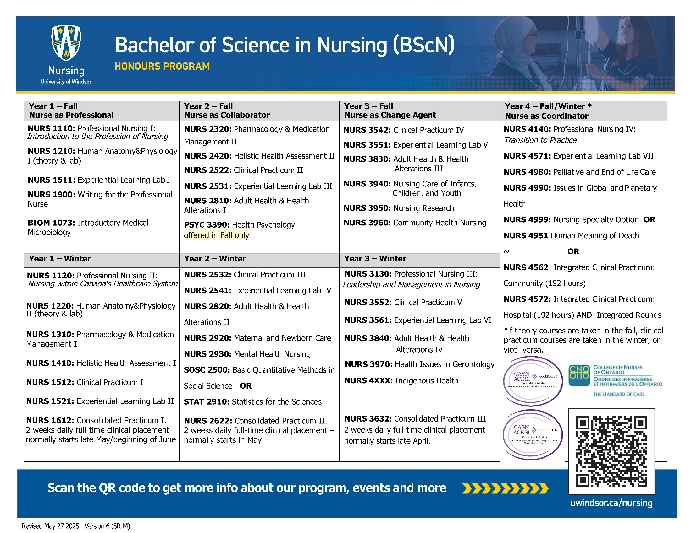
NURSING YEAR 1 COURSE DESCRIPTIONS

NURS 1110- Professional Nursing I: This is the first in a series of five courses that address professional nursing practice. The learner is introduced to the roles and responsibilities of registered nurses and fundamental concepts of professional nursing practice. Emphasis is on exploring the concept of health and professional nursing skills (i.e. critical thinking, therapeutic communication, evidence-informed decision-making, teaching and learning) that promote patient/client and family-centered care.

NURS 1210- Human Anatomy & Physiology I: This is the first of two courses that introduce the learner to the foundations of anatomy and physiology within the context of nursing and health. Content includes an overview of the structure, function, and organization of the human body (from the cellular level, to tissues, organs, and organ systems) and review of selected organ systems such as the integumentary, nervous, endocrine, hematologic, and musculoskeletal systems. Review of systems will incorporate the anatomy and physiology of the system and its relevance, and importance to patient/client care.

NURS 1511- Experiential Learning Lab I: This is the first in a series of seven onsite experiential learning labs in which the learner will apply theory to clinical practice through a variety of interactive and simulated activities. In this course, the learner is introduced to clinical and communication skills for the professional nurse.

NURS 1900- Writing for the Professional Nurse: This course introduces the principles of effective written communication that are essential in the diverse roles of a nursing professional. The aim is to help the learner develop the skills to accurately and reliably communicate written information in a variety of forms: personal reflections, documentation in charts/records, and scholarly writings (e.g., educational materials, abstracts, posters, journal articles, project reports).

BIOM 1073- Introductory Medical Microbiology: This introductory course provides a foundation in microbiology relating to Nursing. Key concepts in the biology of infectious agents, human-microbe interactions, mechanisms of microbial diseases, control of microbial growth, immunology, epidemiology, and public health. (Open only to Nursing students. May not be used for credit in any Science program). (Co-requisite: Registration in all courses required for 1st year fall semester). (Antirequisites: BIOL-2070, BIOL-2071, BIOM-3070, BIOM-3071).

NURS 1120- Professional Nursing II: This is the second in a series of five courses addressing professional nursing practice. The learner will explore concepts that contribute to safer, high-quality patient/client-centered health care systems. Examples include leadership, collaboration, quality, and nursing informatics. The learner is introduced to the history and structure of the Canadian health care system. They explore the legal and professional roles and responsibilities of registered nurses in various care settings, and how nurses promote community and population health.

NURS 1220- Human Anatomy & Physiology II: This is the second of two courses that introduce the learner to the foundations of anatomy and physiology within the context of nursing and health. Emphasis is on interrelationships among the cardiovascular, immune, respiratory, digestive, urinary, and reproductive systems. The learner will also examine the regulation of physiological functions involved in maintaining homeostasis.

NURS 1310 Pharmacology & Medication Management I: This is the first in a sequence of two pharmacology courses. This course introduces the learner to the fundamentals of the science of pharmacology and safe medication management. Selected herbal, over the counter, and major drug classifications are introduced.

NURS 1410- Holistic Health Assessment I: This is the first of two courses that introduce the learner to concepts and principles underlying the holistic health assessment of the well adult. In this introductory course, the focus is on the development of interviewing and history taking skills, and foundational health assessment skills (physical, psychosocial, cultural, and spiritual). The learner will recognize normal findings and deviations from normal and communicate assessment findings to promote health.

NURS 1521 Experiential Learning Lab II: This is the second in a series of seven onsite experiential learning labs in which the learner will apply theory to clinical practice through a variety of interactive and simulated activities. In this course, the learner will apply introductory holistic health assessment skills and select clinical and communication skills for professional nursing.

NURS 1512- Clinical Practicum I: This is the first in a series of clinical practica that provide the learner with the opportunity to apply knowledge and skills in clinical practice settings. The learner will practice professionalism, components of holistic health assessment, and communication skills with the adult population, in the context of family and community.

NURS 1612- Consolidated Practicum I: This course provides the learner with the opportunity to consolidate knowledge and skills in a clinical practice setting. The learner will practice professionalism, select clinical and health assessment skills, and communication skills with the adult population in the context of family and community.

BScN PROGRAM REQUIREMENTS

Important note: All costs associated with fulfilling requirements are the responsibility of the student.

SECTION A: MEDICAL/NON-MEDICAL CLINICAL PRACTICUM ENTRY REQUIREMENTS
You are about to enter training for a profession in which you will be taking care of people in many different circumstances. Due to the sensitive and/or vulnerable nature of their circumstances, you must complete/obtain certain medical and non-medical requirements prior to starting your first clinical placement, and annually thereafter.

Year 1 Requirement Check list

**Please start working on these requirements AFTER June 8th 2026 **
Please review the Year 1 ERV (Electronic review Verification) and non-medical forms links posted on the main Faculty of Nursing website prior to your Synergy document review appointment so you do not miss any requirements. https://www.uwindsor.ca/nursing/375/pre-clearance-information-and-forms

Medical Requirements:

- Diphtheria/Tetanus- documented proof of vaccination within 10 years
- Pertussis- Documented proof of Vaccination
- Measles, Mumps, Rubella (MMR)- Documented proof of vaccination of 2 doses or if no documentation is available, you can submit blood work that has been done within 5 years showing immunity.
- Varicella- Documented proof of vaccination of 2 doses or if no documentation is available, you can submit blood work that has been done within 5 years showing immunity.
- COVID Vaccine - Documented proof of primary vaccination series with a Health Canada approved vaccine (2 doses of a two-dose vaccine series or 1 dose of a one-dose vaccine series). If you do not have your COVID vaccine, please reach out to the clinical placement team to discuss this ASAP to get guidance.
- Hepatitis B- Must submit blood work that has been done within 5 years showing immunity.
- 2-Step Tuberculosis Skin Test (TB)- Documented proof of a 2 step TB skin test required. If you have had a positive TB skin test before you will need a medical exam and submit a chest x-ray. (The x-ray would then be valid for 2 years)
Non-Medical Requirements:

- Vulnerable Sector Police Check (VSS)
- For students who are 18 years old and older you must apply for the Vulnerable Sector Search (VSS) at your local police department
- If you are 17-years-old you must wait till you turn 18 to complete a VSS. You will have 10 weeks after your 18th birthday to submit your VSS certificate to the Synergy platform. Please complete your Synergy clearance by the October 15th deadline regardless of when your 18th birthday is. You will receive a conditional pass for your VSS up to 10 weeks after your birthday. The “Police Records Check Request” form from your city or region may be downloaded from the nursing website (www.uwindsor.ca/nursing/police-clearance). If the form from your city or region is not available, please email nurse@uwindsor.ca.
- NOTE: Police clearances can take several months to obtain.
- Please start this process soon after June 8th to ensure that you will have it back in time.
- N95 Mask Fit Testing
- You will need to find an agency that does N95 mask fit testing for the sizes available in our local hospitals. Please see the mask size options on the ERV or this link: Mask Fit Testing Information | Faculty of Nursing
- Mask fit testing is required every 2 years
- Standard First Aid- this is a 1-time requirement
- Canadian (BLS or HCP) Basic Life Support or CPR- for Health Care Providers- Must be in person or hybrid only (theory online/practical in person). Valid for 1 year only regardless of the expiration date on the card
- SMG- Health Care Crisis Intervention and Physical Techniques on-line Training – Must be University of Windsor training SMG – no substitutions
- https://windsoruniversity-safemanagement.talentlms.com/index
Non-Medical Forms:

https://www.uwindsor.ca/nursing/sites/uwindsor.ca.nursing/files/non_medical_forms_may_2025.pdf
- Student Verification of Health Status Form
- Attestation of Notification of Change in Criminal Record Status form
- WSIB form
Where to send all your preclinical clearance requirements:

- The Faculty of Nursing uses Synergy Gateway Verified Inc to clear students prior to their clinical practicum by verifying medical and non-medical requirements listed above.
- Basic information such as your name, email, student number and year of program will be shared with Synergy Gateway Verified Inc to build an account.
- Verified Synergy Gateway invitation emails will begin coming out over the summer. Be sure that you have activated and extended your uwindsor emails as soon as possible so that you can receive this email.
- The due date for your Synergy Clearance is October 15th 2026 please schedule your appointments after Sept. 8th to give priority to students in years 2-4 who require their clearances done in August.

SECTION B: ADDITIONAL PROGRAM REQUIREMENTS
- Important Dates
Mandatory attendance at all orientations is an expectation. These are held before the start of classes each term in all 4 years of the BScN program. Visit: Important Academic Dates to view details regarding date/time/location of your orientations.

For Fall 2026/Winter 2027: Nursing orientations will take place as follows:

Fall 2026: Year 1 Program Orientation September 9th, 2026
Winter 2027: Tuesday, January 19th, 2027 (virtual/recorded)

Consolidated Practicum I (NURS-1612): This is a 2-week, 72-hour course held in late spring. Participants must be available for the full duration of the course, including days, afternoons, evenings, and weekends. The scheduled dates for 2027 Year 1 Consolidation are May 21 to June 4, 2027. An alternate session will run June 7 to June 20, 2027, if required.

- Lab Coat and Uniform – required for September
Students are responsible for purchasing their own uniforms (scrubs) and lab coat prior to starting school in September. The uniform must be worn for university sanctioned clinical practicum courses and experiential lab classes. A lab coat and safety goggles are needed for the Anatomy & Physiology labs. For first and subsequent years of clinical practicum courses, you will require the following:

White Lab Coat: Lab coats are available for purchase at Work Authority; however, students may purchase them at any store.

Uniform: The Collaborative BScN program has a standard uniform (scrubs) for nursing students. The uniform consists of a navy blue short-sleeve scrub top with “BScN Student” embroidered in white on the sleeve, and a navy-blue pant or navy-blue skirt (scrub leggings and capped sleeves are not allowed).

The Work Authority is the preferred vendor for uniforms. They have several locations in southwestern Ontario and can do the embroidery work. To ensure that students obtain their uniform in time for September, orders should be placed by July 1st or as soon as possible. Click here for details regarding style options and Work Authority locations. Work Authority will only arrange embroidery on uniforms purchased through Work Authority. If a student purchases their navy-blue uniform elsewhere, they will be responsible to get embroidery completed on the left sleeve horizontal (using standard Arial Font with an overall size of 2.5” x 2.5” high).

Any shirt worn under the uniform or head coverings worn for religious/cultural purposes must be white, navy blue or black to match the uniform. Head coverings must be plain and unadorned for infection control purposes. Students may only wear the approved University of Windsor lab coat/clinical sweater when in client care areas. Lab coats/clinical sweaters must be removed when providing direct care to patients. Lab coats must not be worn outside of the clinical area. Clothing must be clean, free from rips/tears/odour, sized appropriately and modest.

Shoes – closed, non-slip duty or athletic shoes required, with no mesh openings to allow penetration of fluids. Clogs, “Crocs”, or plastic slip-on shoes are not acceptable due to health and safety concerns, including ankle injuries, trips and falls, spillage, and/or build-up of static electricity that interrupts electronic devices. Shoes must be kept clean.

Nursing Badge - Nursing students are required to purchase a Nursing Badge from the UWinCard Office. This Nursing Badge is part of the uniform required for clinical and experiential learning labs. This is the same place that students obtain their University of Windsor (UWIN) student card.

- Stethoscope
A stethoscope is required and may be purchased at a medical supply store or through the Nursing Society at the start of the fall term.
Stethoscope Requirements: Students are required to have a good quality dual-headed adult stethoscope equipped with both a bell and a diaphragm. The head of the stethoscope must be 45 to 50 mm and made of stainless steel or aluminium. The earpieces of the stethoscope should have an angle to align with the ear canal. The stethoscope should have a large internal diameter, shorter length of tubing and thicker walls to reduce external noise. An example is a Littman Classic III stethoscope.

If you are uncertain about the quality of a particular stethoscope, we recommend that you wait to purchase your stethoscope until you start your courses in September.

- Watch
A watch with second hand or digital display with seconds is required for monitoring vital signs. Smart watches are not permitted for exams and clinical.

- Essential Requirements for Study in Baccalaureate Nursing Programs in Ontario
Please read the document titled “Essential Requirements for Study in Baccalaureate Nursing Programs in Ontario.” This document provides a comprehensive overview about the essential requirements necessary for successful program completion.

- Use of Technology Requirements
Students must possess a minimum technical skill set that enables them to use the technology required in the BScN program. All students should be comfortable using a computer and basic software/programs listed below:

- Microsoft Office, Open Office or Google Docs - word processing (e.g. Word) and presentation application (e.g. PowerPoint)
- Email (e.g. Outlook)
- Web browsers: Google Chrome, Microsoft Edge, Firefox, Safari
- Additional open educational resources, such as webinar platforms and professional social media sites

Adopting a flexible attitude towards digital technologies is highly important for this program, as technology requirements may evolve and change during the BScN program. If you do not know how to use a specific tool or software/program, it is your responsibility to educate yourself to these requirements.

- Code of Conduct
We strongly recommend that you read the College of Nurses of Ontario’s Code of Conduct for Nurses, available at: http://www.cno.org/codeofconduct. It outlines the expectations of professional behaviour and conduct for all nurses, regardless of their role, job description or practice setting, and will help you to learn more about your future nursing accountabilities.

- College of Nurses of Ontario Requirements
The licensing body in Ontario is the College of Nurses of Ontario (CNO). While the CNO has no role in admission of students to nursing programs, upon graduation, students must apply to the CNO for registration to write the licencing exam in order to practice/work as a Registered Nurse (RN) in Ontario.

You will be required to provide proof of Canadian Citizenship, permanent resident status, or authorization under the Immigration and Refugee Protection Act (Canada) in order obtain your RN designation and practice nursing. For more details, please see the CNO website – www.cno.org.

"At the completion of their nursing educational program, all student nurses must demonstrate the capacity to meet the CNO’s Entry-to-Practice Competencies for Ontario Registered Practical Nurses or National Competencies in the context of entry-level Registered Nurse practice and be able to practise within the context of CNO's nursing practice standards" (CNO Requisite Skills and Abilities Fact Sheet - http://www.cno.org/globalassets/docs/reg/41078-skillabilities-4pager-final.pdf). In order to meet these entry-to-practice competencies, certain skills and abilities are required.

9. Estimated Additional Costs to Nursing Students

https://www.uwindsor.ca/nursing/sites/uwindsor.ca.nursing/files/estimated_nursing_costs_2025.pdf

If you have any questions, please contact our office at nurse@uwindsor.ca.

For additional information for current students go to the University of Windsor- Faculty of Nursing website and choose “Current Students” to find some important resources closer to the start of the fall semester: Resources for Current Students | Faculty of Nursing
- Under the tab “All BScN students” you will find resources like:
- BScN Student Academic Handbook
- Policies and Bylaws
- Course Sequence Guide
- Forms
- Under the tab “BScN Clinical Placement Information” you will find resources like:
- Collaborative BScN Nursing Student Clinical Placement Policies-updated Summer 2025
- Other valuable links to help with your clinical preparation
- Under the “year 1” tab you will also find many different resources to help you get ready for the fall!

