UNIVERSITY OF WINDSOR
Chemistry and Biochemistry

Chemistry 59-235 Apr. 17, 2012
Final Exam Time: 3 hours

Answer all questions in the exam booklet(s). Use the following values for molecular weights: C, 12.011; H, 1.008; Br, 79.904; Cl, 35.453; O, 15.999; N, 14.007

- Predict the predominant product of the following substitution reaction on the indicated substituted nitrobenzene. Explain the expected regiochemistry in terms of the reasonable possible resonance forms of the temporarily de-aromatized intermediates, including the complete set and all steps for the actual reaction pathway. Reaction at sites not bearing a halogen may be ignored. (10 marks)
- The following two reactions may or may not give different products, and one of them proceeds more slowly than the other. Indicate which product(s) are obtained, which reaction is faster (or slower), and for both clearly explain the reasons why. Note: In terms of size, isopropyl > bromide. (10 marks).
- Predict the major products of the following transformations. Mechanisms are not necessary, but showing your work may be useful (5 marks each, 50 total).
a)
b)
c)

d)
e)
- Show by equation (normally several steps) how you could prepare the products illustrated below from the given starting materials. You may use any other reagents you deem fit. Show all reagents, conditions, and isolable intermediates. Mechanisms are not necessary, but showing your work may be a help. Do any four (40 marks).
a)
b)
c)
d)
e)
5. Rank all four of the following reactions in their relative ability to undergo E2 elimination as opposed to an E1. Include the reasons for your ordering and the product structures. It is possible that there might be small amounts of substitution products in some cases; you may ignore the substitution products. Note: ^{i}Pr₂NEt is ‘just like’ Et₃N, except it is more sterically hindered and gives less S_{N}2 side products. Dielectric const., THF = 7.6, H₂O = 78.3 (15 marks).

6. Rank the following in terms of their preference for an E2 elimination as opposed to an S_{N}2 substitution. I am not asking for products or rationale. (5 marks)
7. The following compound has been analyzed, revealing a composition C, 54.53%; H, 9.15%; O, 36.32%. The mass spectrum gives a highest m/e of 132. The IR (infrared) and ¹H NMR spectra are also included below. Which of the following structures is the most reasonable candidate for the compound in question, and why? Assign the NMR spectrum, showing the comparison of your calculated chemical shifts with the observed ones. Your answer should include the assignment of the most important features (i.e., the starred ones) of the IR spectrum. (15 marks)

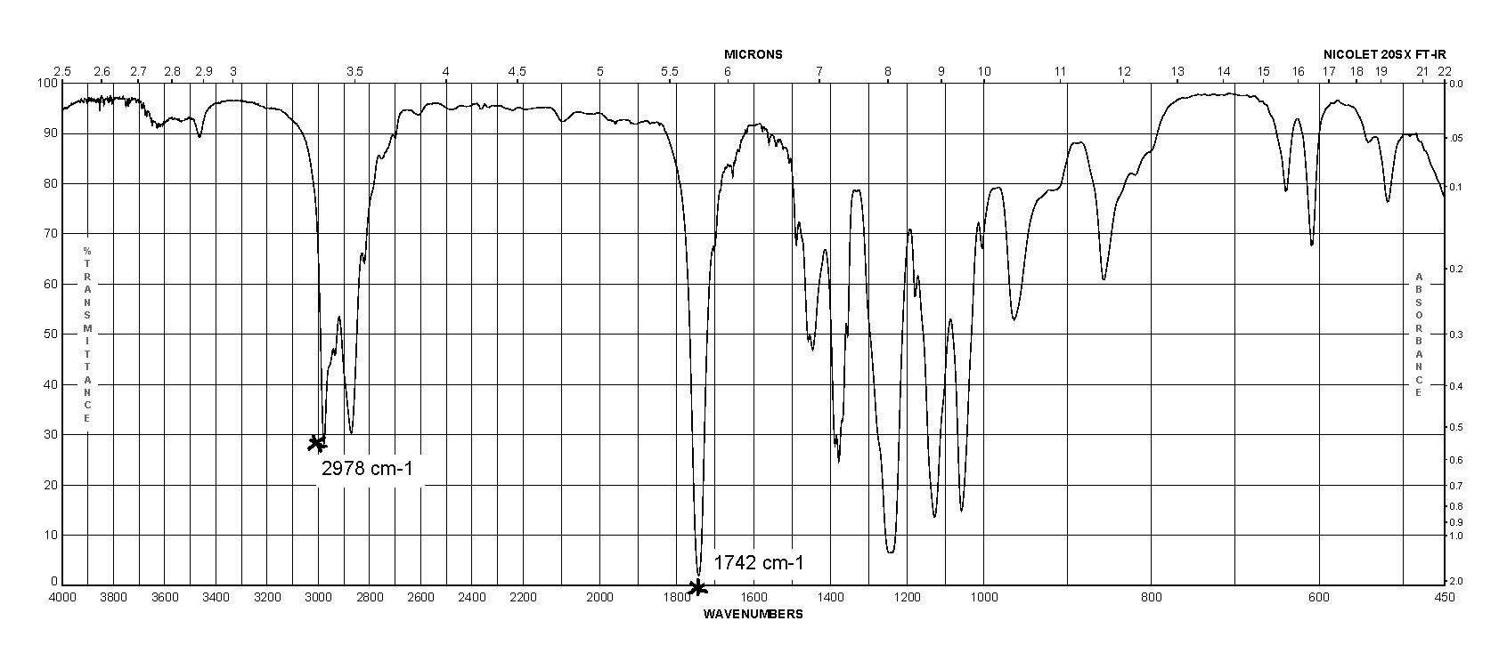

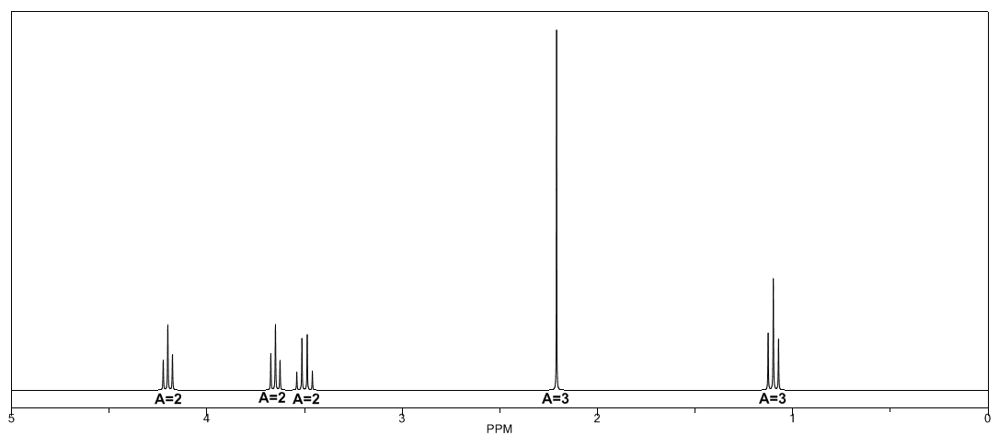

Bonus: Furan (and some modified thiophenes and pyrroles), undergoes a very different type of reaction, that is not a substitution, with alkenes bearing electron withdrawing groups. Can you propose how the following is occurring?

¹H Nuclear Magnetic Resonance Chemical Shifts

Chemical Shifts in ppm downfield from tetramethylsilane (defined as δ = 0.000 ppm). Values are approx. ± 0.2 ppm).

Protons on a Carbon Adjacent to a Functional Group

Functional Group CH₃ CH₂ CH
δ (Δδ) δ (Δδ) δ (Δδ)
saturated system 0.8 1.2 1.6
M-C=C 1.6 (0.8) 2.0 (0.8) 2.4 (0.8)
M-C≡C 1.7 (0.9) 2.2 (1.0) 2.8 (1.2)
M-Phenyl 2.2 (1.4) 2.6 (1.4) 2.8 (1.2)
M-Cl 3.0 (2.2) 3.4 (2.2) 4.0 (2.4)
M-Br 2.7 (1.9) 3.4 (2.2) 4.1 (2.5)
M-I 2.2 (1.4) 3.1 (1.9) 4.2 (2.6)
M-OH 3.2 (2.4) 3.4 (2.2) 3.8 (2.2)
M-OR 3.2 (2.4) 3.4 (2.2) 3.6 (2.0)
M-O-Phenyl 3.9 (3.1) 4.1 (2.9) 4.5 (2.9)
M-OC(=O)R 3.6 (2.8) 4.1 (2.9) 4.5 (2.9)
M-OC(=O)Ph 3.8 (3.0) 4.2 (3.0) 5.0 (3.4)
M-CH=O (aldehyde) 2.2 (1.4) 2.4 (1.2) 2.5 (0.9)
M-C(R)=O (ketone) 2.1 (1.3) 2.3 (1.1) 2.6 (1.0)
M-COOH (acid) 2.1 (1.3) 2.3 (1.1) 2.5 (0.9)
M-COOR (ester) 2.0 (1.2) 2.2 (1.0) 2.5 (0.9)
M-NR₂ 2.4 (1.6) 2.6 (1.4) 2.9 (1.3)
M-NHC(=O)R 2.9 (2.1) 3.3 (2.1) 3.9 (2.3)

Protons on a Carbon Once Removed from a Functional Group

Functional Group CH₃ CH₂ CH
δ (Δδ) δ (Δδ) δ (Δδ)
M-C-CH₂ 0.8 1.2 1.6
M-C-C=C 1.0 (0.2) 1.55 (0.35) 1.8 (0.2)
M-C-C≡C 1.2 (0.4) 1.5 (0.3) 1.8 (0.2)
M-C-Ph 1.2 (0.4) 1.6 (0.4) 1.8 (0.2)
M-C-Cl 1.5 (0.7) 1.8 (0.6) 2.0 (0.4)
M-C-Br 1.8 (1.0) 1.9 (0.7) 1.9 (0.3)
M-C-I 1.8 (1.0) 1.8 (0.6) 2.1 (0.5)
M-C-OH (or OR) 1.2 (0.4) 1.5 (0.3) 1.8 (0.2)
M-C-OPh 1.3 (0.5) 1.6 (0.4) 2.0 (0.4)
M-C-OC(=O)R 1.3 (0.5) 1.6 (0.4) 1.8 (0.2)
M-C-CH=O 1.1 (0.3) 1.6 (0.4) 2.0 (0.4)
M-C-C(R)=O 1.1 (0.3) 1.6 (0.4) 2.0 (0.4)
M-C-CO₂R 1.1 (0.3) 1.7 (0.5) 1.9 (0.3)
M-C-NR₂ 1.0 (0.2) 1.5 (0.3) 1.7 (0.1)
M-C-NH-C(=O)R 1.1 (0.3) 1.5 (0.3) 1.9 (0.3)

Protons on sp2 and sp Hybridized Carbons

R₂C=CH ₂ 4.7-5.3 C=CH-C=O 6.0
R₂C=CHR 5.1 C=CH-Cl 6.5
RCH=CHR 5.3 C=CHBr 6.5
cyclohexene 5.6 CH=CH-C=O 6.9
ArCH=C-C=O 7.7 RCH=O 9.1

R-C≡C-H 2.3-3.3 R-OH (alcohol) 0.5-5.5

Aromatic hydrogens 6.0-9.0 (mostly 6.7-8.2) R-NHR (amine) 0.5-5.0

R-C(=O)OH 12-14 R-NH-C(=O)R (amide) 5-8

Nuclear Magnetic Resonance Chemical Shifts

Chemical Shifts in ppm downfield from tetramethylsilane (TMS) (defined as δ = 0.000 ppm).

General Regions:

0 - 1 δ cylopropyl hydrogen s and methyl groups not shifted by electronegative atoms

1 - 2 δ methyl groups β- to O or N atoms, attached to C=C or attached to aromatic rings; methylene groups

2 - 3 δ methyl and methylene groups next to carbonyls or attached directly to nitrogen of amines

3 - 4 δ methyl and methylene groups attached to oxygen or halogens (Br, Cl). C=CH₂ groups

4.5 - 6.5 δ hydrogens on sp² hybridized carbons of alkenes (not aromatics)

6.8 - 8.5 δ aromatic protons

9 - 10 δ aldehyde protons
IMPORTANT AND DIAGNOSTIC INFRARED BANDS
(a very condensed table)

ν (cm-1) Comments

3000-3400 O-H stretching alcohols- unassociated OH's - 2 bands around 3600 (sharp)
H-bonded - broad absoprtion at 3400
acids- very broad, centred at ca. 3000

3400-3200 N-H stretching amines- unassociated NH's - 2 bands around 3400 (sharp)
H-bonded - broad absorption at 3200, weaker than OH

3300 C-H stretching of
an acetylene

3100-2850 C-H stretching sp2 - hybridized > 3000; sp3 - hybridized < 3000

2900-2700 C-H stretching of
ALDEHYDE

2250-2100 C≡C stretching of usually weak (weaker than C≡N), unless
ALKYNE conjugated to C=O

2250-2225 C≡N stretching of 2250 if not conjugated, 2225 conjugated
NITRILE Band may be weak

1800 C=O stretching of >>>>
ACID CHLORIDE >>>> Conjugation LOWERS these
>>>>
1735-1740 C=O stretching of >>>> bands by 30 cm⁻¹
ESTER >>>>
>>>> Being in a 5-membered ring
1710 C=O stretching of >>>>
ALDEHYDE or KETONE >>>> raises these bands by 35 cm⁻¹
>>>>
1700 C=O stretching of >>>>
ACID >>>>
>>>>
1660 C=O stretching of >>>>
AMIDE >>>>

1650-1600 C=C stretch may be weak. Intensity increases with conjugation, especially to C=O

