**RETIRED PROFESSORS of THE UNIVERSITY OF WINDSOR**

**PHILOSOPHY DEPARTMENT**

*This file contains brief biographies of Professors who taught in the Department of Philosophy at the University of Windsor. The file has been created for the interest of present students and faculty in the Department, as well as for all Friends of the Philosophy Department. The file is not complete: we have much more information on some than on others; some were here only for a few years, and some for their whole careers. But in as much as the past shapes the present, we appreciate that all these Professors have helped lay the foundation and orientation of the present Department. We acknowledge them and thank them.*

*In putting together this file, I would like to thank everyone who contributed, either by writing entries or sending us pictures. I am especially grateful to Professor Cunningham for his support and participation. For additional research assistance, I thank Lucas Wentzell, a graduate of our M.A. program (2015), now pursuing a PhD in the Argumentation Studies Program. The order of the profiles is chronological, reflecting the year of first appointment at Windsor. We will be glad to receive your comments and suggestions for corrections and modifications as we revise and update this file going forward.* *The picture immediately below is of the Department, 1965*. (*Hans V. Hansen, Head, Dept. of Philosophy. Aug 2018.*)



**Patrick Flood (1945 - 1982)**

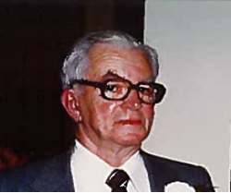Patrick Flood was born in Windsor, Ontario, in November 1916. He earned his B.A. at Assumption University (1939), his M.A. from University of Western Ontario (1941), and his Ph.D. at the University of Ottawa (1969). Professor Flood taught at the Assumption University and then the University of Windsor from 1945 until his retirement in 1982. He served as Head of the Department from 1961-1966. Dr. Flood’s wide range of teaching over the years reflected his broad interests in philosophy, but he was especially drawn to works of Aristotle and St. Thomas Aquinas. He is remembered by his students as a kind and dedicated professor. In retirement Professor Flood continued to live near the campus and teach part-time. He passed away in 2006. (*SC*)

**John N. Deck** **(1957 – 1979)**

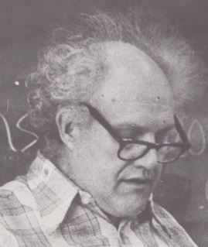John N. Deck was born in Buffalo, NY, in 1921. He earned his BA in 1946 and MA in 1948 from Assumption College, the precursor to the University of Windsor, affiliated at that time with the University of Western Ontario, and his PhD from the University of Toronto in 1960.

He started teaching philosophy at Boston College in 1955, coming to Assumption University/ University of Windsor in 1957, where he continued teaching until his death in 1979. He may have set a record when he submitted his last graduate-course research paper (on Hegel) *after* completing and defending his doctoral dissertation (on Plotinus). In the years that followed, his distinctive teaching style was influential at both the undergraduate and graduate levels.

Deck’s specialties were metaphysics, Plotinus and Hegel. The book that emerged from his Ph.D. dissertation, *Nature, Contemplation and the One* (1967) was described by one authority as “the best book on Plotinus.” Professor Deck also made substantial contributions to the understanding of scholasticism in “St. Thomas Aquinas and the Language of Total Dependence” in *Aquinas: A Collection of Critical Essays* (1969) and “Metaphysics or Logic?” (1989).

As a teacher, John Deck was best known for his introductory courses, especially “Dream Worlds vs. Real Worlds”, a course which asked if “the “ordinary man” lived in a world of dreams. In the departmental syllabus, students were warned: “There will be tests. No field-trips.” He also supervised over 20 masters’ theses in his time at Windsor and was well-loved by grad students. Each year, this University awards the John N. Deck Memorial Prize in Philosophy.

Dr. Deck was recognized across campus by the monastic-looking cape he wore in wintertime. The cape was made by his loving wife Margaret. John and Margaret met at St. Michael’s College in Toronto. They married in 1955 and had nine children. After Professor Deck’s untimely death, Margaret completed the B.A. in English literature she had begun in Toronto in the 1950s, and she and all of her children graduated from the University of Windsor in the 1980s and 1990s. (*Martin Deck & SC)*

**Joseph Martin Graham (1959 - 1965)**

Born in Woodslee, Ontario, in 1926, Professor Graham earned an Honours B.A. Philosophy and English (1947) and an M.A. in Philosophy (1952) from what was then Assumption College, and a Ph.D. in Philosophy from Notre Dame University in 1962. In his doctoral dssertation, he examined the concept of causality in the thought of St. Thomas Aquinas.

Professor Graham taught at Assumption/University of Windsor from 1959 to 1965. From 1965 to 1970, he moved on to teach at Stonehill College in Easton, Massachusetts, followed by 42 (!) years (1970-2012) in the Department of Philosophy at St. Thomas University in Houston, Texas. Blessed with an infectious sense of humor, Graham also was a very knowledgeable observer and critic of the contemporary political scene in both Canada and United States, and he did not hesitate to voice his opinions. He died in July, 2014 at the age of 88. (*SC*)

**F. Temple Kingston (1959 - 1991)**

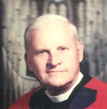

Frederick Temple Kingston was Professor of Philosophy at the University of Windsor from 1959 to 1991 and Principal of Canterbury College, University of Windsor from 1965 to 1991, as well as an Anglican priest. He was born in 1925 in Toronto and studied at Trinity College at the University of Toronto (B.A. and M.Div.) before completing his D.Phil at Oxford University as a student of Eric Mascall. He taught for several years at the Anglican Theological College in Vancouver before coming to the University of Windsor where he made a home for the rest of his academic career.

His academic interests focused on the intersection of philosophy and religion, with particular emphasis on the French and English traditions. His early work explored theological implications of French existentialism (*French Existentialism. A Christian Critique,* 1961). Later in his career he took an interest in the work of Malebranche, George Berkeley (*The Metaphysics of George Berkeley, 1685-1753: Irish Philosopher*, 1992) as well as in the work of the contemporary French philosophers Michel Henry and Gabriel Marcel. In response to years of political crisis in Canadian confederation, he wrote and organized conferences on the theme of friendship and dialogue between the intellectual cultures of English and French Canada with special collaboration from Henri-Paul Cunningham and Thomas de Koninck, both philosophers at the Université Laval.

The civic mindedness that informed his philosophical work (in a spirit of Christian humanism) was also a clear principle of his daily interactions at the university. He devoted a great deal of his time and energy to building a community of students, faculty and fellows at Canterbury College, making it not only a welcome residential community for students from all over the world, but an academic hub of the university on the model of an English college. He and his wife Pauline Boyd Smith (Polly) entertained countless numbers of students and college Fellows in their home. Canterbury College has established the Rev. Dr. F. Temple Kingston scholarship fund in honour of his service.

While outwardly quiet and humble, Temple had a fun sense of humour stemming in part from his Irish roots. He loved riddles. He also had strong convictions about the direction of the church and was a defender of more traditionalist currents against what he called ‘the swingers’. He and Polly had four children, Frederick, Elizabeth, Paul and Rebecca. He died in 1993 and is buried at the chapel of his well-loved summer community of Llewellyn Beach on St. Joseph Island, Ontario. (*R. Kingston*)

**Jerome V. Brown (1961 - 1997)**

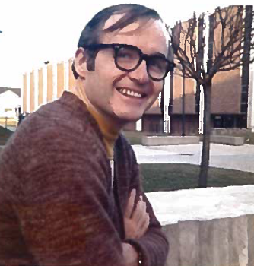Born in the Bronx, N.Y., in September of 1936, Jerry Brown received a B.A. from Iona College (New Rochelle) in 1958, his M.A. (1960) and Ph.D. (1969) from the University of Toronto, and a Licentiate (M.S.L., 1973) from the Pontifical Institute of Mediaeval Studies (Toronto). Throughout his student years, he received an impressive number of scholarships. His full-time teaching career at Assumption University and the University of Windsor extended from 1961 until he retired in 1997. During that period he was President of the Faculty Association from 1970-71 and he also served as Dean of Faculty of Arts from 1981-1985. Following retirement, Jerry taught a religion course (Catholicism) in the Faculty of Education for several years.

Professor Brown was a widely acknowledged authority on the philosophy of Henry of Ghent (d. 1293) and on the responses of Duns Scotus (d. 1308) to Henry's theory of knowledge, and over the years he published a series of at least seven related and definitive studies in highly reputable scholarly journals. He was a longtime member of the *Société Internationale pour l'Étude de la Philosophie Médiévale*. His distinction in the area of medieval philosophy won for him status as a Visiting Scholar at the DeWulf-Manson Centre for Ancient, Medieval and Renaissance Philosophy in KU Leuven-University, Belgium. Throughout his career and well into retirement, he worked assiduously on an edition of Henry's *Quodlibet XIV,* and although he was unable to complete the task because of illness, he will be acknowledged as the posthumous co-editor of that volume when it appears in the future. Professor Jerome Brown died from Parkinson's disease in November, 2014. (*SC*)

**Stanley B. Cunningham (1961 - 1997)**

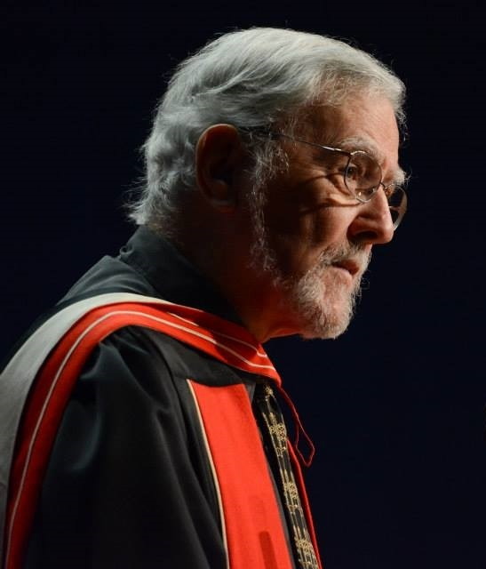Born in Winnipeg, in January of 1934, Stanley Cunningham received his early education in Saskatoon and Winnipeg. After completing his B.A. at University of Manitoba (St. Paul's College), he pursued graduate studies at the University of Toronto (M.A., 1957; Ph.D., 1965), and at the Pontifical of Institute of Mediaeval Studies (Licentiate, 1963). In 1960, he began his teaching career in the Department of Philosophy at John Carroll University in Cleveland, Ohio. The next year, he joined the Department of Philosophy at Assumption University, later the University of Windsor, where he served until 1980, including a period as Head from 1966 to 1970. In 1973 he became full Professor. During these years, he taught a range of courses in the history of philosophy, moral philosophy, action theory, philosophy of mind, and philosophy of language. In 1972-73, he served as President of the Faculty Association.

In 1980, Professor Cunningham was invited to join the University's Department of Communication Studies where he served until retirement in 1997. In those years, besides a commitment to teaching introductory courses, he taught and designed course materials—e.g., language and propaganda, media ethics and social responsibility, truth and objectivity in communication—in which he was able to draw widely upon his philosophical skills and background. In his publications, he regularly delivered philosophical criticisms of current communication-studies approaches and notions. For instance, in *Communication Yearbook* 15 (1992), he presented a detailed critique of what he demonstrated to be a widespread spurious notion: '*intra*personal communication'.

Following retirement, Cunningham continued his research and publication in both philosophy and communication studies. In his book, *The Idea of Propaganda: A Reconstruction* (2002), he was the first to officially launch a new field of study and criticism: the “philosophy of propaganda.” From 1998 to 2001, he was President of the Faculty Retirees' Association. For nine years, he served on the University of Windsor's Board of Governors, and for six years on the Board of Assumption University. Over a period of 22 years, he was also an active member in the Friends of Windsor Public Library, and in the Windsor Public Library Foundation Board. For eight years, he was an active tenor in the local Sun Parlor Barbershop Chorus.

**Ralph C. Nelson (1961 - 1993)**

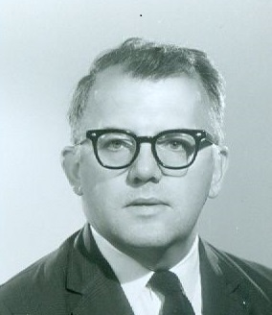

Ralph C. Nelson was born in Evanston, Illinois in 1927, and was raised as the middle one of seven children in Park Ridge, Illinois during the Depression. Right out of high school he joined the United States Marine Corps, officially serving in World War II. While working various jobs, he gained his B.A. (1953) and M.A. (1955) from De Paul University, attended the University of Paris (1958-1959) on a Fulbright Scholarship, and then garnered a Doctorate of Philosophy from the University of Notre Dame (1961) under Dr. Joseph W. Evans, Director of the Jacques Maritain Center. He was hired in 1961 as a lecturer at Assumption University, then became an assistant (1962), associate (1965), full (1969), and emeritus (1993) professor at the University of Windsor. From 1961 to 1966 he was a member of the Philosophy department and he taught courses on moral philosophy, philosophy of law and politics, and social philosophy. His philosophical interests are displayed in a book he co-authored, *Foresight and Knowledge* (1996). In 1966 he moved to the department of Political Science, where he was head in 1973-1974. He specialized in political philosophy, the history of political thought, French social and political thought, and democracy. While he wrote on various aspects of politics and government (see his co-authored, *Introduction to Canadian Politics and Government*, 1972), the main focus of his scholarship was the French neo-Thomist philosopher Jacques Maritain and his student Yves Simon. Among other institutional contributions, he was a member of the University Senate (1966-1970, 1972-1973, 1984-1988, and 1989-1990) and he was president of the Faculty Association (1966-1967) and the chief negotiator for the organization in 1976-1977, being instrumental in helping to create its first contract when it unionized. He retired in 1993 but continued to teach until 1998, and he still attended conferences and published until his death at the age of 80 in Windsor, in May, 2008. He is remembered as a very learned, soft-spoken, and fair-minded gentleman. His son Max has taught at the University of Windsor in the department of Languages, Literatures, and Cultures since 2001. (*Max Nelson*)

**Peter F. F. Wilkinson (1962 – 1990)**

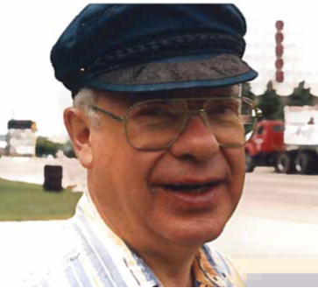

Peter was born August 24, 1925 in Hamilton, Ontario. His father and grandfather were Anglican clergymen, a profession Peter too would follow. In 1944, age 18 and half way through his second year at McGill University, he enlisted in the Royal Regiment of Canada, seeing active service as an infantry signaller in Belgium and Holland during the late stages of World War II, and suffering a serious shrapnel wound that left him with a permanently damaged leg. Following the war, his family having moved to Toronto, he enrolled in the University of Toronto, receiving an Honours BA in Philosophy in 1948, an MA in 1950, and a Licentiate in Sacred Theology (Wycliffe College) in 1951. Peter was ordained to the Anglican priesthood in 1951. He served as Rector of the Church of St. Andrews-by-the-Lake, Hamilton Beach, Ontario, 1952-56, moving on from there to doctoral studies, supported by a Canada Council Fellowship at Columbia University in New York City, and to service, at the same time, as a curate at the famous Church of the Ascension on Fifth Avenue in Greenwich Village.

Peter’s professorial career began in 1962, when he was appointed, Lecturer in Philosophy and Religious Knowledge and Assistant Chaplain, at Canterbury College within Assumption University. The following year, he joined the new University of Windsor’s Philosophy Department at the rank of Lecturer. Tenure and promotion to Assistant Professor followed in 1967, and promotion to Associate Professor, in 1972. In July 1970, Peter assumed the Headship of the Department, a position he held for over a decade, during a difficult period of adjustment after the halcyon years of expansion in the late 1960s. Peter did an admirable job administering the affairs of the Department, his scrupulous fairness satisfying all his colleagues, so that in 1976 they re-elected him (with celerity) to a second term as Head.

When he left the Headship in 1981, Peter’s service to the Department and University continued to be sterling. A deeply committed teacher, Peter was greatly respected and much loved by his students. He was interested in them as individuals, treated them with respect, encouraged their curiosity, exposed them to all sorts of new ways of thinking, and cultivated their particular strengths. He made an especially strong impression on students in his courses on the Philosophy of Art, a number of whom he inspired to continue studies in art history. Upon encountering Peter years later, many a former student in a variety of his courses would eagerly tell him what a powerful influence he had had on them.

Peter was also an active supporter of Informal Logic, both the enterprise and the journal, ever since the whole thing began. In fact, he played a prominent role in its development, for it was due to a suggestion from him that Ralph Johnson began doing research and preparation for a course in Applied Logic in 1970-71, and thereafter persuaded Tony Blair to take an interest. Peter continued to support the Informal Logic undertaking, willingly assuming the role of Business Manager in 1981, in which post he did yeoman service through to his retirement from the University in 1990.

In retirement Peter returned part-time to his ministerial calling, becoming a much-loved assistant priest at several parishes, and to pursuing rich and varied interests, from reading reference books, to art and music, to building and playing musical instruments, to birds and animals, to trees, to antique tools, silverware, and scientific instruments, to astronomy, to steam trains, to cooking, to travelling, to spending time with friends, and more.

Wise and learned, patient and calm, gentle and kind, sensitive and perceptive, thoughtful and courteous, selfless and generous, Peter was never one to call attention to himself or to his activities and accomplishments. When summarizing what Peter Wilkinson was, and what he meant to the Department of Philosophy and the University of Windsor, the phrase “a gentleman and a scholar” comes to mind. A finer colleague than he, one could not hope to have.

Peter died in Windsor on May 29, 2011, in his 86th year, and is buried with his parents in the cemetery of the Church of St. John, York Mills, Toronto. (*K. McCrone*)

**John R. Catan (1963- 1965)**

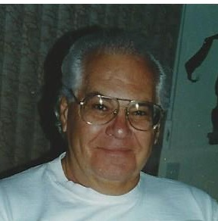

Born in Brooklyn, N.Y., Professor John R.Catan received his M.A. (1958) and Ph.D. (1965) from the University of Toronto. In the early 1960s, he taught at Iona College in New Rochelle, N.Y, and then at the University of Windsor from 1963 to 1965. From 1965 until his retirement as Professor Emeritus, he taught at the Brockport campus of State University of New York.

Professor Catan's research interests lay primarily in the field of ancient philosophy, especially Parmenides, Plato and Aristotle. Over the years, he translated into English several volumes on ancient philosophy by the Italian philosopher, Giovanni Reale. In teaching activity, John made it his mission to enable students to discern the misconceptions and flawed reasoning emanating from their culture and earlier education. Currently, at the age of 84, he is working on a book on the Aristotelian concept of mind. (*SC*)

**Leonard A. Kennedy, C.S.B. (1963 – 1977)**

Leonard Kennedy, born in 1922 in Oldham, Lancashire, UK, earned his philosophy degrees—M.A. (1947), Ph.D. (1958)--at the University of Toronto. He was a member of Windsor's Department of Philosophy from 1963 to 1977. Before that, he had taught at St. Thomas More College, University of Saskatchewan, from 1948 to 1952, and later at St. Michael's College, University of Toronto, from 1960-1963. He also served as President of Assumption University (1972-75) and as President/Principal of St. Thomas More College (1977-82). In 1982, he became Dean of Philosophy at St. Thomas University in Houston, Texas, and Director of its School of Thomistic Studies. Leonard retired from full-time teaching in 1988, but quickly returned to it the next year (1989-94) as a Professor of Philosophy at St. Peter's Seminary in London, Ontario. As his teaching and publications indicate, Leonard was deeply interested in medieval philosophy and the influences of the thought of St. Thomas Aquinas. Among his publications are *Peter of Ailly and the Harvest of Fourteenth Century Philosophy* (1986) and *A Catalogue of Thomists*: *1270-1900* (1987).

A colleague once remarked that, when playing basketball, Leonard was not averse to using elbows under the net. Professor Kennedy died in early April 2010. (*SC*)

**Robert C. Pinto (1963 – 2000)**

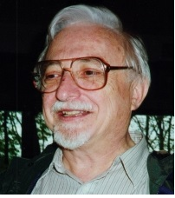Dr. Robert C. Pinto joined the Philosophy Department at what is now the University of Windsor in 1963 and remained a member until 2000 when he retired as professor emeritus. Born in Hartford, Connecticut, in November 1935, he earned his PhD at the University of Toronto (1974).

Professor Pinto was a popular and inspiring teacher. His introductory courses in philosophy had a significant impact on many undergraduate students, and he was widely sought after as a graduate-student advisor. Firmly based in the analytic tradition of philosophy, Professor Pinto’s interests range from Marxism to Heidegger and from Wittgenstein to Sellars.

Within the University, Professor Pinto took a turn as philosophy department head and for many years was either chair of or a member of the graduate studies committee. He also took on a leadership role in the Faculty Association, with terms as president (1985-86) and chief negotiator. Professor Pinto was an early enthusiast of computers and introduced and helped many of his colleagues to get started in computing themselves. He developed a program for tracking and scoring student assignments, the once widely used Class Record. He also created the first web site for the Canadian Philosophical Association and for several years was its editor.

In argumentation theory, Pinto was one of the first to recognize the essential dialectical nature of argumentation. His early papers on informal logic and argumentation develop this insight and are gathered in *Argument, Inference and Dialectic* (2001). His views that reasoning standards are distinct from logical standards and that arguments are invitations to inference are given concrete application in the textbook *Reasoning: A Practical Guide* (with J. A. Blair and K. Parr, 1993). Pinto was associate editor of the department’s journal, *Informal Logic*, and a member of the editorial board of *Argumentation.* His most recent research is focussed on the nature of reasons and the relationship between belief and acceptance.

Professor Pinto passed away in September of 2019. (*L. Pinto and HVH*)

**John Underwood Lewis (1964 – 1997)**

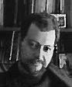Born in Stevens Point, Wisconsin in 1936, John Lewis received his B.A. at North Texas University, and his Ph.D. from Marquette University (1966). The title of his dissertation was: “Man's Natural Knowledge of the Eternal Law.” He served as a popular professor in Windsor for 33 years (1964-1997). His special interest lay in the areas of jurisprudence and the Philosophy of Law; and over the years he published a number of book reviews in both philosophical and legal journals. John was a regular organizer and participant (and, at least once, a winner) in an annual Windsor Chili cookout competition.  He made a fine chili. (*SC*)

**Ralph H. Johnson (1966 – 2006)**

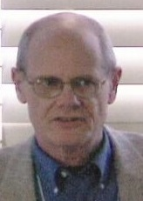Professor Johnson was born in Detroit in 1940. He earned his BA at Xavier University and his Ph.D. in Philosophy from the University of Notre Dame in 1972. First hired as an instructor in the department at Windsor in 1966, he retired in the fall of 2006 after 39 years during which he served two terms as Head of Department as well as on some major university committees. In 1971, along with his colleague, Professor Blair, he developed a new approach to logic they called “informal logic” which led to the publication in 1977 of their textbook, *Logical Self-Defence.* In 1979, Johnson and Blair founded the *Informal Logic Newsletter*, which became the journal, *Informal Logic*, in 1985. Among Johnson’s books are *The Rise of Informal Logic* (1996) and *Manifest Rationality: A Pragmatic Study of* *Argument* (2000).

When Johnson was a PhD student at the University of Notre Dame, Dr. Harry Nielsen stimulated his interest in the works of Søren Kierkegaard and Ludwig Wittgenstein. Some years later, Professor Johnson was instrumental in bringing Nielsen to the Windsor philosophy department.

In 1986 Professor Johnson developed a course titled “The Philosophy of Rock” which he taught at intervals to undergraduates. He was affectionately referred to as “Dr J.” by his students. Johnson has conducted seminars and workshops on informal logic and critical thinking across North America and in Europe. In 1993, he received a 3M Teaching Fellowship for outstanding university teachers In 1994 he was awarded the rank of University Professor by the University of Windsor; in 2000 he received the Distinguished Research Award by the International Society for the Study of Argumentation; in 2003 he was elected a Fellow of the Royal Society of Canada.

Professor Johnson is now retired and lives in Windsor.

**Donald Kuspit (1966 – 1970)**

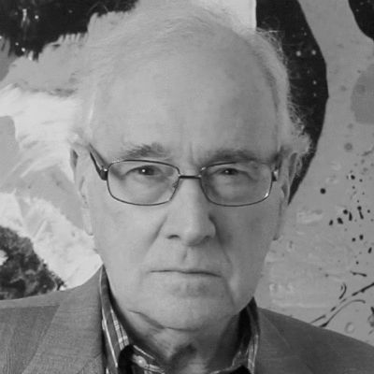Donald B. Kuspit was born in New York City in 1935. He received his BA from Columbia University, MA from Yale University, and his PhD from the University of Michigan. He was awarded a Canada Council fellowship in 1968-69. Professor Kuspit’s overriding interest was in aesthetics and art criticism. He published *The Philosophical Life of the Senses* (1969) while at the University of Windsor, and he continues to write and edit extensively in philosophy and art history and criticism. Professor Kuspit has gone on to teach at other universities, including the University of North Carolina (Chapel Hill) and the State University of New York (Stony Brook).

**Thomas J. Stokes, C.S.B. (1966 – 1983)**

Thomas Stokes was born in Toronto in 1926. He received both his Bachelor of Science degree in physics and mathematics, and a PhD in philosophy from the University of Toronto. From 1960 to 1966, he was a lecturer in philosophy at St. John Fisher College in Rochester, N.Y., and an assistant professor at St. Thomas More College, University of Saskatchewan. Following those stints, he served as an associate professor at the University of Windsor from 1966 to 1983, during which he regularly taught a course in the philosophy of science. Thereafter, for more than twenty years, he served as hospital chaplain in two Toronto Hospitals until 2005. A quiet and unassuming colleague, Tom Stokes had a warm sense of humor, and wonderful laughter. He died in February, 2009. (*SC*)

**John Anthony (Tony) Blair (1967 - 2006)**

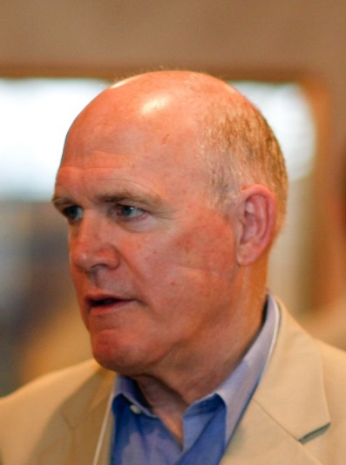John Anthony (Tony) Blair retired in 2006 as a University Professor after 39 years in the UW philosophy department. He was born in Ottawa (August 1941) and attended McGill University where, in addition to studying philosophy, he played on championship intercollegiate football and ski teams. After three years of philosophy doctoral studies at the University of Michigan he began his career at the University of Windsor in 1967 and gradually progressed from lecturer to full professor by 1987.

Professor Blair initially taught courses in ethics, political philosophy, and philosophy of education. In 1972 he started collaborating with Ralph Johnson on a new kind of logic course focusing on informal rather than formal inferences, and by 1977 they had written a textbook for it, *Logical Self-Defense*. After that, a great part of Professor Blair’s teaching was devoted to reasoning skills, informal logic and argument theory. In 1978 Blair and Johnson organized the first of three Windsor informal logic conferences and started a newsletter that in 1984 became the journal *Informal Logic*. Professor Blair is still an editor of the journal as it moves into its thirty-fifth year.

In the mid-1990s and the early 2000s Professor Blair served terms as department head. He was always active in departmental life and started the “Dry Run” series for faculty to try out scholarly papers. To stem enrolment declines he helped design a handful of new “popular” philosophy course. He proposed “Philosophy & Sex” but fuddy-duddies renamed it “Philosophy & Sexuality.”

In 2012, the International Society for the Study of Argumentation honored Professor Blair by awarding him its prize for lifetime achievement in argumentation studies. In recognition of his involvement with student research, the Ontario Society for the Study of Argumentation has awarded “The Blair Prize” at every one of its conferences since 2001.

Before retiring in 2006, Professors Blair and Johnson founded the Centre for Research in Reasoning, Argumentation and Rhetoric (CRRAR). The Centre, which now enjoys a considerable international reputation, draws scholars from around the world every year to work with the CRRAR fellows at the University of Windsor.

Professor Blair published more than 120 papers. About two-dozen of them have been republished in *Groundwork in the Theory of Argumentation* (2011). In addition to *Logical-Self Defence*, which he co-authored with Ralph Johnson, he worked with other Windsor colleagues, Robert Pinto and Kate Parr, in producing *Reasoning Skills*: *A Practical Guide for Canadian Students* (1993).

Professor Blair lives in Windsor and is active as an editor of *Informal Logic*, as a Senior Research Fellow in CRRAR, and as a contributor to the PhD in Argumentation Studies Program.

**Harry A. Nielsen (1968 - 1989)**

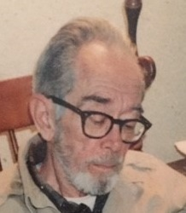Harry Andersen Nielsen was born in Bridgeport, Connecticut in 1924. He received a B.A. from Rutgers (1949), an M.A. from the University of Connecticut (1952), and a Ph.D. from the University of Nebraska (1955). Professor Nielsen taught at the University of Notre Dame from 1957 to 1968, and at the University of Windsor from 1968 until his retirement in 1989. Nielsen took a turn as Department Head (1981-84).

Professor Nielsen’s teaching had a great impact on his students. He had a unique voice, formed by his reading of Søren Kierkegaard and Ludwig Wittgenstein (with a dose of Peirce thrown in). Harry was one of the very first to see the internal chemistry between these two thinkers. From Kierkegaard, he took the ability to locate himself within the posture of the existing individual, to find way to ask the basic questions again and again. From Wittgenstein, he learned how to avoid getting wrapped up in metaphysical snarls.

Early in his career, Professor Nielsen had an interest in the philosophy of science and he published *Methods of Natural Science* (1967); later in his career, he took a deep interest in the philosophy of Kierkegaard, hence his *Where the Passion Is: A Reading of Kierkegaard’s* *Philosophical Fragments* (1983). Nielsen also wrote a novel, a children’s book and a book of poetry.

Professor Nielsen passed away in Windsor, February 16, 2003. (*with notes from R. Johnson*)

**John P. Wright (1983 – 1997)**

John P. Wrightwas a faculty member of the Department of Philosophy at the University of Windsor from 1983 to 1997 when he resigned to take up a position at Central Michigan University. He has a B.A. and M.A. from the University of Toronto, and a Ph.D. from York University. Wright was Acting Chair of the Department of Philosophy in 1988-9 and attained the rank of Full Professor in 1990. He had taught previously at the University of Saskatchewan, University of Toronto, and Simon Fraser University.

Dr. Wright taught undergraduate courses in a numbers of areas including “The Rationalists” and “The Empiricists.” He was especially active in the graduate program and supervised several masters’ theses. An accomplished scholar, Professor Wright won several external awards during his years at the University of Windsor. His central interests were in the Early Modern Philosophy with particular interests in Descartes, Locke and Hume. The books he published while at the University of Windsor included his *The Sceptical Realism of David Hume* (1983) and *Hume and Hume’s Connections*, edited with M.A. Stewart (1994). Recently he has authored, *Hume’s ‘A Treatise of Human Nature’: An Introduction* (2012). Professor Wright has also contributed significantly to the literature on the philosophy of medicine.

**Jo Kornegay (1985 – 1987)**

Dr. Kornegay taught in the department for two years during the 1980s. She has both her MA and PhD from the University of Toronto. Dr Kornegay had interests both in the history of philosophy as well as in applied ethics. She now teaches at Ryerson University in Toronto (see www.ryerson.ca/philosophy/facultystaff/kornegay-jo/).

**Laura Westra (1991 – 1999)**

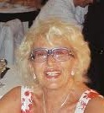

Dr. Laura Westra received her BA from York University (1977) and MA and PhD from the University of Toronto (1983). Because of her considerable previous teaching experience (Lakehead University, University of Toledo), she was hired at the associate professor level at the University of Windsor in 1991 and promoted to full professor in 1997. Professor Westra’s main teaching interests were in Greek philosophy and applied ethics, with a concentration in environmental philosophy and ethics. Among her publications during her Windsor years are *Freedom in Plotinus* (1990) and *Living in Integrity: Toward a Global Ethic to Restore a Fragmented Earth* (1998). After retiring from the Windsor philosophy department in 1999, Dr Westra had a one-year appointment at Sarah Lawrence College (NY) before she returned to Canada to earn a doctorate in law at Osgoode Hall in Toronto (2005). She is now a sometime sessional instructor at the University of Parma and the University of Windsor’s Faculty of Law. Professor Westra recommends the following website for those interested in following her current research interests: ([www.globalecointegrity.org](http://www.globalecointegrity.org)).

**Linda Fisher (1992 – 2000)**

Dr. Fisher took her BA in Philosophy and French from Wilfrid Laurier University (1978), her MA from the University of Ottawa (1985), and her PhD from Pennsylvania State University (1991). She began teaching at the University of Windsor in 1992. Her main teaching interests were feminist philosophy and phenomenology. Her research interests also extended to Heidegger and other continental philosophers. Since leaving the University of Windsor in 2000, Dr. Fisher continues her career as Associate Professor in the Department of Gender Studies at the Central European University in Budapest, Hungary (see <https://gender.ceu.edu/people/linda-fisher>).

**Deborah Cook (1989-2020)**

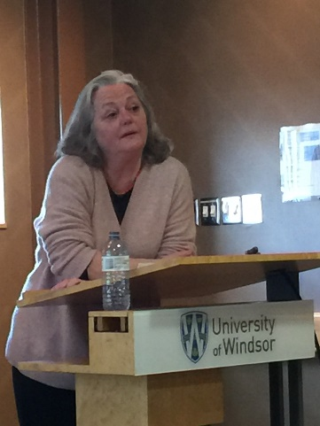Dr. Deborah Cook earned her BA and MA in Philosophy from the University of Ottawa and received her doctorate from Paris I-Panthéon-Sorbonne in 1985. She joined the faculty department of Philosophy at the University of Windsor in 1989, having previously taught at Queen’s University and the University of Victoria. Her teaching interests included philosophy and human nature, existentialism, aesthetics and recent German philosophy. Dr. Cook took a deep interest into the work of Theodor W. Adorno, translating some of his works and publishing articles extensively through her career. Her publications on Adorno include *The Culture Industry Revisited: Theodor W. Adorno on Mass Culture* (Rowman and Littlefield, 1996) and *Adorno, Habermas, and the Search for a Rational Society* (Routledge, 2004). Other notable works include *The Subject Finds a Voice: Foucault’s Turn Toward Subjectivity* (New York: Peter Lang Publishing, Inc., 1993) and *Adorno, Foucault, and the Critique of the West* (New York: Verso, 2018). She was an active member on several university committees. Dr. Cook passed away October 2020.