

2026/27 Cyclical Review of Undergraduate and Graduate Programs*
Department of ……
Self-Study Brief
[Template]

* Data ranges in tables intended for 2025/26 review cycle
(7 Academic years of 2019/2020 - 2025/2026, broadly from May 1, 2019 to April 30, 2026)
(updated February 2026)

self-study table of contents
A. DEVELOPMENT OF THE SELF STUDY 4
B. PROGRAMS 5
B.1. PROGRAMS CONTEXT (Both Undergraduate and Graduate Programs) 5
B.1.b. Recommendations and Actions from Previous Review 5
B.2. UNDERGRADUATE PROGRAMS 6
B.2.a. Undergraduate Program Overview (includes program listings, emphases, options, specializations or minors) and Admission Requirements 6
B.2.1. Undergraduate Program Learning Outcomes, Program Curriculum and Course Sequence 6
B.2.1.a Undergraduate Program Learning Outcomes and Curriculum Maps 6
B.2.1.b Curriculum Structure and Course Sequence 7
B.2.2 Modes of Delivery and Assessment Methods 8
B.2.2a Undergraduate Modes of Delivery and Student/Faculty Interaction with Learning and Scholarly Community 8
B.2.2.b Undergraduate Program Learning Outcomes Assessment Methods 8
B.2.3 Undergraduate Program Enrolment and Retention 10
B.2.3.a Undergraduate Applications, Offers, and Registrations 10
B.2.3.b Undergraduate Class Sizes and Course and Program Capacity 11
B.2.3.c Undergraduate Retention and Graduation Rates 12
B.1.3.e Undergraduate Enrolment Profile 14
B.3. GRADUATE PROGRAMS 15
B.3.a. Graduate Program Overview (includes program listings, emphases, options, specializations or fields) and Program Requirements 15
B.3.1 Graduate Program Learning Outcomes, Program Curriculum and Course Requirements 15
B.3.2.a Graduate Level Course and Research Requirements 16
B.3.2.b Graduate Program Learning Outcomes Assessment Methods 17
B.3.3 Graduate Program Enrolment and Retention 18
B.3.3.a Graduate Applications, Offers, and Registrations 18
B.3.3.b Graduate Program Times-to-completion and Graduation Rates 19
B.3.3.c Graduate Enrolment Profile 20
C. STUDENT EXPERIENCE FOR UNDERGRADUATE AND GRADUATE PROGRAMS 21
C.1 Student Orientation, Advising and Mentoring 21
C.2 Student Satisfaction 21
C.3 Student Funding and Research (graduate programs only) 21
C.4 Student Publications (Graduate Programs) 22
C.5 Career Paths, Employment, and Career Data of Graduates from both Undergraduate and Graduate Programs 23
D. THE FACULTY 23
D.1 Faculty Complement 23
a. Faculty Complement 23
D.2 Faculty research funding 25
D.3 Faculty record of scholarly activity 26
D.4 Distribution of Thesis Supervision 26
D.5 Teaching Assignments 27
D.7 Discussion of Faculty Quality Indicators 29
E. GOVERNANCE 30
F. RESOURCES 31
F.1. Human Resources 31
F.2 Physical Resources 31
a. Library Resources/Report 31
b. Space and Laboratory (and Computer) facilities 32
G. CONCLUSIONS AND RECOMMENDATIONS 33
H. FACULTY DEAN COMMENTARY 34

LIST OF COMMON APPENDICES TO THE SELF-STUDY BRIEF AND EXAMPLES*

Appendix A – Faculty CVs – All faculty members in all Programs

Appendix B – Copies of previous review documents (latest biennial PDC UPR report (Reference to Self-Study Brief sections B.1.f. and B.2.f.)

Appendix C – Leddy Library Report

Appendix D – Undergraduate Course Syllabi

Appendix E – Graduate Course Syllabi

Appendix F – Course Descriptions

*Additional appendices may be added such as:
- Student Handbook
- Student satisfaction survey results
- Organizational charts
- Special AAU policies regarding course loads, course relief and related policies
- Faculty criteria for promotion, renewal and tenure
- Other curriculum documents, etc.

LIST OF TABLES IN THE SELF-STUDY:
Tables 1a to 5a (Undergraduate)
Table 1a: Undergraduate Program Learning Outcomes 7
Table 2a: Undergraduate Applications and Registrations 10
Table 3a: Undergraduate Courses offered to Students in the Past Four Years/ Courses Demand Data 11
Table 4a: Undergraduate Retention and Graduation 13
Table 5a: Undergraduate AAU Enrolment Distribution 14

Tables 1b to 4b (Graduate)
Table 1b: Graduate Program Learning Outcomes 15
Table 2b: Graduate Applications and Registrations 18
Table 3b: Graduate New Enrolment, Completions and Withdrawals by Year of Admission (Cohort Data) 19
Table 4b: Graduate Student Complement, Withdrawals and Completions by Academic Year (Flow-Through Data) 20

Tables 6 to 10
Table 6: Financial Support for Graduate Students: 22
Table 7: Faculty Members by Field/Program (created by the AAU): 24
Table 8: External Research Funding 25
Table 9: Completed (Career) and Current Numbers of Thesis Supervisions by Faculty Members: 26
Table 10 (a) to (d) Teaching Assignments for past 4 years 27

DEVELOPMENT OF THE SELF STUDY

It is strongly recommended that the development of the self-study includes information gathered from a variety of stakeholders, including faculty, students, alumni, and community partners through focus groups, surveys, interviews, meetings, retreats, Departmental NSSE data, CGPSS data, or data from other externally validated instruments etc. In addition, all contributing units should be consulted and included in the self-study.

(This section is best completed at the end of the writing of the self-study.)

Please provide a brief summary only in these sections:

Faculty and staff consultation: summarize how faculty, admin, and staff members participated in the preparation of the self-study report, e.g. AAU meetings and/or retreats, review of self-study drafts, etc.
[INSERT COMMENT HERE]

Students and alumni feedback: (Brief summary here only. Content from surveys would be used to support in more detail the Section C: Student Experience)
- specify what students/alumni groups from each program under review were consulted:
- how their views were obtained e.g. surveys; interview groups; student representatives at AAU meetings/retreats; review of self-study report by elected student representatives; etc.
[INSERT COMMENT HERE]

For combined programs, or where other AAUs at Windsor contribute significantly to the delivery of the program(s) under review:
- specify whether testimonials or other input was solicited from the partner program/AAU(s);
- if components of the program (courses, practicum, clinical experience) are delivered by an affiliated partner institution/college/centre, state how the partners were included in the review process of that part of the program:
[INSERT COMMENT HERE]

Date Final Self Study Submitted by AAU to Office of Quality Assurance _______________

PROGRAMS

B.1. PROGRAMS CONTEXT (Both Undergraduate and Graduate Programs)
PROGRAM OBJECTIVES AND STRATEGIC DIRECTIONS
- Briefly explain the program(s) objectives and how those objectives are consistent with and supports the University’s Strategic Plan.
- Describe how the program(s) is consistent with and supports the faculty’s academic plans.

[INSERT COMMENT HERE]

RECENT PROGRAM and COURSE CHANGES
Comment on Senate, Faculty or Departmental policies and practices approved during the period to improve the program (e.g. to improve time to completion, program delivery, etc.) Were any changes made to the program – such as course changes (addition/deletion of courses, etc.)? What was the rationale for those changes?

[INSERT COMMENT HERE]

PLANNED CURRICULUM CHANGES
Explain any or planned curriculum changes that have been made or will be made in the near future to improve the student learning experience and/or to help them better meet program level learning outcomes.

[INSERT COMMENT HERE]

B.1.b. Recommendations and Actions from Previous Review
Use the latest PDC Final Assessment Report, Implementation Plan(FAR/IP), previously called the University Program Review (UPR), as a point of reference (this will be provided by IQAP office). Please comment on developments since the last report, with particular attention to those that have not been satisfied.
An example of how to structure this section is provided below:

Please refer to Appendix [X] for the full PDC FAR/IP status report.

The current status of the recommendations from the report that are still not satisfied or are behind target is as follows:

Recommendation #1: State the recommendation directly from relevant report.
Response: Describe departmental response to recommendation and actions taken/not taken since the latest biennial status report.

B.2. UNDERGRADUATE PROGRAMS

B.2.a. Undergraduate Program Overview (includes program listings, emphases, options, specializations or minors) and Admission Requirements

For each undergraduate degree program (BA, BSC, Certificates, etc.), provide the following:

- PROGRAM LISTING FOR EACH DEGREE PROGRAM
- List all programs under review, including relevant features of the degree (thesis/non-thesis options, co-op, collaborative programs, etc.)
- List all emphases, options, specializations, concentrations or minors in the program.

[INSERT COMMENT HERE]

- PROGRAM ADMISSION REQUIREMENTS
DESCRIBE:
- the admission requirements – for each undergraduate program.

[COPY ADMISSION REQUIREMENTS FROM CALENDAR HERE]

COMMENT ON ADMISSION REQUIREMENTS MUST INCLUDE:
- on the appropriateness and efficiency of the admission requirements (e.g. preparation and achievement) for achieving the intended program learning outcomes.
- Are requirements sufficiently rigorous to ensure that students have appropriate backgrounds to be successful in the program?
- Include in this discussion a description of any initiative established to address the transitional needs of students entering the program.
- Are requirements sufficiently flexible to allow interested and qualified students to be admitted?

[INSERT COMMENT HERE]

B.2.1. Undergraduate Program Learning Outcomes, Program Curriculum and Course Sequence

B.2.1.a Undergraduate Program Learning Outcomes and Curriculum Maps
For each Program, insert the corresponding Program Learning Outcomes and a Curriculum Map.

Programs are encouraged to contact CTL for assistance with their curriculum maps (ext. 4923).
After the Learning Outcomes Table (1a) below, a screenshot of the Curriculum Mapping Tool offered by CTL has been inserted, for your reference.

Table 1a: Undergraduate Program Learning Outcomes

Insert Program Learning Outcome table Here (copy each program LO from CuMA):

Insert Corresponding Curriculum map:

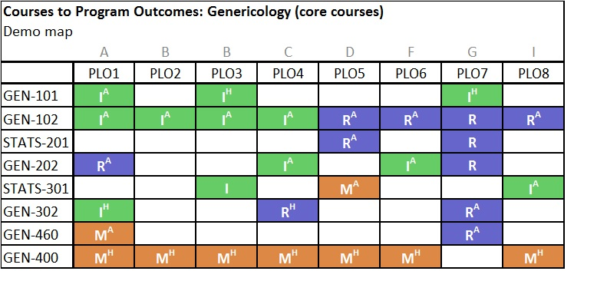

B.2.1.b Curriculum Structure and Course Sequence

For each program level learning outcomes and curriculum map:

- Comment on the appropriateness of the program’s structure and the requirements to meet its objectives and the program-level learning outcomes.

- Comment on expected progress and student pathways through the program. (A table summarizing this information may be useful to include here.)
  - For each year of the program(s), for example, please include:
- Required courses
- Number of courses required from a specific discipline
- Number of electives to be taken

- How the curriculum reflects the current state of the discipline or area of study

[INSERT COMMENT HERE]

High Impact Practices

- Describe innovative content, teaching practices, or course delivery models, with evidence of impact on student learning or engagement, where available.
- In the case of experiential learning opportunities that include an external placement, please discuss how the program ensures sufficient placement opportunities and supervision for students.
[INSERT COMMENT HERE]

B.2.2 Modes of Delivery and Assessment Methods

B.2.2a Undergraduate Modes of Delivery and Student/Faculty Interaction with Learning and Scholarly Community

Comment on how the programs’ modes of delivery are appropriately and effectively employed to meet the programs’ learning outcomes (including e.g. distance or on-line delivery, experiential learning, etc.)
[INSERT COMMENT HERE]

Comment on the nature of the learning community, and structured opportunities for meaningful intellectual interaction among students, and with faculty (e.g. departmental seminars where faculty and student research or creative activity is presented and discussed, workshops on research ethics, safety regulations, grant and award applications, career planning, etc.)
[INSERT COMMENT HERE]

Comment on measures to introduce students to the wider community of scholars in the discipline.
[INSERT COMMENT HERE]

B.2.2.b Undergraduate Program Learning Outcomes Assessment Methods
In this section, clearly label which Learning Outcome(s) from Table 1a (section B.1.1.a) relate to each method of assessment. A table of assessment methods and to which Learning Outcomes they relate to is very helpful here.
NOTE: If assessment data is inputted into CuMA, a table like this can be created directly from CuMA.

This is a SAMPLE:
PROGRAM LEARNING OUTCOMES  (or list instead program LO from Table 1a (section B.1.1.a) | Assessment Methods (these are examples listed below, please delete and use ones pertinent to your programs)
a) Acquisition, application & integration of knowledge | - exams  - annotated bibliographies  - paper proposals  - policy papers  - position papers  - research papers  - summaries of readings  - class and seminar presentations  - class debates and discussions  - book reviews
b) Research skills | - documentary research  - annotated bibliographies  - data analysis  - qualitative research projects  - quantitative research projects  - research/paper proposals  - policy papers  - position papers  - theoretically based papers  - argument based and methodological research papers
c) Critical thinking and problem-solving | - class debates  - class presentations  - position papers  - critical review papers  - theoretical/methodological discussion papers
d) | …
Etc. - address all LOs (a) to (i)

Describe the appropriateness and effectiveness of the methods for assessing student achievement of the program-level learning outcomes and degree-level expectations.
[INSERT COMMENT HERE]

PLANS TO MONITOR AND ASSESS: Describe plans on how the program will monitor and assess:
- The overall quality of the program: [INSERT COMMENT HERE]

- Whether the students are achieving the program-level learning outcomes: [INSERT COMMENT HERE]

- How these plans to monitor and assess will be documented and used to inform continuous improvement of your program(s): [INSERT COMMENT HERE]

B.2.3 Undergraduate Program Enrolment and Retention

B.2.3.a Undergraduate Applications, Offers, and Registrations

Table 2a (program-specific) is provided to facilitate your discussion in this section. Table 2a will be provided for year range of 2019-2025.

(Please note: Table 2a (and b) defines the Academic Term differently from Table 5 a (and b) and therefore do not have correlating or matching numbers.)

Table 2a: Undergraduate Applications and Registrations
Table 2a will be provided for year range of 2019-2025.
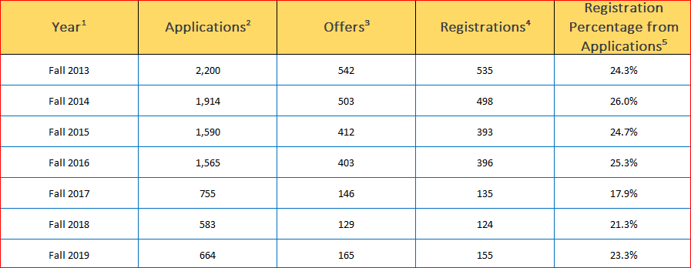
¹ Fall Term Only.
² Number of applications to enter the program in the Fall Term identified. One student may have one or more applications.
³ Number of accepted applications.
⁴ Number of registrations, resulting from the number of applications.
⁵ Percentage of registrations, resulting from the number of applications.
⁶ Applications, offers, and registrations are allocated to faculties based on program. Students in single major programs are allocated 100% to their home faculty, while those in combined majors are allocated proportionally to the faculty/department of each major. For example, a student in Combined Psychology and Political Science is allocated 50% to the FAHSS/Psychology and 50% to FAHSS/Political Science. Students in joint programs are also allocated 50% to the faculty/department of each major. For example, a student in Honours Mathematics and Computer Science is allocated 50% to Faculty of Science/Mathematics and Statistics and 50% to Faculty of Science/Computer Science.

Comment on the quality of the applicant pool, and whether the size and quality of the pool can be improved.
[INSERT COMMENT HERE]

Comment on the admission targets and the admissions against program capacity. Comment and analysis can also be made on the pattern of students admitted to the program after first year.
[INSERT COMMENT HERE]

Comment on the percentage of applicants receiving offers, the percentage of offers accepted or confirmed, and the percentage conversion of acceptance and confirmations into registrations
[INSERT COMMENT HERE]

Comment on the unit’s efforts or initiatives towards supporting EDI, Indigenization in the recruitment process
[INSERT COMMENT HERE]

B.2.3.b Undergraduate Class Sizes and Course and Program Capacity

Table 3a is provided in this section to facilitate a discussion on course and program capacity and whether a program can accommodate more students. Use the information in the data table (to be attached as an Appendix) to inform the text boxes included below.

Table 3a: Undergraduate Courses offered to Students in the Past Four Years/ Courses Demand Data: Enrolment Waiting Lists (ATTACH AS AN APPENDIX)

Comment on student to faculty ratios
[INSERT COMMENT HERE]

Comment on class sizes and course and program capacity
[INSERT COMMENT HERE]

Are there sufficient course/course selections to enable students to complete their program in a timely manner?
[INSERT COMMENT HERE]

What is the impact of class sizes on the achievement of the program-level learning outcomes?
[INSERT COMMENT HERE]

B.2.3.c Undergraduate Retention and Graduation Rates

Using the Section Prompts below, provide comment and analysis on the retention and graduation rates for undergraduate programs.

Tables 4(a) are provided to facilitate discussion for this section and will be provided for year range 2019 to 2025.

(Please note: Table 4a defines the Academic Term and full cohort of students and Table 2a (and b) is students that directly applied to the program and therefore do not have correlating or matching numbers.)

Comment on number of first-year students that proceeded to second year, and any changes over the review period? (It may be helpful to comment or provide narrative about the context of incoming students, and how that impacts retention rates.)

[INSERT COMMENT HERE]

Comment on retention of student cohorts between year 1 and graduation for all programs over the review period: (It may be helpful to comment or provide narrative about the context of incoming students, and how that impacts retention rates.)
[INSERT COMMENT HERE]

Provide Recommendations for improving Retention Rates and explain any corrective measures taken for improving Retention and Graduation rates:
[INSERT COMMENT HERE]

Provide Comment and Analysis on Graduation Rates:
[INSERT COMMENT HERE]

Table 4a: Undergraduate Retention and Graduation
Table 4(a) will be provided for year range 2019 to 2025.
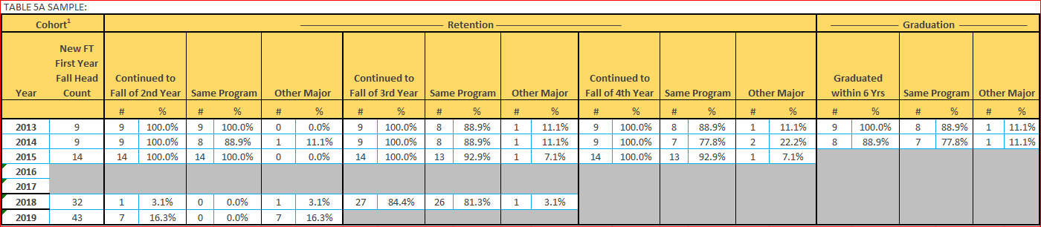

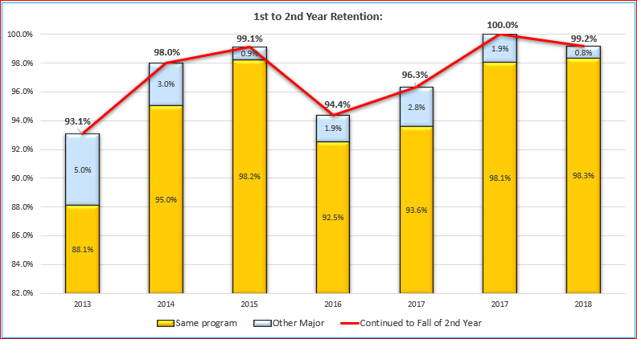

B.1.3.e Undergraduate Enrolment Profile
Using the Section Prompts below, discuss the enrolment profile (gender, Citizenship, etc.) in the programs.

Assess the distribution of students among programs in the department:
[INSERT COMMENT HERE]

Comment on the location of students (Domestic: locally, outside Ontario; International: countries, regions) enrolled in each program and proportion of students:
[INSERT COMMENT HERE]

Assess enrolment by gender and comment:
[INSERT COMMENT HERE]

Assess the proportion of international students and comment:
[INSERT COMMENT HERE]

Table 5a: Undergraduate AAU Enrolment Distribution

B.3. GRADUATE PROGRAMS

B.3.a. Graduate Program Overview (includes program listings, emphases, options, specializations or fields) and Program Requirements

For each graduate degree program provide the following:

PROGRAM LISTING FOR EACH DEGREE PROGRAM
- List all graduate programs under review, including relevant features of the degree
- List any approved “fields” in the Master’s or Doctoral program.

[INSERT COMMENT HERE]

B.3.1 Graduate Program Learning Outcomes, Program Curriculum and Course Requirements
For each Program, insert the corresponding Program Learning Outcomes and a Curriculum Map.

Programs are encouraged to contact CTL for assistance with their curriculum maps (ext. 4923).
After the Learning Outcomes Table (1a) below, a screenshot of the Curriculum Mapping Tool offered by CTL has been inserted, for your reference.

Table 3b: Graduate Program Learning Outcomes
Insert Program Learning Outcome table Here (copy each program LO from CuMA):

Insert Corresponding Curriculum map:

B.3.2.a Graduate Level Course and Research Requirements

Graduate Level Course Requirements
Please provide evidence that each graduate student in the program is required to take a minimum of two-thirds of the course requirements from among graduate level courses.

[INSERT COMMENT HERE]

Graduate Research Requirements
For research-focused graduate programs, clear indication of the nature and suitability of the major research requirements for degree completion.

[INSERT COMMENT HERE]

Please also provide comment on:
Comment on the nature of the learning community, and structured opportunities for meaningful intellectual interaction among students, and with faculty (e.g. departmental seminars where faculty and student research or creative activity is presented and discussed, workshops on research ethics, safety regulations, grant and award applications, career planning, etc.)
[INSERT COMMENT HERE]

Comment on opportunities and support for students to present their research at the university and elsewhere (e.g. departmental seminar, “brown bag” lunch series, annual graduate student conference, conference travel fund, etc.)
[INSERT COMMENT HERE]

Comment on measures to introduce students to the wider community of scholars in the discipline.
[INSERT COMMENT HERE]

B.3.2.b Graduate Program Learning Outcomes Assessment Methods

In this section, clearly label which Learning Outcome(s) from Table 1b relate to each method of assessment. A table of assessment methods and to which Learning Outcomes they relate to is very helpful here.

Note: If assessment data is inputted into CuMA, a table like this can be created directly from CuMA.

This is a SAMPLE:
PROGRAM LEARNING OUTCOMES  (or list instead program LO from Table 1a (section B.1.1.a) | Assessment Methods
a) Acquisition, application & integration of knowledge | - exams  - annotated bibliographies  - paper proposals  - policy papers  - position papers  - research papers  - summaries of readings  - class and seminar presentations  - class debates and discussions  - book reviews  -PhD comprehensive exam
b) Research skills | - documentary research  - annotated bibliographies  - data analysis  - qualitative research projects  - quantitative research projects  - research/paper proposals  - policy papers  - position papers  - theoretically based papers  - argument based and methodological research papers  - Master’s thesis, major paper/internship; PhD dissertation
C. critical thinking and problem-solving skills  Etc. | …

Demonstrate that methods of assessment, are appropriate and effective in clearly demonstrating the graduating students have achieved the programs’ learning outcomes and the institution’s graduate attributes.
[INSERT COMMENT HERE]

Provide an overview of the procedures in place to ensure effective, accurate and fair assessment of student progress in program-specific activities (e.g. thesis evaluation procedures, comprehensive or oral examinations, experiential learning opportunities).
[INSERT COMMENT HERE]

B.3.3 Graduate Program Enrolment and Retention

B.3.3.a Graduate Applications, Offers, and Registrations

Table 2b (program-specific) is provided to facilitate your discussion in this section. Table 2b will be provided for year range 2019 to 2025.

Table 2b: Graduate Applications and Registrations
¹ Fall Term Only.
² Number of applications to enter the program in the Fall Term identified. One student may have one or more applications.
³ Number of accepted applications.
⁴ Number of registrations, resulting from the number of applications.
⁵ Percentage of registrations, resulting from the number of applications.
⁶ Applications, offers, and registrations are allocated to faculties based on program.

Comment on the quality of the applicant pool, and whether the size and quality of the pool can be improved.
[INSERT COMMENT HERE]

Comment on the admission targets and the admissions against program capacity.
[INSERT COMMENT HERE]

Comment on the percentage of applicants receiving offers, the percentage of offers accepted or confirmed, and the percentage conversion of acceptance and confirmations into registrations
[INSERT COMMENT HERE]

Comment on the unit’s efforts or initiatives towards supporting EDI, Indigenization in the recruitment process
[INSERT COMMENT HERE]

B.3.3.b Graduate Program Times-to-completion and Graduation Rates
Using the Section Prompts below, provide comment and analysis on Times-to-Completion and Graduation Rates

- Table 3 isprovided to facilitate discussion in this section.

(Please note: Table 3 defines the Academic Term differently from Table 2b and therefore do not have correlating or matching numbers.)

Comment on Enrolment, Completion and Withdrawal Data:
[INSERT COMMENT HERE]

Comment on Times-to-Completion and Graduation Rates and demonstrate that students’ time-to-completion is both monitored and managed in relation to programs’ defined length and requirements.
[INSERT COMMENT HERE]

Table 3b Notes – Cohort Data (GRADUATE)
Cohort data reports the experiences of a particular group of individuals who shared a specific experience during a set period of time. In this case, cohort data reports the experiences of the group of students who entered a program during a given academic year at any entry point (Fall, Winter, or Summer semester) during that year. This data provides insights into what happens to groups of students over the course of multiple terms as they pursue their degree, and might, for example, provide insights into whether a specific year of the program appears to be associated with particularly high withdrawal rates.

Table 3b: Graduate New Enrolment, Completions and Withdrawals by Year of Admission (Cohort Data)
Table 3b will be provided for year range 2018/19 to 2024/25
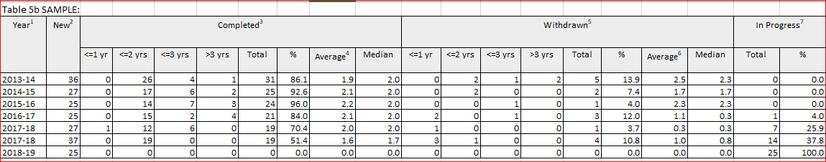

Table 4b: Graduate Student Complement, Withdrawals and Completions by Academic Year (Flow-Through Data)
Table 4b will be provided for year range 2018/19 to 2024/25.
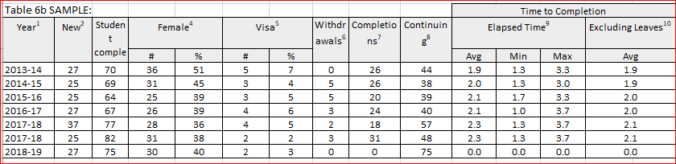

B.3.3.c Graduate Enrolment Profile
Using the Section Prompts below, discuss the graduate enrolment profile (gender, Citizenship, etc.) in the programs.

Table 4b is also to be used to facilitate discussion for this section.

GRADUATE PROGRAMS:
Assess the distribution of students among programs in the department:
[INSERT COMMENT HERE]

Assess enrolment by gender and comment:
[INSERT COMMENT HERE]

Assess the proportion of international students and comment:
[INSERT COMMENT HERE]

STUDENT EXPERIENCE FOR UNDERGRADUATE AND GRADUATE PROGRAMS

C.1 Student Orientation, Advising and Mentoring

- Provide comment on student orientation, advising and mentoring in the program.
- Provide comment on communication with students, such as website, handbooks, etc.

Address both Undergraduate and Graduate Programs

[INSERT COMMENT HERE]

C.2 Student Satisfaction

- Provide comment and analysis on student experience and satisfaction.
- Please include a summary of any survey/focus group results, indicating:
  - Response rate/number of participants
  - Common themes arising from results and/or comments, such as areas of program strength and opportunities for program improvement
- AAU and programs are encouraged to identify ways in which they believe levels of student satisfaction can be improved.
- In discussing student experience, AAUs should comment on formal and informal opportunities for students within the program and/or academic units, such as (but not limited to):
  - Student representation on committees;
  - Student societies/clubs;
  - Opportunities for students to present research projects;
  - Faculty and community presentations.
- Programs can request through the Quality Assurance office their NSSE (National Survey of Student Engagement) and CGPSS (Canadian Graduate and Professional Student Survey) data.
- Through the Quality Assurance office AAUs can request Expedited IQAP Ethics Board approval to conduct surveys specifically for IQAP purposes.

Address both Undergraduate and Graduate Programs

[INSERT COMMENT HERE]

C.3 Student Funding and Research (graduate programs only)

A Graduate Student Funding Table 5 will be provided by the Quality Assurance Office that is to be used for facilitation of the financial questions in this discussion.
Provide comment and analysis on total student funding (Comment and analysis should include a discussion of the AAUs students’ success in external scholarships (e.g. OGS, SSHRC, NSERC, CIHR).
[INSERT COMMENT HERE]

Comment on trends and explain fluctuations in average funding included in the tables.
[INSERT COMMENT HERE]

Comment here on the number of students that have applied for, and received, conference travel funding.
[INSERT COMMENT HERE]

Provide evidence of guidance and development provided to TAs and GAs.
[INSERT COMMENT HERE]

For course-work options, comment and analysis should focus on how students gain research experience in the program.
[INSERT COMMENT HERE]

Table 6: Financial Support for Graduate Students:
(Table will be provided.)

C.4 Student Publications (Graduate Programs)

- Provide comment and analysis on students’ scholarly output in terms of peer-reviewed publications.
- Comment and analysis should focus on the encouragement, advice and support provided by the AAU’s or program’s core faculty to enable students to develop their list of publications.

[INSERT COMMENT HERE]

C.5 Career Paths, Employment, and Career Data of Graduates from both Undergraduate and Graduate Programs

- Provide comment and analysis on the expected career paths of graduates (Undergraduate and Graduate students)
- Career paths can include entry into graduate and second entry programs as well as positions as postdoctoral fellows
- Provide any data on employment data of graduates post-graduation (Undergraduate and Graduate).
Address both Undergraduate and Graduate Programs

[INSERT COMMENT HERE]

THE FACULTY

D.1 Faculty Complement

a. Faculty Complement

Table 7 is developed by the AAU and will facilitate discussion in this section. Instructions for completing Table 8 are included below.

Using the Section Prompts below to complete this section: Identify and provide comment and analysis on the faculty appointed to the unit or program(s) under review.

Comment on any changes in Faculty Composition since previous review (last 7 years):
[INSERT COMMENT HERE]

Comment on the participation of a sufficient number of qualified core faculty who are competent to teach and or supervise in the goals of the program and foster the appropriate academic environment.
[INSERT COMMENT HERE]

Discussion/explanation of the role and approximate percentage of adjunct and part-time faculty/limited term appointments used in the delivery of the program and the associated plans to ensure the sustainability of the program.
[INSERT COMMENT HERE]

Discuss any shared teaching or courses, etc.
[INSERT COMMENT HERE]

- Table 7 should reflect the current faculty complement in the AAU (i.e. as of the end of the reporting cycle)
- CVs will be required for all faculty members listed in Table 8, including for faculty members from other AAUs who are contributing to the core curriculum, e.g. teaching required courses in the programs under review, supervising or co-supervising student’s research, etc.
- The last three columns of the table (“Program/Field A”, etc.) should be adjusted to reflect the AAU’s specific program(s) and field(s) structure – see comment #3 after the table.

Table 7: Faculty Members by Field/Program (created by the AAU):
Faculty Name & Rank (alphabetical) | M/F | Home Unit¹ | Supervisory  Privileges ² | programs and/or graduate program fields Affiliation³
Category 1: Tenured Professors teaching exclusively in this AAU |  |  |  | Program/Field A | Program/Field B | Field C
e.g. Adams, Lionel Assistant Professor | M |  | Full | X |  | x
Category 2: Tenure-track Professors teaching exclusively in this AAU
Category 3: Ancillary Academic Staff such as Learning Specialists Positions
Category 4: Sessional Lecturers* (list here any sessional lecturer positions that were introduced in the 2011 WUFA collective agreement)
*8-month permanent positions
Category 5: Limited-term Appointments teaching exclusively in this AAU
Category 6: Cross-Appointments, Adjuncts, Tenure or tenure-track or LTA professors involved in teaching and/or supervision in other AAUs, in addition to being a member of the program under review
Category 7: Sessional Instructors and other non-tenure track faculty
Category 8: Others
¹ This is the budget unit paying the salary: department, school, research centre or institute, or other.
² for graduate programs only, indicate the level of supervisory privileges at the graduate level held by each faculty member, i.e. full or affiliate graduate faculty designation
³ Identify all the AAU’s programs in which the instructor teaches or supervises. For graduate programs indicate also the faculty member’s affiliation to the OCGS-approved fields in the graduate program(s).

D.2 Faculty research funding

External Research Funding data will be provided by the Office of Quality Assurance from the ORI Office. The information can be pasted into the self-study or used as an Appendix, but discussion of the funding data should be included here.

Table 8: External Research Funding

Provide comment on research activities of the faculty associated with the program and describe the major funded research projects currently underway in the department.
[INSERT COMMENT HERE]

Undergraduate: Provide comment on the manner in which faculty research funding supports student learning (i.e. through research assistantships, opportunities to co-publish, integration of research and teaching).

Provide any examples from undergraduate programs (e.g. Outstanding scholars, UWILL discover conference, undergraduate research grants and awards, etc.).
[INSERT COMMENT HERE]

Graduate: Provide comment on the manner in which faculty research funding supports student learning (i.e. through research assistantships, opportunities to co-publish, integration of research and teaching).

Elaborate specifically on Master’s research programs and doctoral programs where RAs from faculty grants and other research opportunities are to be expected.
[INSERT COMMENT HERE]

Comment on reasons for increase/decrease in research funding, (e.g., granting council budget changes, increase/decrease in faculty, alternative sources of funding such as foundations, etc.)
[INSERT COMMENT HERE]

Discuss the manner in which programs integrate research and teaching at the undergraduate level and at the professional master’s level (where applicable).
[INSERT COMMENT HERE]

D.3 Faculty record of scholarly activity
Publication Report – attach as appendix or pull from report…..IA providing
[INSERT COMMENT HERE]

D.4 Distribution of Thesis Supervision
Table 8 will be provided by Quality Assurance office following finalization of Faculty CVs.

Table 9: Completed (Career) and Current Numbers of Thesis Supervisions by Faculty Members:

Provide evidence of how supervisory loads are distributed, in light of qualifications and appointment status of the faculty.

[INSERT COMMENT HERE]

Provide comment on how students find a faculty supervisor.
[INSERT COMMENT HERE]

D.5 Teaching Assignments
This section will identify graduate and undergraduate courses taught by each faculty member. Comment and analysis on these and other topics can build on discussions begun in section D.1.

PROVIDE COMMENT AND ANALYSIS:
- On the distribution of teaching assignments. The focus of this narrative can be on the distribution:
    - between required and optional courses;
    - across year levels;
    - across areas of individual faculty specializations;
    - between graduate and undergraduate programs.
- Explain what constitutes a normal teaching assignment and reasons for major discrepancies.
- Explain special course-relief and related policies, e.g. ‘the supervision of graduate theses is recognized in the teaching assignments in accordance with a formula’ (specify). Explain the impact such policies have on the program.

Data will be provided by the Quality Assurance office with instructions for the creation of Tables 9 (a-d) for the past four years (current review year and the preceding three academic years).
Faculty members in Tables 9 (a-d) should be listed in the same order as they are presented in Table 6 from section D.1, using the same category subheadings.
UNDERGRADUATE PROGRAMS:

[INSERT COMMENT HERE]

GRADUATE PROGRAMS:

[INSERT COMMENT HERE]
Table 10 (a) to (d) Teaching Assignments for past 4 years
SAMPLE TABLE 10a: Teaching Assignments for 2024/25¹
Faculty Member & Rank ² | Undergraduate (course number, name, semester taught, enrolment)³ | Graduate (course number, name, semester taught, enrolment) | Comments⁴
Category 1 : Tenured Professors teaching exclusively in this AAU
Adams, Lionel  Associate Professor | [For each course list the course number & name, semester taught and enrolment – see footnote #3], e.g. :  02-48-100 – Introduction to Psychology; F13 ; enrolment: 120 (3 cr)⁴ | 02-24-504 (3cr) | Dept. Chair
Watanabe, Miyako  Professor | 02-48-330- Course Title & enr.(3 cr)  02-24-245- Course Title & enr.(3 cr)  02-48-345- Course Title (3 cr) | 02-48-510 (3cr)
Category 2: Tenure-track Professors teaching exclusively in this AAU
Weller, Peter  Assistant Professor | 02-48-162 – Course Title (3cr) |  | Sabbatical (0.5 year) – reduced responsibility

TABLE 10b: Teaching Assignments for 2023/24¹
Faculty Member & Rank ² | Undergrauate (course number, name, semester taught, enrolment)³ | Graduate (course number, name, semester taught, enrolment) | Comments⁴
Category 1 : Tenured Professors teaching exclusively in this AAU
Adams, Lionel  Associate Professor | 02-48-100 – Course Title (3 cr)⁴ | 02-24-504 (3cr) | Sabbatical
Watanabe, Miyako  Professor | 02-24-245- Course Title-(3 cr)  02-48-345- Course Title (3 cr) | 02-48-510 (3cr)
Category 2: Tenure-track Professors teaching exclusively in this AAU
Etc.

TABLE 10c: Teaching Assignments for 2022/23 ¹
Faculty Member & Rank ² | Undergraduate (course number, name, semester taught, enrolment)³ | Graduate (course number, name, semester taught, enrolment) | Comments⁴
Category 1 : Tenured Professors teaching exclusively in this AAU
Adams, Lionel  Associate Professor | 02-48-100 – Course Title (3 cr)⁴ | 02-24-504 (3cr)
Watanabe, Miyako  Professor | 02-48-330- Course Title (3 cr) | 02-48-510 (3cr) | Admin. leave
Category 2: Tenure-track Professors teaching exclusively in this AAU
Etc.

TABLE 10d: Teaching Assignments for 2021/22¹
Faculty Member & Rank ² | Undergraduate (course number, name, semester taught, enrolment)³ | Graduate (course number, name, semester taught, enrolment) | Comments
Category 1 : Tenured Professors teaching exclusively in this AAU
Adams, Lionel  Associate Professor | 02-48-100 – Course Title (3 cr)⁴ | 02-24-504 (3cr) | Dept. Chair
Watanabe, Miyako  Professor | 02-48-330- Course Title (3 cr) | 02-48-510 (3cr)
Category 2: Tenure-track Professors teaching exclusively in this AAU
Etc.
¹ the raw data provided by the IQAP office needs to be split into separate tables for each of the four years preceding the review: Table 10a – Year 1, Table 10b – Year 2, Table 10c – Year 3, Table 10d – Year 4. These lists identify courses by their formally identified primary instructors. If the data does not accurately represent teaching assignments in your AAU, please comment in the Comments section regarding normal teaching assignments and reasons for major discrepancies.
² Follow same faculty categories as in Table 8.
³ List course number, course name, term taught, and enrolment. Provide credit load for each course, and explain course value in a footnote appended to Table, i.e., 3 credits normally means 3 contact hours per week for one term.
⁴ Include notes regarding specifics of course load adjustments for professors. Indicate where there are secondary instructors (team-taught, etc.) associated with a course.

D.7 Discussion of Faculty Quality Indicators

Provide an Executive Level Summary on the Research, Service and Teaching Expertise of the faculty in the program.

Using the Section Prompts below, describe and analyse the structures and procedures within the unit for facilitating new initiatives in research, teaching and service.

Promotion of Research Excellence (incl. new faculty mentorship and grantsmanship):
[INSERT COMMENT HERE]

Facilitation and Distribution of Service by Faculty:
[INSERT COMMENT HERE]

List of Teaching Awards to Instructors: (It may be helpful to review the Centre for Teaching and Learning site)
[INSERT COMMENT HERE]

Initiatives to Enhance Teaching Effectiveness (e.g. CTL workshops, AAU seminars on teaching, grants, etc.):
[INSERT COMMENT HERE]

GOVERNANCE

- Describe the governance structure of the AAU including Department Heads, Undergraduate and Graduate Committees, Subcommittees, etc.
- Describe the decision-making structures of the AAU.

The purpose of this section is to provide assurance that the administrative structure in question allows for the successful delivery of the program. In this respect, account should cover the development and establishment of academic policies for programs, as well as more routine administrative matters, such as committee structures for processing applications, and for developing and submitting program and curriculum changes.

The committee(s) responsible for the assessment of learning outcomes, as outlined in Section B.1.1 (Undergraduate) and Section B.2.1 (Graduate) should also be noted.

[INSERT COMMENT HERE]

RESOURCES

F.1. Discussion of Current Financial Resources
Comment on the impact of current level of financial resources and their deployment, identifying potential opportunities for efficiencies and revenue streams.
Identify effective and innovative solutions to resource problems that have been implemented.
Include specific input describing the impact of the department’s financial resource allocation on each program.
[INSERT COMMENT HERE]

F.2. Human Resources

- For the AAU as well as at the program level, please provide a summary of administrative and staff support.
- Detail the contributions made to the program(s) by the support and technical staff and identify any challenges the AAU or program feels it faces in this regard.
- Describe the human resources currently dedicated to the department and its programs.
- Describe how those resources are currently deployed within the department to achieve the programs’ missions and goals.
- Assess the effectiveness of the department’s human resources deployment.

[INSERT COMMENT HERE]

F.3 Physical Resources

Library Resources/Report

- Provide a description of the institution’s library resources, including unique resources on site and access that faculty and students have to other resources.
- Provide a brief summary of the University holdings pertinent to the fields, the collection policy and library expenditures for the last seven years.
- Discuss the strengths and challenges of the current library holdings.
- The detailed documentation on library holdings is to be attached in an Appendix.
- Provide a qualitative analysis of the collections against existing standards for the discipline, where these standards exist, is most useful.
- Explain special collections not listed in the library report.

Contact the administrative assistant to the University Librarian at the Leddy Library for the library report. You can find who your Librarian is using this link: https://leddy.uwindsor.ca/find-a-librarian

[INSERT COMMENT HERE]

Space and Laboratory (and Computer) facilities
Space
- Comment on the space utilized by the program, including faculty and student space.
- The AAU and programs should discuss both the positive aspects of the space they utilize, as well as the challenges they may face.
- Discuss the future commitments/plans ((e.g. relocation or space expansion) for the space for the next seven years.

Laboratory and Computer facilities (if applicable)
- List the major equipment available for use and commitments/plans for the next seven years.
- Describe anticipated developments.
- Describe laboratory/studio facilities that are used by students. Both on- and off-campus facilities should be described.
- Discuss the manner in which these facilities contribute to the delivery of the programs and the achievement of learning outcomes, together with any challenges faced by the AAU or program in this regard.

[INSERT COMMENT HERE]

CONCLUSIONS AND RECOMMENDATIONS

Using the Section Prompts below, provide a high-level summary of the suggestions and recommendations for program improvement made in previous sections of the self-study.

Conclusions and Recommendations Must Include:
Looking Forward:
Provide a future-focused analysis of the programs under review and:

- Identifying strengths the programs can build on:

- Program areas that require improvement:

- Best possible future opportunities, and aspirations of the difference you hope the programs can make through its graduates.
[INSERT COMMENT HERE]

Assess the degree to which the program is fulfilling its objectives:
[INSERT COMMENT HERE]

There must be Identification of Challenges and/or Opportunities where the reviewers’ advice is sought:
[INSERT COMMENT HERE]

FACULTY DEAN COMMENTARY

This section is where the Faculty Dean provides their perspective, including focus that would be helpful from the Faculty-level perspective:

Identify Areas of Strength from a Faculty-level perspective:
[INSERT COMMENT HERE]

Identify areas that hold promise for enhancement from a Faculty-level perspective:
[INSERT COMMENT HERE]

Identify areas noted in the Self-Study that require improvement:
[INSERT COMMENT HERE]

Identify any specific areas that would be helpful for the external reviewers to address:
[INSERT COMMENT HERE]

