
University of Windsor Quality Assurance Flow Chart New Programs – PDC Form Approval Process

AAU Responsibility

QA Responsibility
Notice of Intent

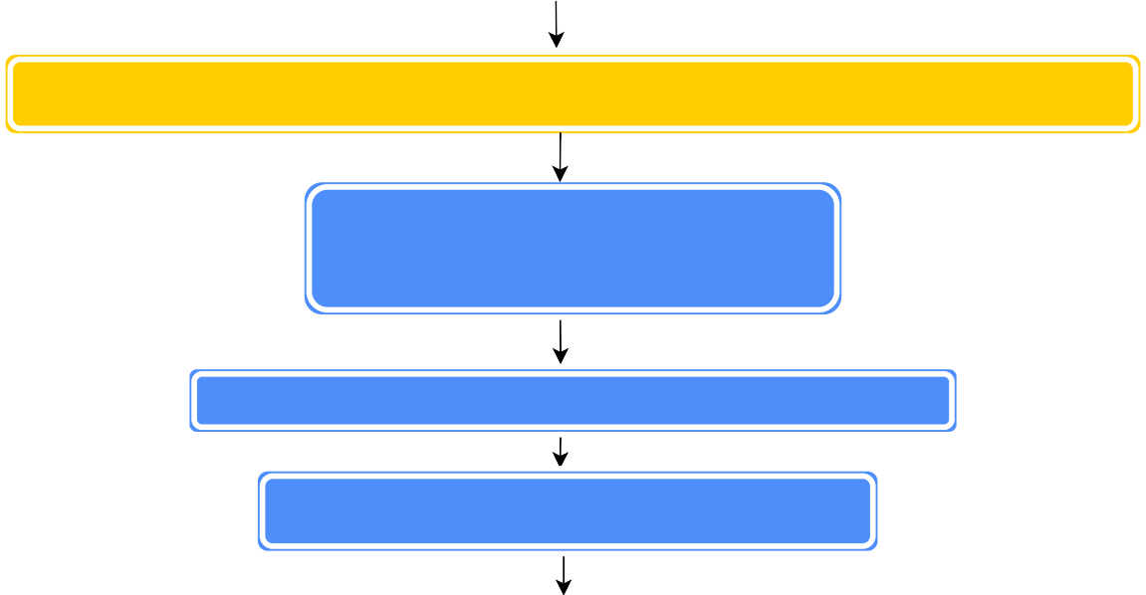
New Program Steering Committee

PDC Form A Development and Approval by AVPA

External Review

Response to Reviewers' Report from:
1. AAU(s) (proposers) 2. Dean(s)

Departmental Council(s) Approval (and Faculty Council(s) if required)

Faculty Coordinating Council(s) (for non-departmentalized faculties)

Graduate Studies Council (for graduate programs or courses)

Provost

Program Development Committee

Senate

Quality Council
Quality Council Expedited Review for Graduate Diplomas only (External Review not
required)
MCU for funding approval, as required

