

2022/23 Cyclical Review of Undergraduate and Graduate Programs*
Department of ……

Self-Study Brief
[Template]

* Data ranges in tables intended for 2022/23 review cycle
(last updated January 2022)

self-study table of contents
A. DEVELOPMENT OF THE SELF STUDY 5
B. PROGRAMS 6
B.1. UNDERGRADUATE PROGRAMS 6
B.1.a Undergraduate Program History 6
B.1.b. Undergraduate Program Overview (includes program listings, emphases, options, specializations or minors) 6
B.1.c Undergraduate Mission and Strategic Directions 6
B.1.d. Relationship to Other Undergraduate Programs at Windsor and the Community 7
B.1.e. Comparison to Similar Undergraduate Programs at Other Institutions 7
B.1.f. Recommendations and Actions from Previous Review 8
B.1.1. Undergraduate Program Learning Outcomes and Curriculum Structure 9
B.1.1.a Undergraduate Program Learning Outcomes and Curriculum Mapping 9
B.1.1.b Undergraduate Program Admission Requirements 12
B.1.1.c Undergraduate Modes of Delivery and Student/Faculty Interaction with Learning and Scholarly Community 12
B.1.1.d. Undergraduate Program and Curriculum Structure 13
B.1.1.e Undergraduate Program Progress and Course sequence 13
B.1.1.f Undergraduate Program Learning Outcomes Assessment Methods 14
B.1.2 Undergraduate Program Enrolment and Retention 15
B.1.2.a Undergraduate Applications, Offers, and Registrations 15
B.1.2.b Undergraduate Grade Distribution Profiles for All Courses 17
B.1.2.c Undergraduate Class Sizes and Course and Program Capacity 18
B.1.2.d Undergraduate Retention and Graduation Rates 19
B.1.2.e Undergraduate Enrolment Profile 22
B.1.2.f Undergraduate Projected Enrolment 22
B.2. GRADUATE PROGRAMS 24
B.2.a Graduate Program History 24
B.2.b. Graduate Program Overview (includes program listings and graduate fields) 24
B.2.c Graduate Mission and Strategic Directions 24
B.2.d. Relationship to Other Programs at Windsor and the Community 25
B.2.e. Comparison to Similar Graduate Programs at Other Institutions 25
B.2.f. Recommendations and Actions from Previous Review 26
B.2.1 Graduate Program Learning Outcomes and Curriculum Structure 27
B.2.1.a Graduate Program Learning Outcomes and Curriculum Mapping 27
B.2.1.b Graduate Program Admission Requirements 30
B.2.1.c Graduate Modes of Delivery and Student/Faculty Interaction with Learning and Scholarly Community 31
B.2.1.d. Graduate Program and Curriculum Structure 31
B.2.1.e Graduate Program Progress and Course Sequence 32
B.2.1.f Graduate Program Learning Outcomes Assessment Methods 32
B.2.2 Graduate Program Enrolment and Retention 33
B.2.2.a Graduate Applications, Offers, and Registrations 33
B.2.2.b Graduate Grade Distribution Profiles for All Courses 34
B.2.2.c Graduate Class Sizes and Course and Program Capacity 35
B.2.2.d Graduate Program Times-to-completion and Graduation Rates 35
B.2.2.e Graduate Enrolment Profile 37
B.2.2.f Graduate Projected Enrolment 38
C. GOVERNANCE 40
D. THE FACULTY 40
D.1 Faculty and Human Resources 40
a. Faculty Complement 40
b. Administration and Staff Members 43
c. Impact of Human Resources on Student Learning Outcomes and Degree Programs 43
D.2 Faculty research funding 43
D.3 Faculty record of scholarly activity 44
D.4 Distribution of Thesis Supervision 46
D.5 Teaching Assignments 47
D.6 Contract Instructors: Permanent, Sessional, and Limited-term Faculty 49
D.7 Teaching Effectiveness 50
D.8 Discussion of Faculty Quality Indicators 51
E. STUDENT EXPERIENCE 53
E.1 Student Orientation, Advising and Mentoring 53
E.2 Student Satisfaction 53
E.3 Student Funding and Research (graduate programs only) 53
E.4 Student Publications (Graduate Programs) 54
E.5 Career Paths of Graduates / Employment and Career Data of Program Graduates 54
F. RESOURCES 55
F.1. Financial Resources 55
a. Internal Operating Funding 55
b. External Operating Research Funding 58
c. Discussion of Current Financial Resources 59
F.2. Human Resources 59
F.3 Physical Resources 59
a. Library Resources/Report 59
b. Computer equipment and laboratory facilities 60
c. Space 60
d. Discussion of current physical resources 60
G. CONCLUSIONS AND RECOMMENDATIONS 60

LIST OF COMMON APPENDICES TO THE SELF-STUDY BRIEF:*

Appendix A – Faculty CVs – All faculty members in all Programs

Appendix B – Copies of previous review documents (latest biennial PDC UPR report (Reference to Self-Study Brief sections B.1.f. and B.2.f.)

Appendix C – Leddy Library Report

Appendix D – Undergraduate Course Syllabi

Appendix E – Graduate Course Syllabi

Appendix F – Course Descriptions

*Additional appendices may be added such as:
- Student Handbook
- Student satisfaction survey results
- Organizational charts
- Special AAU policies regarding course loads, course relief and related policies
- Faculty criteria for promotion, renewal and tenure
- Other curriculum documents, etc.

LIST OF TABLES IN THE SELF-STUDY:
Tables 1a to 7a (undergraduate):
Table 1a: Undergraduate Program Learning Outcomes 9
Table 2a: Undergraduate Applications and Registrations 16
Table 3a: Grade Distribution Profiles for All Undergraduate Courses (past 4 years) 17
Table 4a: Undergraduate Courses offered to Students in the Past Four Years/ Courses Demand Data: Enrolment Waiting Lists 18
Table 5a: Undergraduate Retention and Graduation 20
Table 6a: AAU Enrolment Distribution 21
Table 7a: Projected Intake and Enrolments - undergraduate programs 23

Tables 1b to 7b (graduate):
Table 1b: Graduate Program(s) Learning Outcomes 27
Table 2b: Graduate Applications and Registrations 33
Table 3b: Grade Distribution Profiles for All Graduate Courses (past 4 years) 34
Table 4b: Graduate Courses offered to Students in the Past Four Years/ Courses Demand Data: Enrolment Waiting Lists 35
Table 5b: Graduate New Enrolment, Completions and Withdrawals by Year of Admission (Cohort Data) 36
Table 6b(i): Graduate AAU Enrolment Distribution 37
Table 7b: Graduate Projected Intake and Enrolments 39

Tables 8 to 15:
Table 8: Faculty Members by Field/Program (created by the AAU): 42
Table 9: Scholarly and Creative Activity 45
Table 10: Completed (Career) and Current Numbers of Thesis Supervisions by Faculty Members 47
Table 11 (a) to (d) Teaching Assignments for past 4 years 48
Table 12: Proportion of Courses Taught by Permanent, Sessional and Limited-term Faculty 51
Table 13: Financial Support for Graduate Students (past 7 years) 54
Table 14: AAU Operating Funding 55
Table 15: External Operating Research Funding by Source and Year 58
Table 15(a): External Operating Research Funding by Graduate Field 58

DEVELOPMENT OF THE SELF STUDY
Summarize the AAU’s procedures in completing the self-study, demonstrating sound methodology and an open and fair approach to gathering information from all constituents.

- In this section, provide a brief account of:
    - How the self-study was conducted, e.g. participation of faculty, staff and students from each program under review;
    - How their views were obtained; and
    - How their views were taken into account in the development of the self-study.

- Ensure ALL contributing units are consulted and included in the self-study: for combined programs solicit input from the other AAU(s); if components of the program (courses, practicum, clinical experience) are delivered by an affiliated partner institution/college/centre, ensure that the partners are included in the review process of that part of the program.

- It is expected that departments will plan in advance to gather stakeholder data from multiple sources.

- Recommended methods of consultation and involvement include:
    - Stakeholder representation on the self-study review committee
    - Survey data
    - Focus group data
    - Interview data
    - Involvement of elected student representatives
    - Departmental NSSE data, CGPSS data, or data from other externally validated instruments
    - Review of self-study by elected student representatives

[INSERT COMMENT HERE]

PROGRAMS

B.1. UNDERGRADUATE PROGRAMS

B.1.a Undergraduate Program History
Provide a brief history of the undergraduate program(s). Contextualize the program history to the current program(s). Provide the context/brief description of the genesis of the program and the way in which program goals have developed and changed over time, in particular since the last review.

[INSERT COMMENT HERE]

B.1.b. Undergraduate Program Overview (includes program listings, emphases, options, specializations or minors)
This section is where you would provide a brief introduction to the undergraduate program(s) that are part of this cyclical review. This section should include the following:

Separate accounts should be provided for each undergraduate degree program under review.
- Provide brief program listing for each degree program (BA, BSC, Certificates, etc.)
- Describe features of the degree (thesis/non-thesis options, co-op, collaborative programs, etc.)
- List all emphases, options, specializations, concentrations or minors in the program.
- Highlight any innovative or creative features that may characterize the program(s).
- Provide an account of how the program(s) relates to the current international, national and provincial profiles of similar programs in the discipline or interdisciplinary area.

[INSERT COMMENT HERE]

B.1.c Undergraduate Mission and Strategic Directions
- For each program, include the program’s mission statement.
- Describe how the program(s) is consistent with and supports and furthers the University of Windsor’s mission and Strategic Mandate (SMA)
- Describe how the program(s) is consistent with and supports the faculty’s academic plans.

[INSERT COMMENT HERE]

B.1.d. Relationship to Other Undergraduate Programs at Windsor and the Community

Many units draw on courses offered by other units in order to deliver their programs. This is especially the case for interdisciplinary programs, where the majority of courses may be delivered outside of the unit administering the program.
- Provide an account of how other academic programs at Windsor contribute to the delivery of the program(s).
- In providing this account, it may also be appropriate to solicit testimonials from other academic units and Faculties where the service function is significant.

Many units and programs perform an important and invaluable service function for other programs at Windsor, and this service needs to be recognized and accounted for as part of the quality assurance process.

- Provide an account of how the program(s) and its courses contribute to other academic programs at Windsor.
- In providing this account, it may also be appropriate to solicit testimonials from other academic units and Faculties where the service function is significant.

Many units and programs perform an important and invaluable service function in the community.
- Provide an account of community relationships, liaison and service.

[INSERT COMMENT HERE]

B.1.e. Comparison to Similar Undergraduate Programs at Other Institutions
- Comment on the department’s view of how the undergraduate program(s) compare with similar, leading departments, schools or programs in Canada and abroad.
- Provide the basis for the comparison.

[INSERT COMMENT HERE]

B.1.f. Recommendations and Actions from Previous Review
Use the latest PDC biennial University Program Review (UPR) report as a point of reference (will be provided by IQAP office). Please insert only the PDC recommendations that are ‘behind target’ or ‘not satisfied’ and provide a response/status update to each recommendation. Responses to the recommendations may be grouped as appropriate.
An example of how to structure this section is provided below:

[INSERT COMMENT HERE]
The latest IQAP cyclical review of the [program name] was in [previous review year, e.g. 2013/14]. Refer to Appendix [X] for the latest PDC biennial status report.

The current status of the recommendations from the report that are still not satisfied or are behind target is as follows:

Recommendation #1: State the recommendation directly from relevant report.
Response: Describe departmental response to recommendation and actions taken/not taken sine the latest biennial status report.

B.1.1. Undergraduate Program Learning Outcomes and Curriculum Structure

B.1.1.a Undergraduate Program Learning Outcomes and Curriculum Mapping
- Curriculum Mapping:
Each set of Learning Outcomes should have a Curriculum Map and/or statements of how the curriculum is mapped to the Learning Outcomes.

After each Program Learning Outcomes, please provide a Curriculum Map or Curriculum Statement.
Programs are encouraged to contact Allyson Skene in CTL for assistance with their curriculum maps (ext. 4923).

After the Learning Outcomes Table (1a) below, a screenshot of the Curriculum Mapping Tool offered by CTL has been inserted, for your reference.

Table 1a: Undergraduate Program Learning Outcomes

Undergraduate Program(s) Curriculum Map and/or Curriculum Statement:
[INSERT COMMENT AND MAP HERE – SEE SAMPLE BELOW:]

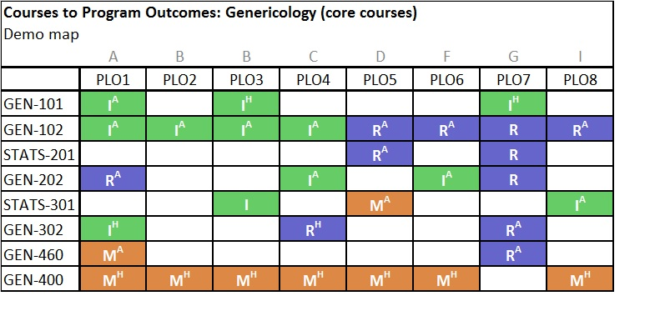

B.1.1.b Undergraduate Program Admission Requirements
DESCRIBE:
- the admission requirements – for each undergraduate program.

COMMENT:
- on the appropriateness and efficiency of the admission requirements (e.g. preparation and achievement) for achieving the intended program learning outcomes.
- Include in this discussion a description of any initiative established to address the transitional needs of students entering the program.

[INSERT COMMENT HERE]

B.1.1.c Undergraduate Modes of Delivery and Student/Faculty Interaction with Learning and Scholarly Community
- Comment on how the programs’ modes of delivery are appropriately and effectively employed to meet the programs’ learning outcomes (including, e.g. distance or on-line delivery, experiential learning requirements, etc.)

- Comment on the nature of the learning community, and structured opportunities for meaningful intellectual interaction among students, and with faculty (e.g. departmental seminars where faculty and student research or creative activity is presented and discussed, workshops on research ethics, safety regulations, grant and award applications, career planning, etc.)

- Comment on measures to introduce students into the wider community of scholars in the discipline.

[INSERT COMMENT HERE]

B.1.1.d. Undergraduate Program and Curriculum Structure
- Provide a brief overview of each program’s structure and requirements, including any innovative features or modes of delivery.

- Provide an account on:
- How the curriculum reflects the current state of the discipline or area of study
- How the program structure and faculty research ensure the intellectual quality of the student experience.

- Describe innovative content, teaching practices, or course delivery models, with evidence of impact on student learning or engagement, where available.

- Comment on Senate, Faculty or Departmental policies and practices approved during the period to improve the program (e.g. to improve time to completion, program delivery, etc.) Were any changes made to the program – such as course changes (addition/deletion of courses, etc.)

[INSERT COMMENT HERE]

B.1.1.e Undergraduate Program Progress and Course sequence
Please insert into this section a copy of the relevant program requirements and program sequence from the calendar (http://www.uwindsor.ca/calendars)

Provide a summary of expected progress through the program(s). For each year of the program(s), for example, please include:
- Required courses
- Required selection of X courses from among the following…
- Number of courses required from a specific discipline
- Number of electives to be taken
- Capstone, thesis, or experiential learning requirements

(A table summarizing this information may be useful to include here.)

A Student Handbook may be included as an appendix and referenced here, if applicable.

[INSERT COMMENT HERE]

B.1.1.f Undergraduate Program Learning Outcomes Assessment Methods

In this section, clearly label which Learning Outcome(s) from Table 1a (section B.1.1.a) relate to each method of assessment. A table of assessment methods and to which Learning Outcomes they relate to is very helpful here. The IQAP Office can provide you with examples of this kind of table.

DESCRIPTION
- Describe the various methods used for assessing student achievement of the defined learning outcomes throughout the program(s), focusing on the progression of assessment methods used in each year of the program.
- Base your description on review of syllabi and representative examples of student assessment, in particular, reference to assessment in required courses.

COMMENT AND ANALYSIS
- Demonstrate that the methods of assessment, especially in students’ final year of the program, are appropriate and effective in clearly demonstrating the graduating students have achieved the programs’ learning outcomes and the institution’s graduate attributes.
- Provide an overview of the procedures in place to ensure effective, accurate and fair assessment of student progress in program-specific activities (e.g. thesis evaluation procedures, experiential, service-learning and co-op placements, capstone and other final-year projects, undergraduate research).
- Demonstrate the consistency of these evaluative procedures with the program learning outcomes.

[INSERT COMMENT HERE]

B.1.2 Undergraduate Program Enrolment and Retention

B.1.2.a Undergraduate Applications, Offers, and Registrations

- Comment on the pattern of applications, offers, confirmations, and registrations for each program in terms of program capacity.
- Discussion must address the following:
  - Quality of the applicant pool, and whether the size and quality of the pool needs to be improved,
  - The admission targets and the admissions against program capacity
  - The percentage of applicants receiving offers, the percentage of offers accepted or confirmed, and the percentage conversion of acceptances and confirmations into registrations.
  - Comment and analysis can also be made on the pattern of students admitted to the program after first year.

Table 2a (program-specific) is provided to facilitate your discussion in this section. Table 2a will be provided for year range of 2015-2021.

(Please note: Table 2a (and b) defines the Academic Term differently from Table 5 a (and b) and therefore do not have correlating or matching numbers.)

[INSERT COMMENT HERE]

Table 2a: Undergraduate Applications and Registrations
Table 2a will be provided for year range of 2015 to 2021.
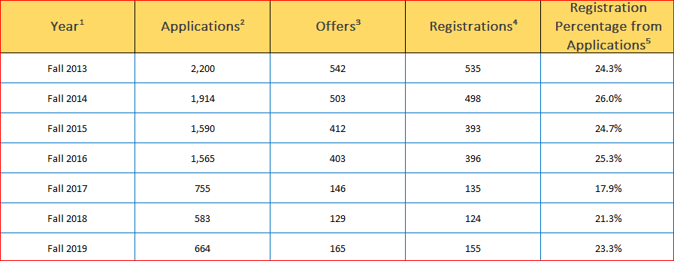
¹ Fall Term Only.
² Number of applications to enter the program in the Fall Term identified. One student may have one or more applications.
³ Number of accepted applications.
⁴ Number of registrations, resulting from the number of applications.
⁵ Percentage of registrations, resulting from the number of applications.
⁶ Applications, offers, and registrations are allocated to faculties based on program. Students in single major programs are allocated 100% to their home faculty, while those in combined majors are allocated proportionally to the faculty/department of each major. For example, a student in Combined Psychology and Political Science is allocated 50% to the FAHSS/Psychology and 50% to FAHSS/Political Science. Students in joint programs are also allocated 50% to the faculty/department of each major. For example, a student in Honours Mathematics and Computer Science is allocated 50% to Faculty of Science/Mathematics and Statistics and 50% to Faculty of Science/Computer Science.

B.1.2.b Undergraduate Grade Distribution Profiles for All Courses
Discuss grade distribution data in light of descriptions of assessment practices documented in Section B.1.1.
- Identify any anomalous distribution patterns that may be of concern.
- Include here any student feedback gathered regarding expectations, assignments and evaluation procedures.
Table 3a: Grade Distribution Profiles for all courses will help facilitate the discussion in this section. The data for Table 3a is provided in a cut and paste format from the Quality Assurance Office.

[INSERT COMMENT HERE]

Table 3a: Grade Distribution Profiles for All Undergraduate Courses (past 4 years)
Table 3a will be provided for 4-year range relevant to this review period (2018 to 2021).
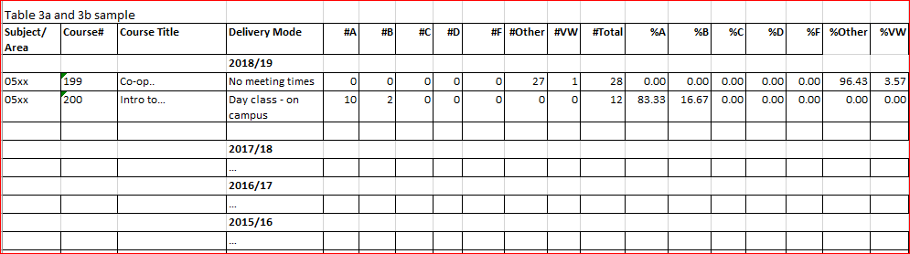

B.1.2.c Undergraduate Class Sizes and Course and Program Capacity

COMMENT AND PROVIDE ANALYSIS:
- On student-faculty ratios.
- On class sizes and course and program capacity of the programs.
- Are there sufficient course/course selections to enable students to complete their programs in a timely manner?
- What is the impact of class sizes on the achievement of the program learning outcomes?
- AAU’s and programs will be supplied with tables providing information on class size, based on course enrolment and course section count.

Table 4a is provided in this section to facilitate a discussion on course and program capacity and whether a program can accommodate more students. This discussion may relate to ways of increasing capacity through the use of new and innovative technologies in teaching and learning, or through outreach and distance delivery. Consideration should be given to measures of variability, such as the range and distribution of class sizes available to students in different course levels of the program.

[INSERT COMMENT HERE]

Table 4a Undergraduate Courses Offered to Students in the Past Four Years/ Courses Demand Data: Enrolment Waiting Lists
Additional Notes for Table 4:
- If you offer any service courses (courses offered only to non-majors/students in other department), add a column, or otherwise insert a comment to the table to indicate which course(s) are service courses.
- required courses must be Italicized
- indicate by asterisk (*) any undergraduate courses that are regularly taken by graduate students
- indicate by a double asterisk (**) any graduate courses regularly taken by undergraduates

Table 4a: Undergraduate Courses offered to Students in the Past Four Years/ Courses Demand Data: Enrolment Waiting Lists
Table 4a will be provided for 4-year range relevant to this review period (2018 to 2021).

B.1.2.d Undergraduate Retention and Graduation Rates

Using the Section Prompts below, provide comment and analysis on the retention and graduation rates for undergraduate programs.

Tables 5(a) and 6(a) are provided to facilitate discussion for this section. Table 5(a) and 6(a) will be provided for year range 2015 to 2021.

(Please note: Table 5a (and b) defines the Academic Term differently from Table 2a (and b) and therefore do not have correlating or matching numbers.)

Provide Comment and Analysis on Graduation Rates:
[INSERT COMMENT HERE]

Provide Recommendations for improving Retention Rates. Recommendations may derive from the program’s contributions to the University of Windsor’s SMA:
[INSERT COMMENT HERE]

Explain any corrective measures already taken for improving Retention and Graduation rates:
[INSERT COMMENT HERE]

Table 5a: Undergraduate Retention and Graduation
Table 5(a) will be provided for year range 2015 to 2021.
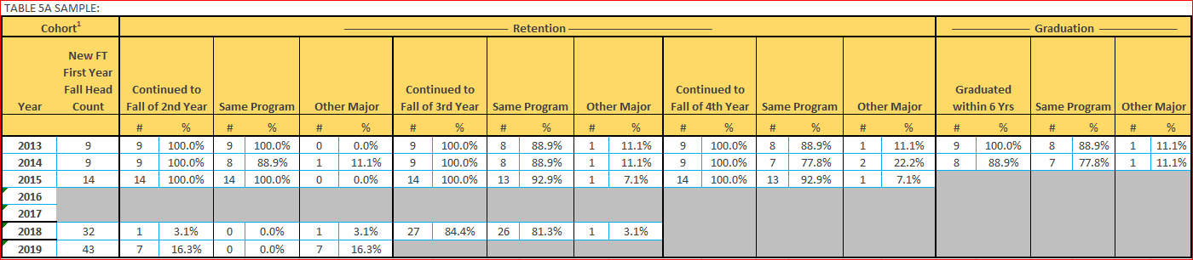

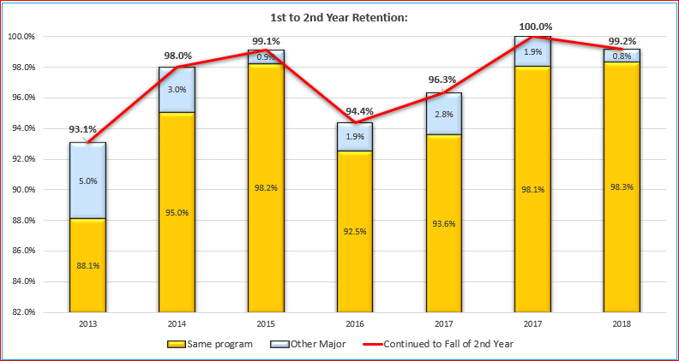

Table 6a: AAU Enrolment Distribution
Table 6(a) will be provided for year range 2015 to 2021
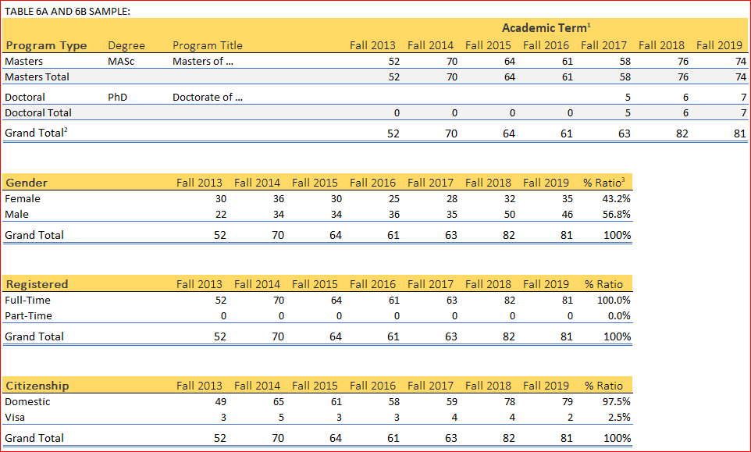

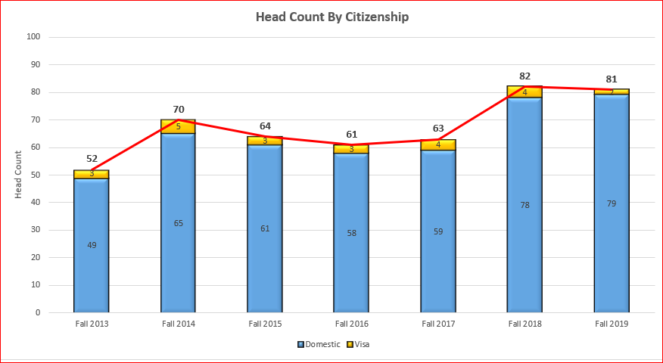

B.1.2.e Undergraduate Enrolment Profile
Using the Section Prompts below, discuss the enrolment profile (gender, Citizenship, etc.) in the programs.

Tables 5a and 6a are also to be used to facilitate discussion for this section.

UNDERGRADUATE PROGRAMS:
Assess the distribution of students among programs in the department:
[INSERT COMMENT HERE]

Comment on the provenance of students enrolled in each program and proportion of students:
[INSERT COMMENT HERE]

Assess enrolment by gender and comment:
[INSERT COMMENT HERE]

Assess the proportion of international students and comment:
[INSERT COMMENT HERE]

B.1.2.f Undergraduate Projected Enrolment

Using the Section Prompts, discuss trends in admissions, transfers, enrolment, and retention in the program, as well as any future initiatives that may impact undergraduate enrolment.

Table 7a is developed by the AAU and will facilitate discussion in this section. Table 7a must be included for all programs offered by the AAU that are under review.

Briefly comment on whether enrolment targets from previous review have been met and discuss trends in admissions, transfers, enrolment and retention in the program:
[INSERT COMMENT HERE]

Provide comment on projected intake and enrolments for the next seven years: intentions to grow, reduce or remain the same, as indicated in Table 7a:
[INSERT COMMENT HERE]

Indicate the magnitude and the reason for significant change in projected enrolment:
[INSERT COMMENT HERE]

Justify intentions to grow and explain and plans to sustain the growth:
[INSERT COMMENT HERE]

Notes on Table 7a:
- Projections are required for ALL programs under review.
- The table below shows sample data. Insert a separate table for each undergraduate program under review using the same table format.
- Intake = number of New students to be admitted and registered for the first time in this academic year. Enrolment = total student complement for this academic year which includes Intake for this academic year plus number of students continuing from the previous academic year.
- Review the actual intake and enrolment stats for the past 7 years reported in Tables 5a and 6a as a starting point for your projections for the next 7 years.
- Please clarify assumptions for your projections (e.g. completion times, attrition, etc.).
- Add a comment on the projections in the table, e.g. according to the sample data in the table below, no growth is projected for the next 7 years.
Table 7a: Projected Intake and Enrolments - undergraduate programs
YEAR | Undergraduate program projections
YEAR | Intake  (new students) | Enrolment  (steady-state, based on approx. 4- year completion time)
2022/23 | 145-155 | 500
2023/24 | 145-155 | 500
2024/25 | 145-155 | 500
2025/26 | 145-155 | 500
2026/27 | 145-155 | 500
2027/28 | 145-155 | 500
2028/29 | 145-155 | 500

B.2. GRADUATE PROGRAMS

B.2.a Graduate Program History
Provide a brief history of the graduate program(s). Contextualize the program history to the current program(s). Provide the context/brief description of the genesis of the program and the way in which program goals have developed and changed over time, in particular since the last review.

[INSERT COMMENT HERE]

B.2.b. Graduate Program Overview (includes program listings and graduate fields)
This section is where you would provide a brief introduction to the graduate program(s) that are part of this cyclical review. This section should include the following:

Separate accounts should be provided for each degree program under review (e.g. master’s and doctoral).
- Provide brief program listing for each degree program (MSc, PhD, etc.)
- Describe features of the degree (thesis/non-thesis options, co-op, collaborative programs, etc.)
- List all graduate fields in the program.
- Highlight any innovative or creative features that may characterize the program(s).
- Provide an account of how the program(s) relates to the current international, national and provincial profiles of similar programs in the discipline or interdisciplinary area.
- Include references to a program’s field of study, if applicable.

[INSERT COMMENT HERE]

B.2.c Graduate Mission and Strategic Directions
- For each program, include the graduate program’s mission statement.
- Describe how the program(s) is consistent with and supports and furthers the University of Windsor’s mission and Strategic Mandate (SMA)
- Describe how the program(s) is consistent with and supports the faculty’s academic plans.

[INSERT COMMENT HERE]

B.2.d. Relationship to Other Programs at Windsor and the Community

Many units draw on courses offered by other units in order to deliver their programs. This is especially the case for interdisciplinary programs, where the majority of courses may be delivered outside of the unit administering the program.
- Provide an account of how other academic programs at Windsor contribute to the delivery of the program(s).
- In providing this account, it may also be appropriate to solicit testimonials from other academic units and Faculties where the service function is significant.

Many units and programs perform an important and invaluable service function for other programs at Windsor, and this service needs to be recognized and accounted for as part of the quality assurance process.

- Provide an account of how the program(s) and its courses contribute to other academic programs at Windsor.
- In providing this account, it may also be appropriate to solicit testimonials from other academic units and Faculties where the service function is significant.

Many units and programs perform an important and invaluable service function in the community.
- Provide an account of community relationships, liaison and service.

[INSERT COMMENT HERE]

B.2.e. Comparison to Similar Graduate Programs at Other Institutions
- Comment on the department’s view of how the graduate program(s) compare with similar, leading departments, schools or programs in Canada and abroad.
- Provide the basis for the comparison.

[INSERT COMMENT HERE]

B.2.f. Recommendations and Actions from Previous Review
Use the latest PDC biennial University Program Review (UPR) report as a point of reference (will be provided by IQAP office). Please insert only the PDC recommendations that are ‘behind target’ or ‘not satisfied’ and provide a response/status update to each recommendation. Responses to the recommendations may be grouped as appropriate.
An example of how to structure this section is provided below:

[INSERT COMMENT HERE]
The latest IQAP cyclical review of the [program name] was in [previous review year, e.g. 2013/14]. Refer to Appendix [X] for the latest PDC biennial status report.

The current status of the recommendations from the report that are still not satisfied or are behind target is as follows:

Recommendation #1: State the recommendation directly from relevant report.
Response: Describe departmental response to recommendation and actions taken/not taken sine the latest biennial status report.

B.2.1 Graduate Program Learning Outcomes and Curriculum Structure

B.2.1.a Graduate Program Learning Outcomes and Curriculum Mapping

- Curriculum Mapping:
Each set of Learning Outcomes should have a Curriculum Map and/or statements of how the curriculum is mapped to the Learning Outcomes.

After each Program Learning Outcomes, please provide a Curriculum Map or Curriculum Statement.

The CTL have created an online Curriculum Mapping Aid (CuMA) to assist with this process: https://ctl2.uwindsor.ca/cuma. CuMA contains an archive of Senate-approved learning outcomes at the University of Windsor as well as mapping and reporting functions. To learn more about CuMA and how to use it, please review our documentation.

For further support and help with curriculum mapping, please contact Allyson Skene at the Centre for Teaching and Learning (askene@uwindsor.ca).

A Screenshot of the Curriculum Mapping Tool offered by CTL has been inserted after the Learning Outcomes Table, for your reference.

Table 1b: Graduate Program(s) Learning Outcomes

Graduate Program(s) Curriculum Map and/or Curriculum Statement:
[INSERT COMMENT AND MAP HERE – SEE SAMPLE BELOW:]

B.2.1.b Graduate Program Admission Requirements
DESCRIBE:
- the admission requirements – for each graduate program.

COMMENT:
- on the appropriateness and efficiency of the admission requirements (e.g. preparation and achievement) for achieving the intended program learning outcomes.
- Include in this discussion a description of any initiative established to address the transitional needs of students entering the program.

[INSERT COMMENT HERE]

B.2.1.c Graduate Modes of Delivery and Student/Faculty Interaction with Learning and Scholarly Community
- Comment on how the programs’ modes of delivery are appropriately and effectively employed to meet the programs’ learning outcomes (including, e.g. distance or on-line delivery, experiential learning requirements, etc.)

- Comment on the nature of the learning community, and structured opportunities for meaningful intellectual interaction among students, and with faculty (e.g. departmental seminars where faculty and student research or creative activity is presented and discussed, workshops on research ethics, safety regulations, grant and award applications, career planning, etc.)

- Comment on opportunities and support for students to present their research at the university and elsewhere (e.g. departmental seminar, “brown bag” lunch series, annual graduate student conference, conference travel fund, etc.)

- Comment on measures to introduce students into the wider community of scholars in the discipline.

[INSERT COMMENT HERE]

B.2.1.d. Graduate Program and Curriculum Structure
- Provide a brief overview of each graduate program’s structure and requirements, including any innovative features or modes of delivery.

- Provide an account on:
- How the curriculum reflects the current state of the discipline or area of study
- How the program structure and faculty research ensure the intellectual quality of the student experience.

- Describe innovative content, teaching practices, or course delivery models, with evidence of impact on student learning or engagement, where available.

- Comment on Senate, Faculty, or Departmental policies and practices approved during the period to improve the program (e.g. to improve time to completion, program delivery, etc.) Were any changes made to the program – such as course changes (addition/deletion of courses, etc.)

[INSERT COMMENT HERE]

B.2.1.e Graduate Program Progress and Course Sequence
Please insert into this section a copy of the relevant program requirements and program sequence from the calendar (http://www.uwindsor.ca/calendars)

Provide a summary of expected progress through the program(s). For each year of the program(s), for example, please include:
- Required courses
- Required selection of X courses from among the following…
- Number of courses required from a specific discipline
- Number of electives to be taken
- Capstone, thesis, or experiential learning requirements

(A table summarizing this information may be useful to include here.)

[INSERT COMMENT HERE]

B.2.1.f Graduate Program Learning Outcomes Assessment Methods

In this section, clearly label which Learning Outcome(s) from Table 1b relate to each method of assessment. A table of assessment methods and to which Learning Outcomes they relate to is very helpful here. The IQAP Office can provide you with examples of this kind of table.

DESCRIPTION
- Describe the various methods used for assessing student achievement of the defined learning outcomes throughout the program(s), focusing on the progression of assessment methods used in each year of the program.
- Base your description on review of syllabi and representative examples of student assessment, in particular, reference to assessment in required courses.

COMMENT AND ANALYSIS
- Demonstrate that the methods of assessment, especially in students’ final year of the program, are appropriate and effective in clearly demonstrating the graduating students have achieved the programs’ learning outcomes and the institution’s graduate attributes.
- Provide an overview of the procedures in place to ensure effective, accurate and fair assessment of student progress in program-specific activities (e.g. thesis evaluation procedures, comprehensive or oral examinations, experiential, service-learning and co-op placements, capstone and other final-year projects, undergraduate research).
- Demonstrate the consistency of these evaluative procedures with the program learning outcomes.

[INSERT COMMENT HERE]

B.2.2 Graduate Program Enrolment and Retention

B.2.2.a Graduate Applications, Offers, and Registrations

- Comment on the pattern of applications, offers, confirmations, and registrations for each program in terms of program capacity.
- Discussion must address the following:
  - Quality of the applicant pool, and whether the size and quality of the pool needs to be improved,
  - The admission targets and the admissions against program capacity
  - The percentage of applicants receiving offers, the percentage of offers accepted or confirmed, and the percentage conversion of acceptances and confirmations into registrations.

Table 2b (program-specific) is provided to facilitate your discussion in this section. Table 2b will be provided for year range 2015 to 2021.

[INSERT COMMENT HERE]

Table 2b: Graduate Applications and Registrations
Table 2b will be provided for year range 2015 to 2021.
¹ Fall Term Only.
² Number of applications to enter the program in the Fall Term identified. One student may have one or more applications.
³ Number of accepted applications.
⁴ Number of registrations, resulting from the number of applications.
⁵ Percentage of registrations, resulting from the number of applications.
⁶ Applications, offers, and registrations are allocated to faculties based on program. Students in single major programs are allocated 100% to their home faculty, while those in combined majors are allocated proportionally to the faculty/department of each major. For example, a student in Combined Psychology and Political Science is allocated 50% to the FAHSS/Psychology and 50% to FAHSS/Political Science. Students in joint programs are also allocated 50% to the faculty/department of each major. For example, a student in Honours Mathematics and Computer Science is allocated 50% to Faculty of Science/Mathematics and Statistics and 50% to Faculty of Science/Computer Science.

B.2.2.b Graduate Grade Distribution Profiles for All Courses
Discuss grade distribution data in light of descriptions of assessment practices documented in Section B.2.1.
- Identify any anomalous distribution patterns that may be of concern.
- Include here any student feedback gathered regarding expectations, assignments and evaluation procedures.
Table 3b: Grade Distribution Profiles for all courses will help facilitate the discussion in this section. The data for Table 3b is provided in a cut and paste format from the Quality Assurance Office.

[INSERT COMMENT HERE]

Table 3b: Grade Distribution Profiles for All Graduate Courses (past 4 years)
Table 3b will be provided for 4-year range relevant to this review period (2018 to 2021).

B.2.2.c Graduate Class Sizes and Course and Program Capacity

COMMENT AND PROVIDE ANALYSIS:
- On student-faculty ratios.
- On class sizes and course and program capacity of the programs.
- Are there sufficient course/course selections to enable students to complete their programs in a timely manner?
- What is the impact of class sizes on the achievement of the program learning outcomes?
- AAU’s and programs will be supplied with tables providing information on class size, based on course enrolment and course section count.

Table 4b is provided in this section to facilitate a discussion on course and program capacity and whether a program can accommodate more students. This discussion may relate to ways of increasing capacity through the use of new and innovative technologies in teaching and learning, or through outreach and distance delivery. Consideration should be given to measures of variability, such as the range and distribution of class sizes available to students in different course levels of the program.

[INSERT COMMENT HERE]

Table 4b Graduate Courses Offered to Students in the Past Four Years/ Courses Demand Data: Enrolment Waiting Lists
Additional Notes for Table 4b:
- If you offer any service courses (courses offered only to non-majors/students in other department), add a column, or otherwise insert a comment to the table to indicate which course(s) are service courses.
- Graduate programs will likely have empty waiting list columns and you have the option of deleting these rows.
- required courses must be Italicized
- indicate by asterisk (*) any undergraduate courses that are regularly taken by graduate students
- indicate by a double asterisk (**) any graduate courses regularly taken by undergraduates

Table 4b: Graduate Courses offered to Students in the Past Four Years/ Courses Demand Data: Enrolment Waiting Lists
Table 4b will be provided for the 4-year range relevant to this review period (2018 to 2021).

B.2.2.d Graduate Program Times-to-completion and Graduation Rates
Using the Section Prompts below, provide comment and analysis on Times-to-Completion and Graduation Rates

- Tables 5b and 6b are provided to facilitate discussion in this section.
(Please note: Table 5b defines the Academic Term differently from Table 2a (and b) and therefore do not have correlating or matching numbers.)

Comment on Enrolment, Completion and Withdrawal Data:
[INSERT COMMENT HERE]

Comment on Times-to-Completion and Graduation Rates and demonstrate that students’ time-to-completion is both monitored and managed in relation to programs’ defined length and requirements:
[INSERT COMMENT HERE]

Note structural challenges in curriculum slowing or impeding student success:
[INSERT COMMENT HERE]

Identify corrective measures taken or to be taken to address challenges:
[INSERT COMMENT HERE]

Provide a narrative to explain trends, anomalies, retention issues, and major delays:
[INSERT COMMENT HERE]

Table 5b Notes – Cohort Data (GRADUATE)
Cohort data reports the experiences of a particular group of individuals who shared a specific experience during a set period of time. In this case, cohort data reports the experiences of the group of students who entered a program during a given academic year at any entry point (Fall, Winter, or Summer semester) during that year. This data provides insights into what happens to groups of students over the course of multiple terms as they pursue their degree, and might, for example, provide insights into whether a specific year of the program appears to be associated with particularly high withdrawal rates.

Table 5b: Graduate New Enrolment, Completions and Withdrawals by Year of Admission (Cohort Data)
Table 5b will be provided for year range 2015 to 2021.
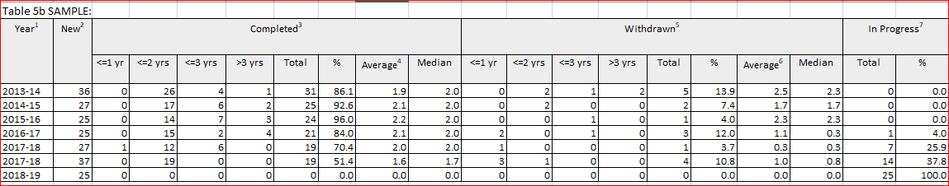

Table 6b: Graduate Student Complement, Withdrawals and Completions by Academic Year (Flow-Through Data)
Table 6b will be provided for year range 2015 to 2021.
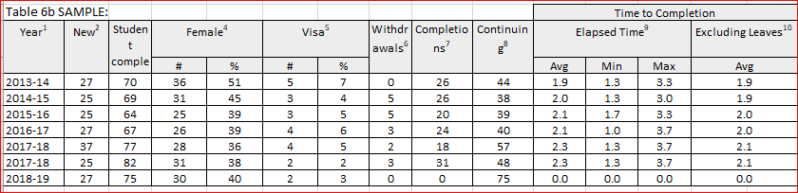

Table 6b(i): Graduate AAU Enrolment Distribution
Table 6b(i) will be provided for year range 2015 to 2021.
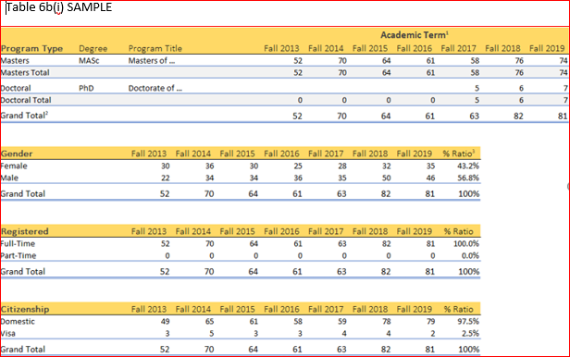

B.2.2.e Graduate Enrolment Profile
Using the Section Prompts below, discuss the graduate enrolment profile (gender, Citizenship, etc.) in the programs.

Tables 5b and 6b are also to be used to facilitate discussion for this section.

GRADUATE PROGRAMS:
Assess the distribution of students among programs in the department:
[INSERT COMMENT HERE]

Comment on the provenance of students enrolled in each program and proportion of students:
[INSERT COMMENT HERE]

Assess enrolment by gender and comment:
[INSERT COMMENT HERE]

Assess the proportion of international students and comment:
[INSERT COMMENT HERE]

B.2.2.f Graduate Projected Enrolment

Using the Section Prompts, discuss trends in admissions, transfers, enrolment, and retention in the program, as well as any future initiatives that may impact graduate enrolment.

Table 7b is developed by the AAU and will facilitate discussion in this section. Table 7b must be included for all programs offered by the AAU that are under review.

Briefly comment on whether enrolment targets from previous review have been met and discuss trends in admissions, transfers, enrolment and retention in the program:
[INSERT COMMENT HERE]

Provide comment on projected intake and enrolments for the next seven years: intentions to grow, reduce or remain the same, as indicated in Table 7b:
[INSERT COMMENT HERE]

Indicate the magnitude and the reason for significant change in projected enrolment:
[INSERT COMMENT HERE]

Justify intentions to grow and explain and plans to sustain the growth:
[INSERT COMMENT HERE]

Table 7b: Graduate Projected Intake and Enrolments
Notes on Table 7b:
- Projections are required for ALL programs under review.
- Please adjust the table as needed (e.g. if program is only FT then delete PT section, etc.)
- Intake = number of New students to be admitted and registered for the first time in this academic year. Enrolment = total student complement for this academic year which includes Intake for this academic year plus number of students continuing from the previous academic year.
- You may review the intake and enrolment stats reported in Tables 5b and 6b as a starting point for your projections.
- Please clarify assumptions for your projections (completion times, attrition, etc.). For example, the following program completion times are assumed for the sample data: 2 years for Master’s fulltime, 3 years for Master’s part-time, and 4 years for PhD, minimal attrition. Insert a similar comment after the table.
- Add a comment on the projections in the table, e.g. according to the sample data in the table, a steady enrolment is projected for the doctoral program for the next 7 years. For the master’s program the projections are for steady enrolments in the first year and growth in fulltime admissions beginning in 2022/23.

PROJECTED INTAKE AND ENROLMENTS
Master’s (M) and Doctoral (D) Programs
YEAR | FULL-TIME |  |  |  | PART-TIME |  |  |  | TOTAL STUDENT COMPLEMENT  (FT+PT)
YEAR | Intake  (new students) |  | Student Complement  (total student complement = intake+continuing from previous year) |  | Intake  (new students) |  | Student Complement  (total student complement = intake+continuing from previous year)
YEAR | M | D | M | D | M | D | M | D | M | D
2021/22 | 5-10 | 3-5 | 10-20 | 12-20 | 7-10 | - | 21-30 | - | 31-50 | 12-20
2022/23 | 7-12 | 3-5 | 12-22 | 12-20 | 7-10 | - | 21-30 | - | 33-52 | 12-20
2023/24 | 7-12 | 3-5 | 14-24 | 12-20 | 7-10 | - | 21-30 | - | 35-54 | 12-20
2024/25 | 7-12 | 3-5 | 14-24 | 12-20 | 7-10 | - | 21-30 | - | 35-54 | 12-20
2025/26 | 10-15 | 3-5 | 17-27 | 12-20 | 7-10 | - | 21-30 | - | 38-57 | 12-20
2026/27 | 10-15 | 3-5 | 17-27 | 12-20 | 7-10 | - | 21-30 | - | 38-57 | 12-20
2027/28 | 10-15 | 3-5 | 17-27 | 12-20 | 7-10 | - | 21-30 | - | 38-57 | 12-20

GOVERNANCE

- Describe the governance structure of the AAU including Department Heads, Undergraduate and Graduate Committees, Subcommittees, etc.
- Describe the administrative and decision making structures of the AAU.

The purpose of this section is to provide assurance that the administrative structure in question allows for the successful delivery of the program. In this respect, account should cover the development and establishment of academic policies for programs, as well as more routine administrative matters, such as committee structures for processing applications, and for developing and submitting program and curriculum changes.

The committee(s) responsible for the assessment of learning outcomes, as outlined in Section B.1.1 (Undergraduate) and Section B.2.1 (Graduate) should also be noted.

[INSERT COMMENT HERE]

THE FACULTY

D.1 Faculty and Human Resources

a. Faculty Complement

Table 8 is developed by the AAU and will facilitate discussion in this section. Instructions for completing Table 8 are included below.

Using the Section Prompts below to complete this section: Identify and provide comment and analysis on the faculty appointed to the unit or program(s) under review.

Comment on any changes in Faculty Composition since previous review (last 7 years):
[INSERT COMMENT HERE]

Comment on core faculty facilitation of the AAU programs, specializations and graduate fields of study:
[INSERT COMMENT HERE]

Reference the number of anticipated retirements and possible future appointments:
[INSERT COMMENT HERE]

Discuss the mentoring of junior faculty and/or postdoctoral fellows:
[INSERT COMMENT HERE]

Discuss Joint or Hybrid Appointments:
[INSERT COMMENT HERE]

Discuss Cross-Appointments:
[INSERT COMMENT HERE]

Discuss Adjunct, Clinical and Faculty from Other Universities:
[INSERT COMMENT HERE]

Discuss any joint research, shared teaching or courses, etc.
[INSERT COMMENT HERE]

- Table 8 should reflect the current faculty complement in the AAU (i.e. as of the end of the reporting cycle)
- CVs will be required for all faculty members listed in Table 8, including for faculty members from other AAUs who are contributing to the core curriculum, e.g. teaching required courses in the programs under review, supervising or co-supervising student’s research, etc.
- The last three columns of the table (“Program/Field A”, etc.) should be adjusted to reflect the AAU’s specific program(s) and field(s) structure – see comment #3 after the table.

Table 8: Faculty Members by Field/Program (created by the AAU):
Faculty Name & Rank (alphabetical) | M/F | Home Unit¹ | Supervisory  Privileges ² | programs and/or graduate program fields Affiliation³
Category 1: Tenured Professors teaching exclusively in this AAU |  |  |  | Program/Field A | Program/Field B | Field C
e.g. Adams, Lionel Assistant Professor | M |  | Full | X |  | x
Category 2: Tenure-track Professors teaching exclusively in this AAU
Category 3: Ancillary Academic Staff such as Learning Specialists Positions
Category 4: Sessional lecturers (list here any sessional lecturer positions that were introduced in the 2011 WUFA collective agreement)
Category 5: Limited-term Appointments teaching exclusively in this AAU
Category 6: Tenure or tenure-track or LTA professors involved in teaching and/or supervision in other AAUs, in addition to being a member of the program under review
Category 7: Sessional instructors and other non-tenure track faculty
Category 8: Others
¹ This is the budget unit paying the salary: department, school, research centre or institute, or other.
² for graduate programs only, indicate the level of supervisory privileges at the graduate level held by each faculty member, i.e. full or affiliate graduate faculty designation
³ Identify all the AAU’s programs in which the instructor teaches or supervises. For graduate programs indicate also the faculty member’s affiliation to the OCGS-approved fields in the graduate program(s).

b. Faculty Administration
- For the AAU as well as at the program level, please provide a summary of administrative support (Undergrad, graduate coordinators, etc)
- List University personnel external to the department who contribute to the academic quality of each program under review (e.g. integrated librarian support, Educational Development Centre, Centre for Career Education, etc.).

Comment and analysis should be provided on information obtained through surveys and/or focus groups where students are asked to comment on their level of satisfaction with the services provided by support and technical staff.

[INSERT COMMENT HERE]

c. Impact of Human Resources on Student Learning Outcomes and Degree Programs

- Assess course and supervision availability.
- Identify barriers to program completion or student success related to course offering schedule and teaching and supervision load distributions.
- Identify effective and innovative solutions to course access problems that have been implemented.
- Assess the impact of faculty research on student learning and educational programming.
- Assess the impact of service contributions on program success, sustainability and growth, as well as challenges involved in this area.
[INSERT COMMENT HERE]

D.2 Faculty research funding

[INSERT COMMENT HERE]
- Provide comment on research activities of the faculty associated with the program and describe the major funded research projects currently underway in the department.
- Provide comment on the manner in which faculty research funding supports student learning (i.e. through research assistantships, opportunities to co-publish, integration of research and teaching)
- The discussion should also consider the manner in which the profile of faculty research supports the delivery of academic programs and the quality and outcomes of graduate and undergraduate student involvement in funded research.

While this issue is clearly of importance at the graduate level, it should not be ignored at the undergraduate level. It may, for example, be of relevance to the manner in which existing undergraduate programs integrate research and teaching at the undergraduate level.

D.3 Faculty record of scholarly activity
Table 9: Scholarly and Creative Activity (lifetime count) will be provided by Quality Assurance office following finalization of Faculty CVs.

Table 9: Scholarly and Creative Activity
Scholarly and Creative Activity
SCHOLARLY ACTIVITY
Books Authored
Books Edited
Books Translated
Chapters in Books
Book Reviews
Books - Other
Abstracts in Professional Journals
Articles in Refereed/Peer Reviewed Journals
Chapters in Books
Edited Journals
Review Journals
Articles in Professional Journals
Articles Translated
Articles in Refereed/Peer-Reviewed Conference, Symposia.
Roundtable, Proceedings and Publications
Articles in Non Refereed Conference, Symposia, Roundtable
Proceedings or Publications
Articles and/or Papers Presented (Posters Presented)
Articles Submitted for Peer Review
Non Refereed Articles
Non Refereed/ Non Peer-Reviewed Publications
Commissioned Research Reports
Contract Research Reports
Technical Reports
Edited Conference Proceedings
Other Research Presentations
Others
Patents
CREATIVE ACTIVITY
Dramatic Art
Music (Composition)
Music (Directing/Conducting)
Music (Artistic Direction)
Music (Performance)
Communication Studies (Film, Video and New Media)

D.4 Distribution of Thesis Supervision
[INSERT COMMENT HERE]
PROVIDE COMMENT AND ANALYSIS:
- On the distribution of thesis supervisions of faculty appointed to the unit or program in question. Discussion should include comment on supervisions of undergraduate honours students, master’s students, doctoral students and postdoctoral fellows both in and outside of the program.
- Comment and analysis should discuss the pattern of distribution of the supervisory load across the core faculty, together with any challenges for the delivery of programs that this presents. Attention should be paid to distribution for master’s and doctoral supervisions across senior and junior core faculty.
- Provide comment on how students find a faculty supervisor.

Table 10 will be made available by the QA Office, after the faculty CVs have been finalized.

Table 10: Completed (Career) and Current Numbers of Thesis Supervisions by Faculty Members
 | Completed |  |  |  | Current
Faculty Member¹ | Undergrad | Master’s | PhD | PDF² | Undergrad | Master’s | PhD | PDF
Category 1: Tenured Professors teaching exclusively in this AAU
Adams, Lionel
Clark, Timothy
…
Category 2: Tenure-track Professors teaching exclusively in this AAU
….
Professor X |  | 1(5) | 3(10) | 6 |  | 1(5) | 0(3) | 2
Etc.
- Faculty members are listed under the categories specified in the Table 8.
- Figures reported in Table 10 should match supervision figures reported in each faculty CV.

D.5 Teaching Assignments
This section will identify graduate and undergraduate courses taught by each faculty member. Comment and analysis on these and other topics can build on discussions begun in section D.1.

PROVIDE COMMENT AND ANALYSIS:
- On the distribution of teaching assignments. The focus of this narrative can be on the distribution:
    - between required and optional courses;
    - across year levels;
    - across areas of individual faculty specializations;
    - between graduate and undergraduate programs.
- Explain what constitutes a normal teaching assignment and reasons for major discrepancies.
- Explain special course-relief and related policies, e.g. ‘the supervision of graduate theses is recognized in the teaching assignments in accordance with a formula’ (specify). Explain the impact such policies have on the program.

Data will be provided by the Quality Assurance office with instructions for the creation of Tables 11 (a-d) for the past four years (current review year and the preceding three academic years).
Faculty members in Tables 11 (a-d) should be listed in the same order as they are presented in Table 8 from section D.1, using the same category subheadings.
UNDERGRADUATE PROGRAMS:

[INSERT COMMENT HERE]

GRADUATE PROGRAMS:

[INSERT COMMENT HERE]
Table 11 (a) to (d) Teaching Assignments for past 4 years
SAMPLE TABLE 11a: Teaching Assignments for 2021/22¹
Faculty Member & Rank ² | Undergraduate (course number, name, semester taught, enrolment)³ | Graduate (course number, name, semester taught, enrolment) | Comments⁴
Category 1 : Tenured Professors teaching exclusively in this AAU
Adams, Lionel  Associate Professor | [For each course list the course number & name, semester taught and enrolment – see footnote #3], e.g. :  02-48-100 – Introduction to Psychology; F13 ; enrolment: 120 (3 cr)⁴ | 02-24-504 (3cr) | Dept. Chair
Watanabe, Miyako  Professor | 02-48-330- Course Title & enr.(3 cr)  02-24-245- Course Title & enr.(3 cr)  02-48-345- Course Title (3 cr) | 02-48-510 (3cr)
Category 2: Tenure-track Professors teaching exclusively in this AAU
Weller, Peter  Assistant Professor | 02-48-162 – Course Title (3cr) |  | Sabbatical (0.5 year) – reduced responsibility

TABLE 11b: Teaching Assignments for 2020/21¹
Faculty Member & Rank ² | Undergrauate (course number, name, semester taught, enrolment)³ | Graduate (course number, name, semester taught, enrolment) | Comments⁴
Category 1 : Tenured Professors teaching exclusively in this AAU
Adams, Lionel  Associate Professor | 02-48-100 – Course Title (3 cr)⁴ | 02-24-504 (3cr) | Sabbatical
Watanabe, Miyako  Professor | 02-24-245- Course Title-(3 cr)  02-48-345- Course Title (3 cr) | 02-48-510 (3cr)
Category 2: Tenure-track Professors teaching exclusively in this AAU
Etc.

TABLE 11c: Teaching Assignments for 2019/20 ¹
Faculty Member & Rank ² | Undergraduate (course number, name, semester taught, enrolment)³ | Graduate (course number, name, semester taught, enrolment) | Comments⁴
Category 1 : Tenured Professors teaching exclusively in this AAU
Adams, Lionel  Associate Professor | 02-48-100 – Course Title (3 cr)⁴ | 02-24-504 (3cr)
Watanabe, Miyako  Professor | 02-48-330- Course Title (3 cr) | 02-48-510 (3cr) | Admin. leave
Category 2: Tenure-track Professors teaching exclusively in this AAU
Etc.

TABLE 11d: Teaching Assignments for 2018/19¹
Faculty Member & Rank ² | Undergraduate (course number, name, semester taught, enrolment)³ | Graduate (course number, name, semester taught, enrolment) | Comments
Category 1 : Tenured Professors teaching exclusively in this AAU
Adams, Lionel  Associate Professor | 02-48-100 – Course Title (3 cr)⁴ | 02-24-504 (3cr) | Dept. Chair
Watanabe, Miyako  Professor | 02-48-330- Course Title (3 cr) | 02-48-510 (3cr)
Category 2: Tenure-track Professors teaching exclusively in this AAU
Etc.
¹ the raw data provided by the IQAP office needs to be split into separate tables for each of the four years preceding the review: Table 11a – Year 1, Table 11b – Year 2, Table 11c – Year 3, Table 11d – Year 4. These lists identify courses by their formally identified primary instructors. If the data does not accurately represent teaching assignments in your AAU, please comment in the Comments section regarding normal teaching assignments and reasons for major discrepancies.
² Follow same faculty categories as in Table 8.
³ List course number, course name, term taught, and enrolment. Provide credit load for each course, and explain course value in a footnote appended to Table, i.e., 3 credits normally means 3 contact hours per week for one term.
⁴ Include notes regarding specifics of course load adjustments for professors. Indicate where there are secondary instructors (team-taught, etc.) associated with a course.

D.6 Contract Instructors: Permanent, Sessional, and Limited-term Faculty

- Provide comment and analysis on the contributions of and reliance on sessional instructors, non-core faculty (e.g. cross appointees, adjunct professors) and part-time faculty per year in the delivery of the program.
- Comment should reference the type of courses and the year levels at which sessional instructors teach and the strengths and challenges related to program delivery.
- Discussion should also include the categories of sessional instructors (distinguished research professors, adjunct professors, postdoctoral fellows, etc.)
- If courses are regularly offered by sessional instructors, describe the qualifications of instructors as well as their involvement in the academic and intellectual culture of the program, opportunities for professional development, etc.

Data will be provided by the Quality Assurance office with instructions for the creation of Table 12.
[INSERT COMMENT HERE]

Table 12: Proportion of Courses Taught by Permanent, Sessional and Limited-term Faculty
If both undergraduate and graduate programs are under review, please generate Table 12 separately for each program (e.g. “Table 12a – undergraduate courses” and “Table 12b – graduate courses”). Additionally, if some programs have substantial involvement of non-permanent (sessional) instructors it may be useful to provide data for such programs separately.
Year | Number of course sections taught by permanent faculty/AAS as learning specialists, and Sessional Lecturers | Number of course sections taught by sessional instructors | Number of course sections taught on overload by permanent faculty/AAS as learning specialists, and Sessional Lecturers | Number of course sections taught by limited term (contract) faculty/AAS as learning specialists, and Sessional Lecturers
2018/19
2019/20
2020/21
2021/22

D.7 Teaching Effectiveness

Document the quality of teaching in the unit following the prompts below.

Data may include a discussion on the following, with full data attached in appendices:
- Student and alumni survey data
- Student and alumni interview/focus group data
- NSSE and CGPSS

UNDERGRADUATE PROGRAMS:

Evidence and examples of innovation and effective teaching strategies employed at the individual or departmental level as well as in first-year and large classes:

[INSERT COMMENT HERE]
Summary of student evaluation of teaching data:
[INSERT COMMENT HERE]

List of Teaching Awards to Instructors:
[INSERT COMMENT HERE]

Evidence of guidance and development provided to TAs and GAs:
[INSERT COMMENT HERE]

How is teaching effectiveness addressed in renewal, tenure and promotion (RTP) criteria:
[INSERT COMMENT HERE]

GRADUATE PROGRAMS:

Evidence and examples of innovation and effective teaching strategies employed at the individual or departmental level as well as in first-year and large classes (incl. graduate seminar courses):
[INSERT COMMENT HERE]

Summary of student evaluation of teaching data:
[INSERT COMMENT HERE]

List of Teaching Awards to Instructors:
[INSERT COMMENT HERE]

Describe initiatives and programs intended to explicitly develop students’ professional skills
[INSERT COMMENT HERE]

Development provided to TAs and GAs:
[INSERT COMMENT HERE]

How is teaching effectiveness addressed in renewal, tenure and promotion (RTP) criteria:
[INSERT COMMENT HERE]

D.8 Discussion of Faculty Quality Indicators

Provide an Executive Level Summary on the Research, Service and Teaching Expertise of the faculty in the program.

Using the Section Prompts below, describe and analyse the structures and procedures within the unit for facilitating new initiatives in research, teaching and service.

Promotion of Research Excellence (incl. new faculty mentorship and grantsmanship):
[INSERT COMMENT HERE]

Facilitation and Distribution of Service by Faculty:
[INSERT COMMENT HERE]

Initiatives to Enhance Teaching Effectiveness (e.g. CTL workshops, AAU seminars on teaching, etc.):
[INSERT COMMENT HERE]

STUDENT EXPERIENCE

E.1 Student Orientation, Advising and Mentoring

- Provide comment on student orientation, advising and mentoring in the program.
- Provide comment on communication with students, such as website, handbooks, etc.
[INSERT COMMENT HERE]

E.2 Student Satisfaction

- Provide comment and analysis on student experience and satisfaction.
- Please include a summary of any survey/focus group results, indicating:
  - Response rate/number of participants
  - Common themes arising from results and/or comments, such as areas of program strength and opportunities for program improvement
- AAU and programs are encouraged to identify ways in which they believe levels of student satisfaction can be improved.
- In discussing student experience, AAUs should comment on formal and informal opportunities for students within the program and/or academic units, such as (but not limited to):
  - Student representation on committees;
  - Student societies/clubs;
  - Opportunities for students to present research projects;
  - Faculty and community presentations.
- Programs can request through the Quality Assurance office their NSSE (National Survey of Student Engagement) and CGPSS (Canadian Graduate and Professional Student Survey) data.
- Through the Quality Assurance office AAUs can request Expedited IQAP Ethics Board approval to conduct surveys specifically for IQAP purposes.

[INSERT COMMENT HERE]

E.3 Student Funding and Research (graduate programs only)

[INSERT COMMENT HERE]
- Provide comment and analysis on total student funding.
- Comment and analysis should include a discussion of the AAUs students’ success in external scholarships (e.g. OGS, SSHRC, NSERC, CIHR).
- Comment here on the number of students that have applied for, and received, conference travel funding.
- For course-work options, comment and analysis should focus on how students gain research experience in the program.

- Table 13 will be provided by the Quality Assurance Office in cut and paste format for facilitation in this discussion.
  - Comment on trends, and explain fluctuations in average funding included in the tables.

Table 13: Financial Support for Graduate Students (past 7 years)
Table 13 will be provided for year range 2015 to 2021.
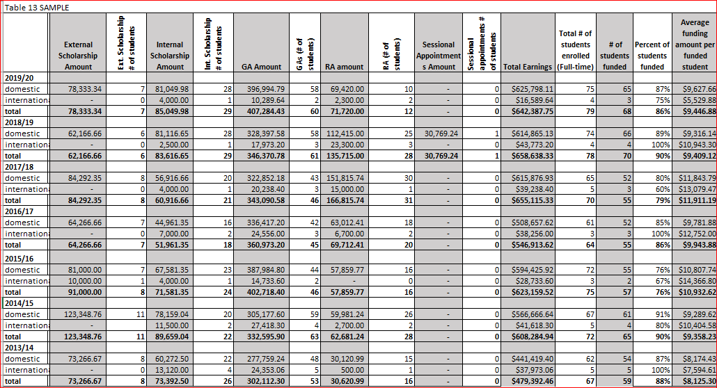
Financial support records are measured by fiscal year (May 1-April 30)
Number of students funded is a unique count of students who received at least one of the listed sources of funding at the graduate level in a fiscal year. Percent of students funded is calculated based on total number of full-time students enrolled.
Average funding per funded student = total earnings / total number of students funded.

E.4 Student Publications (Graduate Programs)

- Provide comment and analysis on students’ scholarly output in terms of peer-reviewed publications.
- Comment and analysis should focus on the encouragement, advice and support provided by the AAU’s or program’s core faculty to enable students to develop their list of publications.
[INSERT COMMENT HERE]

E.5 Career Paths of Graduates / Employment and Career Data of Program Graduates

- Provide comment and analysis on the expected career paths of graduates
- (Career paths can include entry into graduate and second entry programs as well as positions as postdoctoral fellows)
- Provide any data on employment data of graduates post-graduation.
[INSERT COMMENT HERE]

RESOURCES

F.1. Financial Resources

Internal Operating Funding
- Provide details in Table 14 about the operating funds (for the entire AAU) for the unit (excluding salaries) with breakdown of major budget categories.
- The suggested source for this data is the Year-End Budget Comparison Report that can be obtained from the UWinsite Financial system. Please contact your AAU financial administrator for more information.

Table 14: AAU Operating Funding
Table 14 -SAMPLE DATA
 | 2017/18 ² |  | 2018/19 |  | 2019/20 |  |  |  | 2020/21 |  | 2021/22
Departmental Base Budget (less salaries)¹ |  |  |  |  |  |  |  |  |  |  | $12,500
Budget Changes (describe below)³ |  |  |  |  |  |  |  |  |  |  | 4978
Total | $0 |  | $0 |  | $0 |  |  |  | $0 |  | $17,478
Expenditure Categories ⁴ | $ | % | $ | % | $ | % |  |  | $ | % | $ | %
Supplies |  |  |  |  | $0.00 |  |  |  | $0.00 |  | $5,229.00
General Office Supplies (8419) |  |  |  |  |  |  |  |  |  |  | $4,845.00 | 27.7%
Teaching Supplies (8439) |  |  |  |  |  |  |  |  |  |  | $384.00 | 2.2%
Lab Supplies (8440) |  |  |  |  |  |  |  |  |  |  |  | 0.0%
Miscellaneous | $0.00 |  | $0.00 |  | $0.00 |  |  |  | $0.00 |  | $6,722.00
Miscellaneous (8550) |  |  |  |  |  |  |  |  |  |  | $1,686.00 | 9.6%
Recruitment Expenses (8555) |  |  |  |  |  |  |  |  |  |  | $1,007.00 | 5.8%
Special Projects (8560) |  |  |  |  |  |  |  |  |  |  | $1,047.00 | 6.0%
Publicity and Advert. (8572) |  |  |  |  |  |  |  |  |  |  | $447.00 | 2.6%
Travel and Memberships (8749) |  |  |  |  |  |  |  |  |  |  | $2,535.00 | 14.5%
Rentals (8600) |  |  |  |  |  |  |  |  |  |  |  | 0.0%
Repairs (8620) |  |  |  |  |  |  |  |  |  |  |  | 0.0%
Cap. Acquisition & Revo. | $0.00 |  | $0.00 |  | $0.00 |  |  |  | $0.00 |  | $3,734.00
Equipment (8860) |  |  |  |  |  |  |  |  |  |  | $3,734.00 | 21.4%
Furniture ( 8850) |  |  |  |  |  |  |  |  |  |  |  | 0.0%
Renovations (8880) |  |  |  |  |  |  |  |  |  |  |  | 0.0%
One Time Allocations
One Time allocations (8894) |  |  |  |  |  |  |  |  |  |  |  | 0.0%
Fund Transfers
Fund Transfer (8975) |  |  |  |  |  |  |  |  |  |  | $450.00 | 2.6%
Other (describe below) |  |  |  |  |  |  |  |  |  |  |  | 0.0%
Total Expenditures (less salaries) |  |  |  |  |  |  |  |  |  |  | $16,135.00 | 92.3%
Remaining Budget |  |  |  |  |  |  |  |  |  |  | $1,343.00
Trust Funds & Endowments (if applicable) ⁵
Balance Beginning of Fiscal Year
Donations
Expenditures
Balance End of Fiscal Year | $0.00 |  | $0.00 |  | $0.00 |  |  |  | $0.00 |  | $0.00
1 Obtained from yearly Budget Comparison Reports, "Original Budget" column; excludes all staff, faculty, and students salaries
2 Fiscal year (April to March)
3 Includes all other forms of funding (external funds, program funds, infrastructure funds); can be found in the "Budget Changes" column of the Budget Comparison Report. Please footnote what these budget revisions include.
4 These are sample entries. Not all departments will have the same expenditure accounts. Please revise according to your budget comparison report.
5 Section can be extended to record multiple trust or endowment funds as necessary

External Operating Research Funding
- Provide details about the amount of funding available to support faculty research and potentially available to support graduate and/or undergraduate students’ work (through provision of stipends or materials for the conduct of research.)
- For this reason, grants for travel and publication awarded to faculty will not be included in table 15.
- Comment on the major differences among fields/programs
- Comment on reasons for increase/decrease in research funding, (e.g., granting council budget changes, increase/decrease in faculty, alternative sources of funding such as foundations, etc.)
- If appropriate, comment on infrastructure funding or other special funding that has an impact on the program. Provide relevant data.

- Table 15 will be generated by the Quality Assurance Office following completion of Faculty CVs, and is based on entries in the eCV “Grants” section of all faculty members listed in Table 8, “Faculty members by field/program”.

[INSERT COMMENT HERE]

Table 15: External Operating Research Funding by Source and Year
Table 15 will be provided for year range 2015 to 2021.
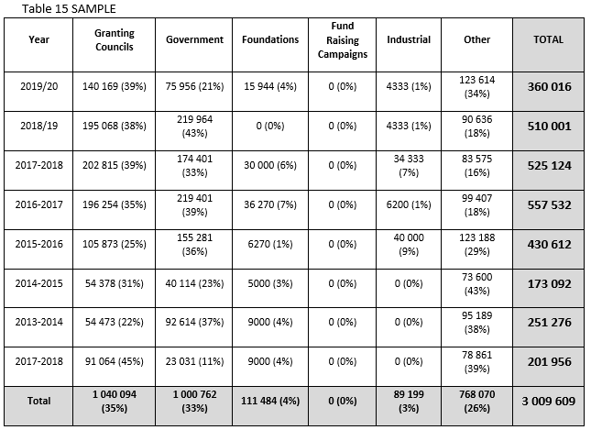
(An additional Table 15a will be provided by IQAP office only for graduate programs that have fields, and will be based on the field affiliation of faculty members, as indicated in Table 8 “Faculty Members by Field”; Table will be provided in cut and paste format after Faculty CVs are finalized)
Table 15(a): External Operating Research Funding by Graduate Field
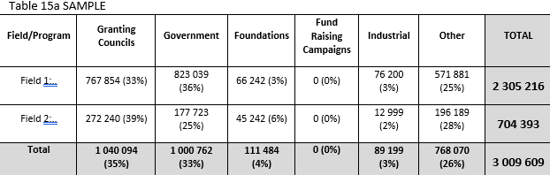

Discussion of Current Financial Resources

- Comment on the impact of current level of financial resources and their deployment, identifying potential opportunities for efficiencies and revenue streams.
- Identify effective and innovative solutions to resource problems that have been implemented.
- Include specific input describing the impact of the department’s financial resource allocation on each program.
[INSERT COMMENT HERE]

F.2. Human Resources

- For the AAU as well as at the program level, please provide a summary of administrative and staff support.
- Detail the contributions made to the program(s) by the support and technical staff and identify any challenges the AAU or program feels it faces in this regard.
- Describe the human resources currently dedicated to the department and its programs.
- Describe how those resources are currently deployed within the department to achieve the programs’ missions and goals.
- Assess the effectiveness of the department’s human resources deployment.
[INSERT COMMENT HERE]

F.3 Physical Resources

Library Resources/Report

[INSERT COMMENT HERE]
- Provide a description of the institution’s library resources, including unique resources on site and access that faculty and students have to other resources.
- Provide a brief summary of the University holdings pertinent to the fields, the collection policy and library expenditures for the last seven years.
- Discuss the strengths and challenges of the current library holdings.
- The detailed documentation on library holdings is to be attached in an Appendix.
- Provide a qualitative analysis of the collections against existing standards for the discipline, where these standards exist, is most useful.
- Explain special collections not listed in the library report.

Contact the administrative assistant to the University Librarian at the Leddy Library for the library report. You can find who your Librarian is using this link: https://leddy.uwindsor.ca/find-a-librarian

Computer equipment and laboratory facilities
[INSERT COMMENT HERE]
- List the major equipment available for use and commitments/plans for the next seven years.
- Describe anticipated developments.
- Describe laboratory/studio facilities that are used by students. Both on- and off-campus facilities should be described.
- Discuss the manner in which these facilities contribute to the delivery of the programs and the achievement of learning outcomes, together with any challenges faced by the AAU or program in this regard.

Space
[INSERT COMMENT HERE]
- Comment on the space utilized by the program, including faculty and student space.
- The AAU and programs should discuss both the positive aspects of the space they utilize, as well as the challenges they may face.
- Discuss the future commitments/plans ((e.g. relocation or space expansion) for the space for the next seven years.

Discussion of current physical resources
[INSERT COMMENT HERE]
- Comment on the impact of the program’s current level of physical resources and their deployment, identifying potential opportunities for efficiencies or access to alternative resources.
- Identify effective and innovative solutions to physical resource problems that have been implemented.

CONCLUSIONS AND RECOMMENDATIONS

Using the Section Prompts below, provide a high-level summary of the suggestions and recommendations for program improvement made in previous sections of the self-study.

Conclusions and Recommendations Must Include:
Elaborate on suggestions and recommendations, with timelines for their execution:
[INSERT COMMENT HERE]

Identify Areas of Strength:
[INSERT COMMENT HERE]

Identify areas that hold promise for enhancement:
[INSERT COMMENT HERE]

Identify areas noted in the Self-Study that require improvement:
[INSERT COMMENT HERE]

Assess the degree to which the program is fulfilling its objectives:
[INSERT COMMENT HERE]

You must include Identification of Challenges and/or Opportunities where the reviewers’ advice is sought:
[INSERT COMMENT HERE]

