WURA Fall General Meeting – Tuesday, December 03, 2024

PENSION REPORT:
- As Interest Rates over the past plan year were higher, our Pension Plan fund performance at June 30, 2024 decreased from a return of 12.58% the prior year to a return of 8.44%.

- As a result, the Faculty Retiree Money Purchase Component of pensions decreased/increased accordingly. The actual decrease/increase is the difference between the return and 6%, plus the mortality adjustment.

  - Pre-July 1, 2004, MPP pensions decreased by -1.14% (8.44% - 6% - 3.58%).

  - Post July 1, 2004, MPP pensions increased by 2.56% (8.44% - 6% + 0.12%)

Note: the difference between the pre and post 2004 groups is directly related to the mortality experience of each group.

  - MGB indexing adjustment of 2.00%
We saw increase in the CPI at June 30, 2024 which resulted in an increase of 2.00% to the Minimum Guaranteed Component (CPI increase was 3.11%, therefore the Plan provides that if the CPI increase is between 2% and 4%, the MGB indexing increase is capped at 2%)

- Retiree demographics over the past year
  - At June 30, 2024 there were 516 persons in receipt of a monthly pension.
  - 74 pensioners with no MGB subsidy required and 442 requiring a subsidy: 14.34% & 85.66%
  - After running the indexing process and picking up new July 1, 2024, retirees (6) we had 81 pensioners with an MPP that exceeded their MGB number, and 441 retirees who qualified for subsidy, for a total of 522. 15.52% & 84.48%.
  - While this shows a slight improvement in MP pensions, pensions are still impacted by the large negative fund return loss of -16.84% in the 2021 / 2022 plan year.
  - In the 2022/2023 year there were 28 retirements, compared to 18 in the prior year.

- The Annual Open Pension Meeting was held on November 26, 2024, through MS Teams for everyone. The presentation video is now posted on the Pensions website. The hardcopy presentation can be found at: Faculty and Employee Plans - Open Pension Meetings | Human Resources

- As of June 30, 2024, the one-year Pension Fund Return was 9.1%, September 30, 2024, is under the review.

- The University and the D2 Committee have been meeting to explore and learn more about the new University Pension Plan of Ontario. U of T, Guelph, Queens and Trent are now participating universities. Dr. Stebelsky is part of the committee and has been active in his questions and representation on behalf of the faculty retirees.

- Over the past year, our area, with wonderful support from finance (Rachel McRae) and legal (William Ma) embarked on a large project to update and restate both the Employees Retirement Plan Text (ERP) and the Faculty Plan Text (FCO). We are almost through ERP and have begun work on FCO. The work is done using a Phase I, II and restatement approach and will result in completely updated Plan texts by next Fall 2025. The last time the Plan Texts were updated was in 2003/2004.

BENEFITS REPORT:
For the upcoming Green Shield Benefits premium renewal for year 2025, WURA is reviewing benefits cost and summary to see if any changes need to be made. Brittany Rife is in contact with WURA to get all needed information to make the final decision about any further Benefits changes.

Current Faculty Retiree GS Premiums:
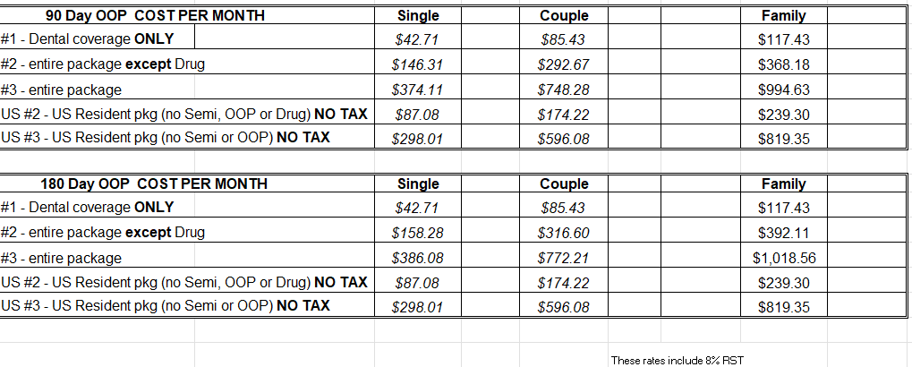
RETIREE HEALTH CARE SUBSIDY:
At April 30, 2024 the Fund held a total of $5,999,762 and the Expendable held a total of $1,046,747 for a
total of $7,146,509. This resulted in a health care subsidy of $64.85 per year of pension service.
Example: with 30 years pension service = $162.13 per month subsidy
Example: with 35 years pension service = $189.15 per month subsidy

As of May 24, 2024, there was an amendment made to the Retiree Healthcare Subside Agreement that was agreed up by both WURA and WUFA to align the investment of the healthcare subsidy and the administration of the expendable account with the endowment investment Statement of Investment Policies monitored by the Investment Committee. The fund will be administered in the same way as our regular endowment funds including a growth and protection fund. Annual reporting will remain the same with the amount of the annual premium being notified to members and calculated the same

