University of Windsor

Faculty Handbook

Student Accessibility Services
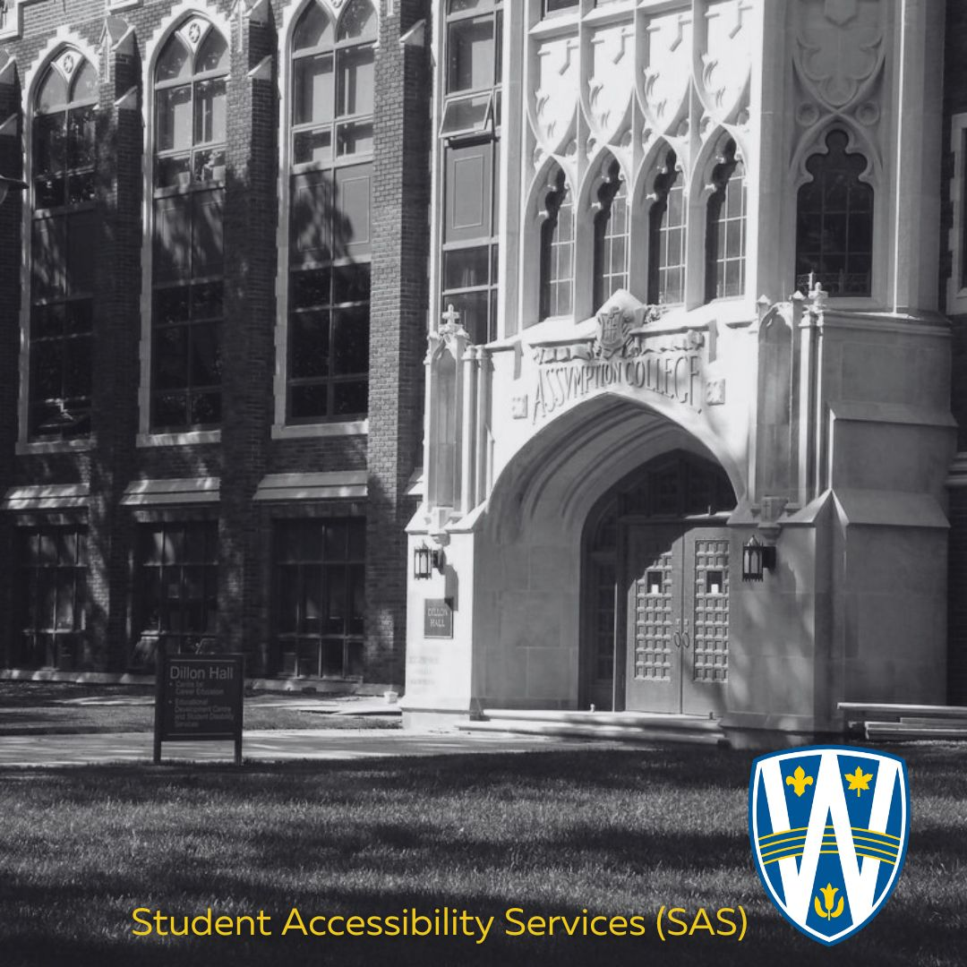
Welcome to the Faculty Handbook for Student Accessibility Services.
At the Student Accessibility Services (SAS) Office, we believe that accessibility is a shared responsibility and a cornerstone of inclusive education. This handbook is designed to support faculty in understanding the accommodation process and the vital role instructors play in ensuring equitable access to learning for all students.
Our office partners with faculty to implement academic accommodations that remove barriers and promote student success. Together, we work to uphold the principles of fairness, respect, and academic integrity while meeting the diverse needs of our student population.

Inside this handbook, you’ll find practical guidance, answers to frequently asked questions, and resources to help you navigate accommodation requests with confidence and clarity. Whether you're new to accessibility practices or looking to deepen your understanding, we’re here to support you every step of the way.

Thank you for your commitment to creating a learning environment where all students can thrive.

University of Windsor Guidelines 3
Accommodations 4
Essential Requirements 4
Privacy and Confidentiality 4
What Student Accessibility Services Provides 5
Types of Accommodation 5
Classroom Accommodation 6
Exam Accommodation 6
Roles and Responsibilities: Who Does What? 6
Instructor 7
Change of Exam Form Process 9
Frequently Asked Questions 9
General 9
What should I do if I think a student has a disability? 9
What should I do if a student brings an animal to class? 9
What do I do if I disagree with the recommended accommodations? 9
Design and Planning 9
How can I create a more accessible learning environment? 9
Delivery 9
What is an Accommodation Letter? 10
What information can I share about a student’s needs with a TA/GA? 10
Evaluation and Assessment 10
What is my role in the test and exam process for students with accommodations? 10
What is my role with the Change of Exam Form? 10
What should I do when a student asks for an extension on an assignment or other work to be submitted for evaluation? 11
How do I handle requests for alternatives from class participation? 11
What does “may miss or be late to class for disability related reasons” mean? 11
What do I do if a student makes a request for a Memory Aid/Formula Sheet 11
What happens if a student is not meeting academic expectations? 11
What security features are in SAS to ensure my exam will remain safe? 11

University of Windsor Guidelines
The University of Windsor is committed to creating an inclusive teaching and learning environment that aligns with provincial guidelines for academic accommodations. For more information about academic accommodations, please review the Senate Policy located here:
Policy on Academic Accommodations: UWindsor Senate

Accommodations
Academic accommodations are provided when students experience disability-related barriers in demonstrating their knowledge and skills. Accommodation provides equitable access for students with disabilities to meet the academic requirements of their program. It is also possible for a student to have a disability and not require accommodation. Graduate students and second-entry professional students may require unique academic accommodation due to their personalized research and/or field work/practicum or other licensing requirements.

Essential Requirements
The provision of accommodation will not change the essential requirements of a course of program curricula.
“An appropriate accommodation enables a student to successfully meet the essential requirements of the program, with no alteration in standards or outcomes, although the manner in which the student demonstrates mastery, knowledge and skills may be altered.”
Policy on Accessible Education - OHRC
Instructors play a key role in the accommodation process by communicating what a student must know and demonstrate. When necessary, instructors assist with problem-solving based on their academic expertise. Students receiving academic accommodations are expected to demonstrate the same knowledge and skill development as their peers.

Privacy and Confidentiality
A student’s specific diagnosis is private medical information under Human Rights Code guidelines. Under no circumstances should you ask a student to disclose this information.
While some students are willing to talk about their disability, many others might be reluctant to do so. You can ask about the functional limitations that impact their education.

What Student Accessibility Services Provides
- Review of the student’s medical documentation and functional limitations to determine if academic accommodation is needed
- A place for students to discuss their disability-related needs in a safe place and to problem-solve with an advisor
- The development of an effective accommodation plan and Faculty Notification Letter (FNL)
- Ongoing support and problem-solving for disability-related challenges that impact a student’s academic and co-curricular experiences (this frequently requires the cooperation of instructors and staff)
- Access to financial support (Student Awards)
- Access to adaptive furniture, equipment, and software
- Coordination of specialized services such as sign language interpreting
- Learning Strategy, Assistive Technology and ADHD Coaching support
- Workshops on how to be a student in a post-secondary environment with a disability
- Exam space for students with exam accommodations
- Support for faculty who have questions about how to best support a student
- Support for faculty using our AIM system

Types of Accommodation
Accommodations are intended to reduce the impact the disability has on a student’s academic performance. They exist to create an equitable environment to overcome functional limitations.

Classroom Accommodation
Some examples include (but are not limited to):
- Extensions on assignments/papers
- Accessible materials in alternative formats (e.g., braille, large print, digitized, voice activated software, assistive listening devices)
- Alternate means to capture course content/lectures Recording Policy and Syllabus Statement and Microsoft Word - Recording of Lectures (Approved 200214).docx
- Sign language interpretation, note taking

Exam Accommodation
Some examples include:
- Writing within the SAS Exam space (distraction reduced, extra time, breaks)
- Specialized software
- Memory Aids or Formula Sheets

Roles and Responsibilities: Who Does What?
Students, staff, and faculty all have responsibilities in the accommodation process and in creating an accessible environment. Each party brings an important perspective: the student has a unique and personal knowledge of their disability, the faculty has course content knowledge and an understanding of the required outcomes, and the advisor has a broad-based knowledge of disabilities and their impact on academic performance.

Instructor
- Provides accommodations as outlined in the Faculty Notification Letter (FNL) as appropriate, and collaborates with the Accessibility Advisor and student to find solutions if challenges arise
- Complete the Alternative Testing Agreement in AIM when requested within the time frames posted on the website
- Upload the exam to the AIM database at least 48 hours prior to the exam.
- Directs students to register with SAS if an accommodation request is made unaccompanied by a Faculty Notification Letter.
- Makes every effort to use Universal Design for Learning Universal Design for Learning (UDL) for Inclusion, Diversity, Equity, and Accessibility (IDEA) (ecampusontario.ca) in the course outcomes
- Provides clear and concise information in the course syllabus about course policies regarding accommodation Syllabus Statement | Student Accessibility Services (uwindsor.ca)
- Approves the Memory Aid and then uploads the approved Memory Aid to the AIM database Memory Aid Information 2026
- Approves the Formula Sheet and then uploads the approved Formula Sheet to the AIM database Formula Sheet Information 2026

Change of Exam Form Process

Frequently Asked Questions

General

What should I do if I think a student has a disability?
Encourage them to fill out an Intake Questionnaire to start the process of being registered with SAS.

What should I do if a student brings an animal to class?
Service Animals | Office of Human Rights, Conflict Resolution and Mediation

What do I do if I disagree with the recommended accommodations?
SAS supports both instructors and students in the negotiating process. If you have questions about the accommodation, contact the student's Accessibility Advisor. Accessibility is a collaborative process that requires everyone to take responsibility.

Design and Planning

How can I create a more accessible learning environment?
Create a section in your syllabus about accommodations and accessibility (UWindsor Syllabus Statement on Accommodation ), and clearly state the knowledge and skills students need to know and demonstrate in your course. A statement in your syllabus can signal your openness and invite students to contact you. You can also implement different Universal Designs for Learning (Universal Design for Learning (Ecampus Ontario)).

Delivery

What is an Accommodation Letter?
An Accommodation Letter informs an instructor that the student has registered with SAS. It may contain classroom, and/or exam accommodations to help support the student.

What information can I share about a student’s needs with a TA/GA?
It is important to ensure the confidentiality of a student is maintained, especially in classroom or casual conversations. There is never a time when you should share a diagnosis with anyone. In most cases as an instructor, you will not have that information, but if a student decides to share it with you, it needs to stay with you.

Evaluation and Assessment

What is my role in the test and exam process for students with accommodations?
Tests and exam accommodations are frequently required, and students must schedule all in-person tests and exams in AIM within the required timeline to write with SAS. Once the student schedules the exam, our AIM system will notify you that SAS students is writing and exam in SAS. You will be required to complete the alternative testing agreement and upload the exam in AIM at least 48 hours (2 days) in advance of the assigned writing date and time.

What is my role with the Change of Exam Form?
The student will need to have an accommodation outlining the need for a change of exam. If the student is unwell and that is outside of the functional limitation, then medical documentation will be needed. Please consult with the Accessibility Advisor if there is any concern as to why the student is making the request for an alternative date for the exam.
- The student will contact the instructor to see if the instructor can accommodate the student.
- If the instructor cannot accommodate, contact exam@uwindsor.ca to obtain the Change of Exam Approval form and you will be provided with available dates/times to reschedule to have the student write in SAS.
- The student will contact the instructor to find out the new date and time.
- The instructor will then sign and send the completed Change of Exam form to exam@uwindsor.ca

What should I do when a student asks for an extension on an assignment or other work to be submitted for evaluation?
Negotiate with the student to find an appropriate date to complete the work, being mindful of the University’s deadlines and policies. In most cases, students are granted up to a 7-day extension.

How do I handle requests for alternatives from class participation?
Clarify how participation may be an essential academic requirement of our course and negotiate viable alternatives early in the course to prevent misunderstanding at the end of the term. Contact the Accessibility Advisor to discuss options if needed.

What does “may miss or be late to class for disability related reasons” mean?
Although there is an expectation that students will attend most classes, this statement informs you that the student may need to miss class because of their medical condition. They should not lose attendance marks, and these should be re-weighted somewhere else for this student.

What do I do if a student makes a request for a Memory Aid/Formula Sheet
Timelines for Memory Aids and Formula Sheets
If you have questions about this process, contact the Advisor at the bottom of the students' Faculty Notification Letter.

What happens if a student is not meeting academic expectations?
Appropriate accommodation should not lead to diminished academic expectations. Contact the student’s Accessibility Advisor if the student is in academic jeopardy, as this may indicate that the accommodation needs to be renegotiated, or the student may benefit from other campus supports and resources.

What security features are in SAS to ensure my exam will remain safe?
SAS follows the University of Windsor Senate Policy on Academic Integrity. Among other security features and processes employed by SAS, it has:
- 2 security cameras (maintained 24/7 by Campus Special Constables)
- A locked storage room accessible only to professional staff
- Cameras to monitor all group exam rooms
- Computers without internet access
- Capable and specifically trained proctors overseen by a professional staff member

