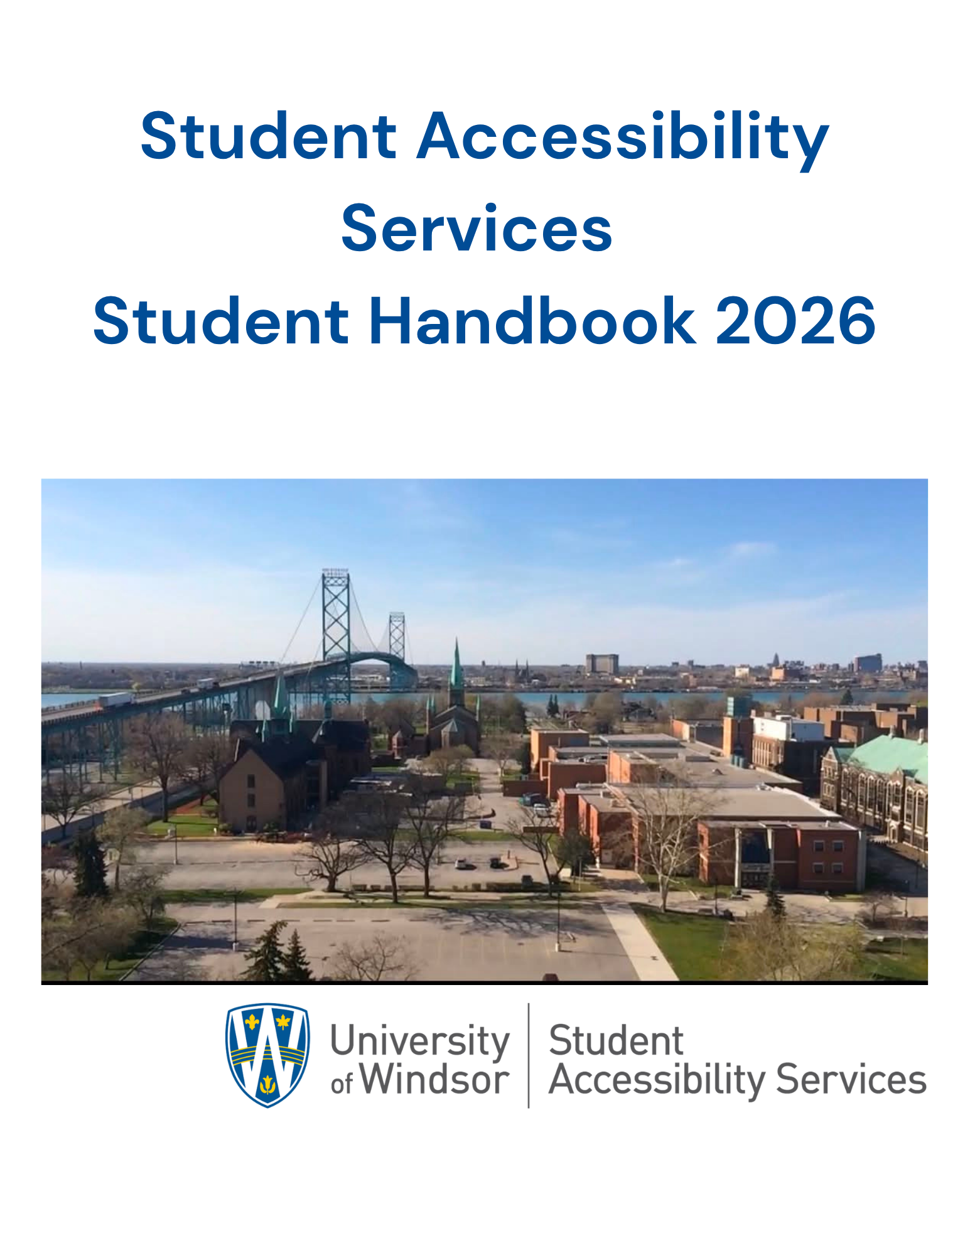
Who are We 1
Student Rights and Responsibilities 2
Rights 3
Responsibility 3
Respect 4
Proctors and Exam Invigilators 4
Exams for Students Registered with SAS 5
Deadlines 5
Change of Exam Process 5
Image: Reasons for a change of exam form 6
Change of Exam Process for Students 6
When can I request a change of exam?: 6
Process 7
Change of Exam Process for Faculty 7
A student can request a change of exam when: 7
Process 7
Change of Exam Process for the SAS Exam Team 8
When a student can request a change of exam: 8
Process 8
Dispute Resolution Process 8
Procedure Statement: 8
Purpose: 9
Procedure: 9
Informal Dispute Resolution Process: 9
Dispute of Accommodations vs. Essential Elements of Courses Process: 9
Internal Escalation within SAS 10
University Dispute Resources: 10
Exam Incidents 10
Music Accommodation 11
Rationale 12
Procedure 12

Who are We

Student Accessibility Services (SAS) is committed to fostering accessible and inclusive learning environments for students with disabilities. Our office is staffed with dedicated professionals who provide comprehensive support and resources to facilitate the accommodation and exam process. In alignment with the standards set forth by the Accessibility for Ontarians with Disabilities Act (AODA), as well as the Postsecondary Education Standards, we strive to ensure equitable access to education and promote full participation in academic life.
Our office assists students with disabilities by facilitation access to reasonable accommodations, promoting self-advocacy, and collaborating with faculty and staff to ensure equitable access to learning. Whether you are new to the accommodation process or seeking continued support, we are here to help you navigate each step with confidence.
The SAS office is dedicated to ensuring that all individuals are treated with dignity and respect.
We encourage you to reach out to our team with any questions or concerns.
Location: Dillon Hall, Room 117
Phone: 519-253-3000 ext. 6172
Email: sas@uwindsor.ca
Website: www.uwindsor.ca/sas

Student Rights and Responsibilities

Rights
- Equal access to courses, programs, services, jobs, activities, and facilities available through the University of Windsor.
- Reasonable and appropriate accommodations, intended to eliminate disability-related barriers while maintaining the fundamental requirements of the course. In contrast, modifications alter the delivery of the course or its academic expectations, which falls outside the purview of Student Accessibility Services.
- Confidentiality of all information pertaining to the condition(s) with the choice of whom to disclose disability-specific information to, except as required by law.
- Information available in accessible formats.
- File a formal grievance through the Office of Human Rights, Conflict Resolution and Mediation (OHRCRM) due to disability discrimination, including the failure to provide reasonable accommodations, and/or discrimination or harassment based on a disability.

Responsibility
- Meet the university’s qualifications and essential technical, academic, and institutional standards, including the Student Code of Conduct.
- Follow the Senate Policy on Conduct of Exams and Tests.
- Follow Bylaw 33: Student Rights and Freedoms
- Identify oneself as an individual with a disability to SAS when seeking accommodation(s).
- Request accommodations each semester in AIM.
- Provide documentation from a registered medical professional the verifies functional limitations, and the need for specific accommodations.
- Participate respectfully in a collaborative process with SAS staff, faculty and other university resources as indicated to obtain and coordinate reasonable and appropriate accommodations.

Respect
Student Accessibility Services is committed to maintaining a safe, healthy, secure, and respectful environment for all staff, students, faculty and visitors. In alignments with the institutional Policy on Code of Conduct. Any form of abuse is strictly prohibited.
- Verbal abuse, including the use of threatening or intimidating language
- Actions or attempted actions that result in or have the potential to cause harm
- Physical or sexual assault, of any kind

Proctors and Exam Invigilators
Proctors and Exam Invigilators are responsible for invigilating tests, quizzes and exams that are being written in SAS.
They are responsible for:
- Verifying the identity of the test taker to ensure the right person is taking the exam
- Setting up the exam room to provide the assigned accommodations
- Distributing and collecting all exam materials
- Observing students writing to maintain exam integrity
- Handling any technical issues that arise
- Reporting irregularities or suspicious activities to the Exam Administrator or Coordinator
- Maintaining all exam-related documentation, including cover sheets, break forms, sign-in/sign-out logs, and accurate records of exam start and end times
They are not responsible for:
- Discussing your exam with you or answering any exam related questions
- Determining which accommodations are appropriate for you
- Making decisions about your ability to write the exam

Exams for Students Registered with SAS
To schedule any test, quiz, midterm or final exam you must register with our office by Requesting your Accommodations through AIM at the beginning of each semester. If you do not request your accommodations, you will not be able to schedule any assessment.

Deadlines
Tests, quizzes, and midterms must be scheduled at least 14 days prior to the scheduled assessment.
Final exams must be scheduled 14 days prior to the start of the final exam period. All deadline dates are posted in the office, on the website, in AIM, and emailed to students in advance. Final exam schedules are posted after the reading breaks each semester.
How to schedule in AIM

Change of Exam Process
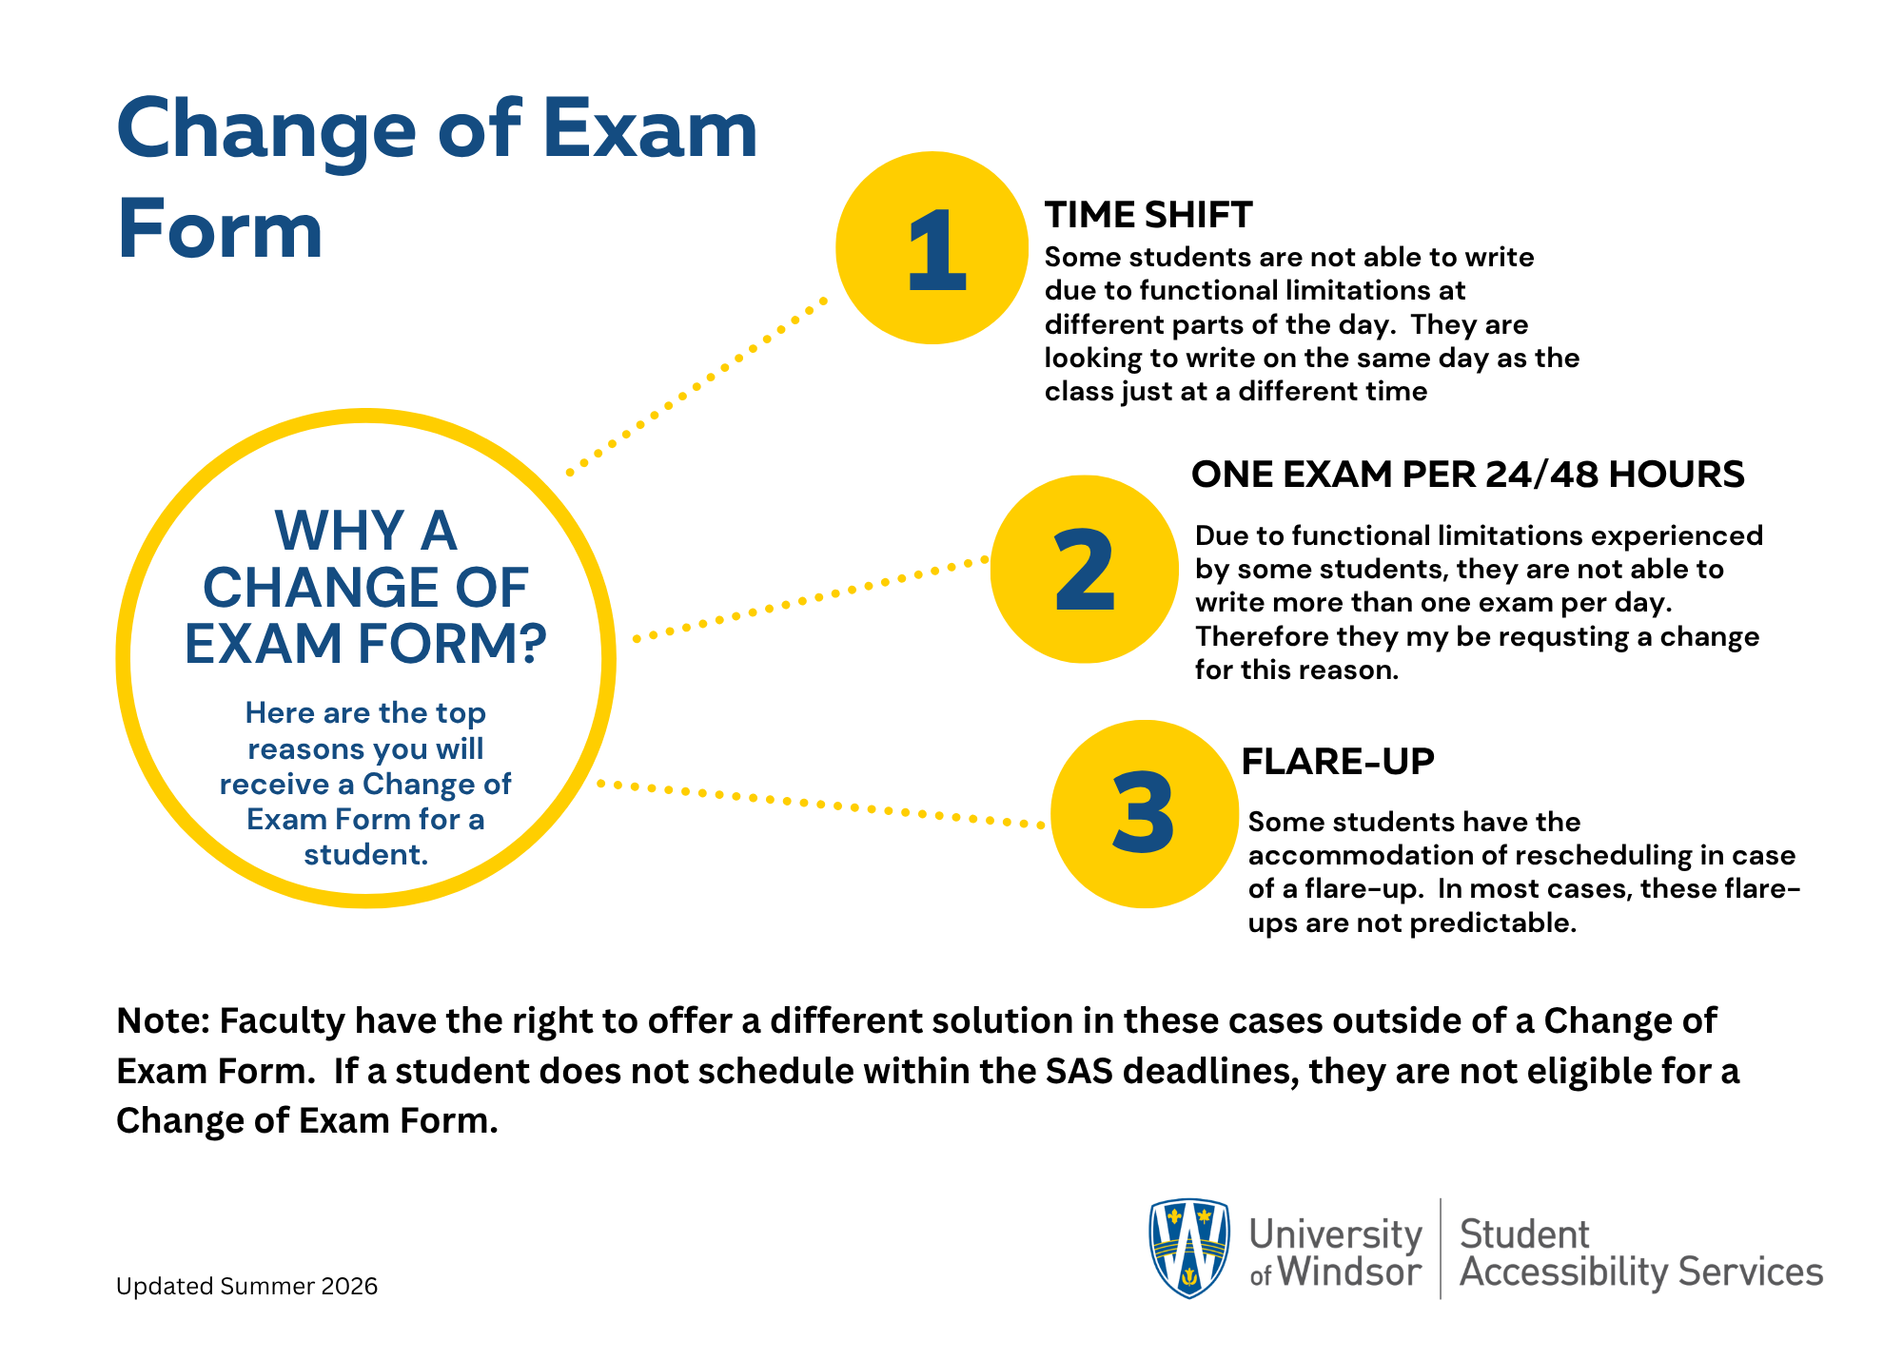

Image: Reasons for a change of exam form

Change of Exam Process for Students

When can I request a change of exam?:
- I have already scheduled all my assessment in AIM as they are in the syllabus or UWinsite Student.
- I have a “Time Shift” accommodation
- I have “One exam per 24/48 hour” accommodation
- I have” May need to reschedule due to flare ups” accommodation
If you are registered with SAS and become ill outside of the functional limitations of your disability, then you will need to follow the "missed exam procedure" through your faculty.
Student Accessibility Services cannot guarantee a professor will grant the request to reschedule; they may re-weight or come up with another equitable solution that they deem suitable under Universal Design for Learning.

Process
- Schedule ALL in-person exams in AIM as they appear in your syllabus/UWinsite by the SAS deadline dates.
- Request a Change of Exam Form from exam@uwindsor.ca. In the email outline the reason for the change as per your accommodations. Please be sure to cc your instructor on the request to the Exam Team.
- The exam team will send you the next available dates that you can choose from for the re-schedule. You will email the exam team back with your choice.
- The exam team will then email the form to your instructor for a signature.
- The exam team will modify your initial request in AIM.
- Continue to check AIM to ensure you see the new information about your new exam date and time.

Change of Exam Process for Faculty

A student can request a change of exam when:
- they have already scheduled all my assessment in AIM as they are in the syllabus or UWinsite Student.
- they have a “Time Shift” accommodation
- they have “One exam per 24/48 hour” accommodation
- they have” May need to reschedule due to flare ups” accommodation
If a student is facing an illness that is not related to their disability, they will be subject to the faculty's Missed Exam Process. As a professor, it remains your responsibility to accommodate the student, and you may collaborate with the Exam Team if you grant them permission to write the exam.
As a professor, you also have the option to speak to the student about an alternative to rescheduling. You may choose to re-weight or another solution you deem suitable under Universal Design for Learning.

Process
- You will be cc’d on an email from the student to the exam team requesting a change of exam form with the reason for the form as per the students’ accommodations.
- The exam team will “Replay All”, providing dates
- The student will choose a date that works for them.
- The exam team will fill out the change form for you to sign and return.
- The exam team will modify the request in for the student in AIM.
- You can contact the exam team to inform them that you will be supplying a new exam and upload it in AIM, or if you want the student to write the same exam.

Change of Exam Process for the SAS Exam Team

When a student can request a change of exam:
- They have already scheduled all my assessment in SIM as they are in the syllabus or UWinsite Student.
- They have a “Time Shift” accommodation
- They have “One exam per 24/48 hour” accommodation
- They have” May need to reschedule due to flare ups” accommodation
If a student is facing an illness that is separate from the functional limitations of their disability, they will be subject to the Faculty Missed Exam Process. This will be communicated to them via the Exam email.

Process
- When you receive the “Ask” for the change form, check to see that the student has scheduled in AIM already.
  - IF the student has not scheduled the exam, then email them to schedule in AIM first with the original date and time.
  - IF the deadline to schedule has passed, then let them know that they will need to follow the Dispute Resolution Process.
- Fill out the change of exam form with the information and email it to the instructor and student with the next available dates to get the signature.
- Once the instructor has signed and returned the form via email, log into AIM and modify the original request.
- Connect with the instructor to confirm if a new exam is being uploaded or the initial exam should be used.

Dispute Resolution Process

Procedure Statement:
The dispute resolution process for SAS aligns with the Ontario Human Rights Code (the Code) the Accessibility for Ontarians with Disabilities Act (AODA), the Ontario Human Rights Commission (OHRC) Policy on Accessible Education for Students with Disabilities, and institutional policies. It emphasizes the duty to accommodate (to the point of undue hardship), the interactive process, timeliness, confidentiality, and non-retaliation.

Purpose:
The process prioritizes informal resolution, clear timelines, documentation, and escalation paths while respecting academic standards/essential requirements. It applies to disputes involving students (most common), but also staff/faculty where relevant.

Procedure:
The University of Windsor Student Accessibility Services Dispute Resolution is an interactive process with collaborative dialogue between the student, SAS, and relevant parties (e.g. faculty). It will respond promptly (e.g. acknowledge within 2-5 business days; aim to resolve initial concerns within 10-15 days and keep written records of discussions, decisions, and rationales in AIM. This process will protect personal and medical information (per FIPPA/PHIPA and privacy policies). It will protect individuals from reprisals for raising concerns. The institution bears the onus to prove undue hardship if denying any accommodation. An accommodation must not fundamentally alter bona fide (legitimate) essential requirements or competencies.

Informal Dispute Resolution Process:
- The student (or other party) discusses the concern directly with the associated Accessibility Advisor. Examples of common disputes: Denied/modified accommodation, implementation problems, delays, or conflicts with course requirements.
- The goal of this discussion is to clarify the decision, provide additional documentation if needed, explore alternatives, or adjust the plan.
- The expected timeline is to schedule a meeting within 5–10 business days.
- The outcome will include a summary of discussion and any agreed changes.
- The expectation is most disputes will be resolved at this stage.
- Special considerations may be needed. For example, interim accommodations during disputes: expedited processes for time-sensitive issues (e.g. exams); accommodations for the dispute process itself.

Dispute of Accommodations vs. Essential Elements of Courses Process:
- When a dispute is raised by a student or faculty member, a collaborative effort will be made between SAS and the academic department/instructor to explore creative solutions.
- A review whether the element/standard is bona fide (rationally connected to learning/course objectives, adopted in good faith, and necessary).
- Student and/or advisor may meet with the instructor or department chair, dean or associate dean to understand the requirement (without disclosing disability details).
- SAS does not override essential elements/academic standards.

Internal Escalation within SAS
- If unresolved, escalate to the Director of SAS.
- An option for a neutral internal review or third-party documentation review can be requested via Ontario’s Regional Assessment Resource Centre – RARC – for learning disabilities, ADHD, etc.
- A response/meeting will be made within 7–10 business days.
- Written reasons will be provided for the decision if the accommodation is denied or modified.

University Dispute Resources:
- A student may file a complaint to the Office of Human Rights, Conflict Resolution and Mediation (OHRCM).
- Student Union/Advocacy Services: Student Respect & Empowerment Office (UWSA), Student Advocacy Program (GSS), OPUS.
- Associate Vice-President, Student Experience or Provost and Vice-President, Academic as final internal escalation.

Exam Incidents
Proctors will complete an Exam Incident Report for any irregularities that occur during an exam. These irregularities could be part of the Senate Policy on Conduct of Exams and Tests could be for other reasons, such as fire alarms or if we cannot reach your instructor during your assessment. These Reports will be reviewed by the Exam Administrator and in some cases the Director. Your Advisor will be notified of the Report as well.

Music Accommodation
Rationale
Eligible students are permitted to listen to music or other audio while writing in-person quizzes, midterms, and final exams with the SAS Testing Centre. This accommodation will be facilitated while maintaining the academic integrity of students’ exams.
The purpose of this accommodation is to engage students’ concentration and focus, permitting them access to familiar music or audio which their SAS Advisor has pre-screened.

Procedure
- The student’s SAS Advisor will verify that the student’s medical documentation supports their having access to music or audio during exams and add this accommodation to their file.
- At least one week prior to the scheduled exam or quiz date, the student will provide their music to their SAS Advisor on a USB drive or via a cloud storage link, such as Google Drive, iCloud, or OneDrive.
- The only acceptable file formats for exam music will be .MP3 or .WAV files, which can be played back on the SAS exam computers.
- To allow sufficient time for screening, there would be a 1-hour limit for students’ exam music. To ensure the integrity of their exams, students would not be permitted to use their personal devices or headphones when writing with SAS. Every student with music or audio accommodation will, therefore, be seated at a computer for their exams. Until such time as the student provides their Advisor with new music files, it will be assumed that they are listening to the files that they had last submitted.
Rev. 2.0 –06/26

