UNI~COM: Lifelong Learning
unicom@uwindsor.ca 226-221-9686
Coordinator: George Plantus

Bulletin #66
Happy New Year and New Semester

We’re ready: to start our Winter Semester 2026. A special thank you to all the instructors who have prepared upcoming classes. We’re happy to offer 9 wonderful courses this semester!

Schedule Changes: Our Dance instructor Anne McCallum is recovering from a leg injury and we’re not sure when she’ll be able to start up her Dance Class. She will inform her group when she plans to begin. Also Tina Simmons is postponing her class World Wide Rise to the Right until she fully recovers from a health issue. We’ll let you know as soon as we’re ready to go.
The start of the Greek Mythology class move to Tue. Feb. 24th due to a church event.

Registration: Thank you to all who registered early. Most of our classes are full and we’re looking forward to starting this semester on Jan. 13th with “Poetry For All” .
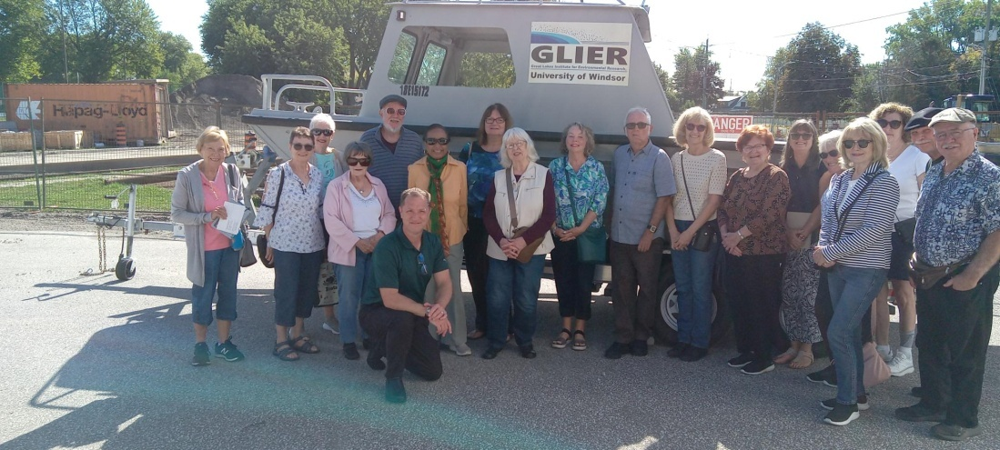
New Participants: It’s great to see many new faces in our Winter Semester. We are always happy to welcome new people. They contribute to the success of our program. Please share information with people you know who may be interested in joining us in the future.

Speaker Luncheon: Our committee is planning a February Luncheon. Information is coming.

In Memoriam: Our condolences are extended to the family and friends of Anne Winterbottom who passed away last week. She was very active in our program for many years and will be missed .

Come From Away Our appreciation is extended to Marilyn McKay for all her efforts planning a May 23rd trip to London to see this fabulous play. See page 2.

A Message from Marilyn:

Come From Away, the popular, outstanding musical, is being performed at the Grand Theatre in London, next spring. People in our group have shown interest in organizing a bus trip to attend a performance. Even though the show is 4 months away, ticket sales have been brisk, and we will have to commit quickly if we want to accommodate our class participants and their friends.
The date chosen is Saturday, May 23 at 2:00. We would leave Windsor, in a comfortable highway bus, at 10:00 am, returning home around 6:00 pm. We would arrive in London with enough time to have lunch before the performance. Cost of the trip would be $140. Lunch will not be included but there are lots of places to eat near the theatre.
There are less than 20 tickets still available and we expect them to go quickly.
If you are interested in participating, please let me know. I have included my email address and telephone number below.
Information about payment will be available soon.
Marilyn Mackay marilynmackay52@gmail.com
709-597-2971

