UNI~COM: Lifelong Learning
unicom@uwindsor.ca 226-221-9686
Coordinator: George Plantus

Bulletin #67
Update

Speaker Luncheon: We’re happy to inform you that the plans for our next Speaker Luncheon are in place. It’s at the L.A. Grill Friday Feb. 20 at 12:00 p.m.
Our speaker is Amy Dodge from C.B.C. Radio. Please see attached flyer.
Contact Judy Bezaire to make a reservation.

Law Class Tour: Last week’s tour of the Law Court and museum was a fabulous experience. Our appreciation is extended to Judge Philips and Janette Long for making this possible.
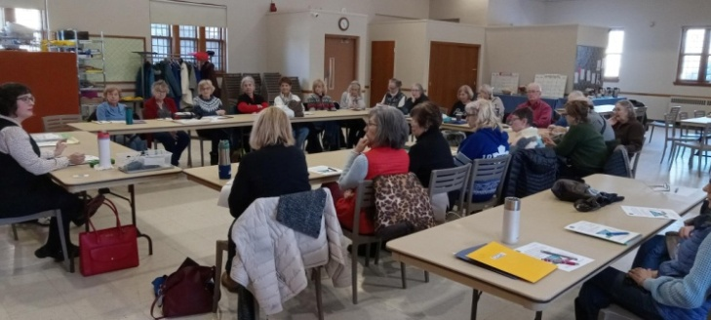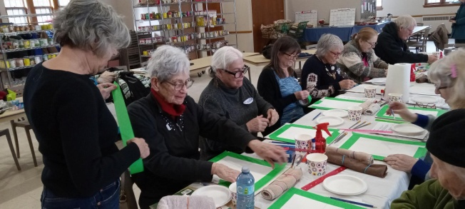
Law Class with Sarah Jacobs Discovering the Art in You

Time to Check our Calendars:
We had to postpone classes due to the snow storms.
This is our updated schedule:
Poetry continues Tue. Jan. 27th at 10:00 a.m.
Pysanky starts Wed, Jan. 28th at 12:30 p.m.
Law continues Thurs, Jan. 29th at 10:00 a.m.
Art continues Thurs. Jan. 29th at 1:00 p.m.
Today in History starts Thurs. Feb. 19th at 10:00 a.m.
Greek Mythology starts Tue. Feb. 24th at 1:00 p.m.
Going Places starts Thurs. Feb.26th at 1:00 p.m.

Come From Away: Marilyn informs us that there is still room for people to join us on our bus trip to see a professional afternoon performance at the Grand Theatre in London of Come From Away Saturday May 23rd. Sounds like a fun time. You can contact Marilyn for a reservation at marilynmackay52@gmail.com

