UNI~COM: Lifelong Learning
unicom@uwindsor.ca 226-221-9686
Coordinator: George Plantus
Bulletin #68
Welcome to Our Fall Semester

Appreciation: Our sincere appreciation is extended to everyone who has demonstrated interest in and support of our program. The classes, speaker luncheons, trips and visitations continue to enrich educational and social experiences that we enjoy. Thank you Martina Stvan for revising our website uwindsor.ca/unicom where all this information can be found..

We’re ready: to begin our 2026 Fall Semester. A special thank you to all the instructors who are preparing for upcoming classes. We’re happy to offer 9 wonderful courses this semester! Thank you to St. Mary’s Anglican Church for providing the venue for most of this semester’s classes.

Welcome Back Anne and Dancers: Our Dance instructor Anne McCallum has recovered from a leg injury is looking forward to starting up her Dance Class. We’re so happy to have her back.

Down the Road: Thank you once again to Marilyn Mackay who organized a very successful trip for 40 participants to visit London to attend an excellent performance of ‘Come From Away’. If you have a suggestion for next year please let us know.

Age Friendly University: It has been an interesting experience being invited to participate, as a committee member, in local efforts to establish the University of Windsor as an Age Friendly University. Our program shares many of the objectives and supports this project.
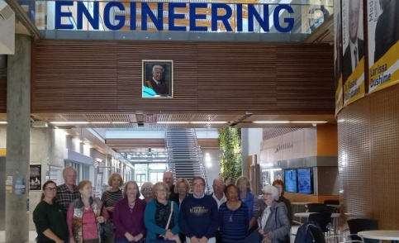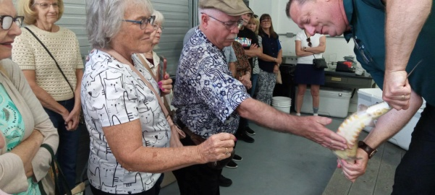
New Participants: It’s great to see many new faces in our Fall Semester. We are always happy to welcome new people. They contribute to the success of our program. Please share information with people you know who may be interested in joining us in the future.

Speaker Luncheon: We’re happy to inform you that we’ve planned our next Speaker Luncheon for Wednesday Oct. 21st at L.A.Grill. Our guest speaker will be Dr. J.J.McMurtry, President and Vice-Chancellor, University of Windsor. It ‘s great to once again invite our president to be an annual presenter. More information is coming soon.

Scholarships: Four students at the University of Windsor have received the annual scholarship award presented on behalf of UNI-COM: Lifelong Learning. Congratulations to all recipients and to all our members who support this program.

